

L1 Training Material
Investment Banking and Brokerage



Cognizant Technology Solutions
500 Glenpointe Centre West
Teaneck, NJ 07666
Ph: 201-801-0233

TABLE OF CONTENTS

1 Financial Instruments 6
1.1 Raising Capital 6
1.1.1 Equity 6
1.1.2 Fixed Income 8
1.1.3 Hybrids 17
1.1.4 Derivatives 18
2 Financial Markets 34
2.1 Types Of Financial Markets 34
2.1.1 Stock Markets 34
2.1.2 Bond Markets 35
2.1.3 Derivatives Markets 35
2.1.4 Money Market 35
2.1.5 Forex Market 36
3 Players in the Securities Industry 37
3.1 Key Entities 37
3.2 Facilitating Institutions 39
3.3 Buy Side and Sell Side of Securities Industry 40
3.4 Role of Technology 41
4 Investment Banking & Brokerage Sub-Vertical 43
4.1 Overview 43
4.2 What is an Investment Bank? 43
4.3 How is a I-Bank different from a commercial bank? 44
5 Investment Banking 46
5.1 Strategic Advisory 46
5.1.1 Mergers and Acquisition (M&A) 46
5.1.2 Financial Restructuring 50
5.1.3 Securitized Products 51
5.2 Securities Underwriting 51
5.2.1 Equity Underwriting 51
5.2.2 Debt Underwriting 52
5.2.3 IPO 52
5.2.4 Private Placements 58
5.3 Structured Finance and Loan syndication 58
5.3.1 Syndicate lending 58
5.3.2 Structured products 65
5.3.3 Leveraged Finance 65
• Credit risks and financial risks 67
• Structural risks 67
6 Global Capital Markets 68
6.1 Trading and Brokerage Function 68
6.1.1 Introduction 68
6.1.2 Full-Service Brokerage 68
6.1.3 Online Brokerage 70
6.1.4 Discount Brokerage 71
6.1.5 Institutional Brokerage Business 72
6.1.6 Proprietary Trading 75
6.1.7 Retail Brokerage 75
6.2 Prime Brokerage Business 79
6.3 Research 84
7 Exchanges and ECNs 86
7.1 Exchanges 86
7.1.1 Basic Function 87
7.1.2 Auction Exchanges 87
7.1.3 Electronic Exchanges 89
7.1.4 Market Makers vs. ECNs 90
7.1.5 NYSE and Nasdaq – A comparative Study 90
7.2 Electronic Communication Networks (ECNs) 92
7.3 Regulation Of Capital Markets 95
7.3.1 SEC 96
7.4 Stock Indices 96
8 Trade Lifecycle 99
8.1 Trade Cycle: Retail investors 100
8.1.1 Trading 100
8.1.2 Post-Trade Processing 101
8.2 Trade Cycle: Institutional Investors 102
8.2.1 Trading 102
8.2.2 Post-Trade Processing 105
8.2.3 Straight Through Processing and T+1 Settlement 107
9 Clearing and Settlement 108
9.1 Process 108
9.1.1 Players involved in the Process 108
9.1.2 Preparing for Clearing and Settlement 108
9.2 Clearing 111
9.2.1 Clearinghouse 111
9.3 Settlement 112
9.3.1 Types of settlements 112
9.3.2 Depositories 112
9.3.3 Procedure for Settlement 112
9.4 Shortages and Objections 113
9.4.1 Shortages 113
9.4.2 Objections 114
9.5 Good Delivery and Bad delivery 115
9.6 Stock Lending 115
9.7 Sell-out 117
9.8 Margin Management 118
9.8.1 Initial Margin 118
9.8.2 Maintenance margin 118
9.8.3 Marking-to-market 119
9.8.4 Buying on Margin 120
9.9 Asset Servicing 122
9.9.1 Dividend Collection 122
9.9.2 Interest Collection 125
9.10 Mandatory Corporate Actions 126
9.11 Voluntary Corporate Actions 128
10 Custody 132
10.1 Custodian 132
10.1.1 Services provided by Custodians 132
10.1.2 Types of Custodians 133
10.1.3 Risks associated with the Custodian’s role 134
11 Reconciliation 136
11.1 Types of reconciliation 136
11.2 Methods of Reconciliation 137
12 Technology in IPO, M&A and Corporate Finance 139
12.1 Market Data access 139
12.2 Modelling 139
12.3 Collaboration and Communication 139
12.4 Loan Syndication 140
13 Capital Market Processes and Technology 141
13.1 Front Office 142
13.1.1 Client Management 142
Introduction 142
Business processes in Client Management 143
Information managed by Client Management Systems 144
13.1.2 Research 145
13.1.3 Pricing and Price distribution 146
13.1.4 Order Management 147
13.1.5 Trade Capture and Execution 148
13.1.6 Business needs for Front Office processes 151
13.2 Middle Office 152
13.2.1 Post trade client service 152
13.2.2 Trade Matching and Confirmations 152
Oasys 152
Swift 153
13.2.3 P&L calculation, Control and Reporting 153
Types of P&L 154
Components of P&L 155
13.2.4 Transaction Accounting and Reconciliation 156
13.2.5 Reference data management 156
13.2.6 Technology incidence in Middle Office 157
13.2.7 Business needs for Middle Office processes 157
13.3 Back Office 158
13.3.1 Margins and Collateral management 158
13.3.2 Settlement 158
13.3.3 Risk Management 160

SECTION I

INSTRUMENTS, MARKETS AND INSTITUTIONS

- Financial Instruments

  - Raising Capital
Corporations need capital to finance business operations. They raise money by issuing Securities in the form of Equity and Debt. Equity represents ownership of the company and takes the form of stock. Debt is funded by issuing Bonds, Debentures and various certificates. The use of debt is also referred to as Leverage Financing. The ratio of debt/equity shows a potential investor the extent of a company’s leverage.
Investors choose between debt and equity securities based on their investment objectives. Income is the main objective for a debt investor. This income is paid in the form of Interest, usually as semi-annual payments. Capital Appreciation (the increase in the value of a security over time) is only a secondary consideration for debt investors. Conversely, equity investors are primarily seeking Growth, or capital appreciation. Income is usually of lesser importance, and is received in the form of Dividends.
Debt is considered senior to equity (i.e.) the interest on debt is paid before dividends on stock. It also means that if the company ceases to do business and liquidate its assets, that the debt holders have a senior claim to those assets.
A security is a financial instrument that signifies ownership in a company (a stock), a creditor relationship with a corporation or government agency (a bond), or rights to ownership (an option). Financial instruments can be classified into:
- Equity
- Debt (or Fixed Income)
- Hybrids
- Derivatives

    - Equity
Equity (or Stock) is viewed by the market as an ownership "share" in the revenue stream of a corporation's income once all prior obligations and debts have been satisfied.
There are two types of equity:
- Common stock
- Preferred stock

Common stock
As the name suggests common stock is the most common method of providing stocks in a company. The characteristic feature of this stock is that the holder of is entitled to voting rights as well as the dividends. Important point to note is that there is no guarantee of dividends
There are various flavors of common shares like Class A and Class B. Class A and Class B shares are shares that are issued at different point of time with slightly different characteristics. These characteristics mainly deal with the voting rights, which differ across these classes.

Preferred stock
Preferred stock is the stock in which the owner has a guaranteed dividend payment at a specified rate. Preferred stock has features of both equity and debt securities. It represents ownership in a corporation, but it does not have the voting rights as common stocks Although preferred stock does not typically have the same growth potential as common stock, it does have two distinct advantages over common stockholders.
No dividends can be paid to common shareholders before obligations to preferred shareholders are met
Preferred stock also has priority claims over common stock; that is, if a company declares bankruptcy, the preferred stock holders are paid before common shareholders. These are also known as preference shares.
Example
Losers Inc. declares bankruptcy and its assets are liquidated for 50,000 $. It has issued 30000 preferred stock with face value of 1$ each and 40000 common stock with face value of 1$ each. Thus the total equity is 30000*1 + 40000*1 = 70,000.
In this scenario, the preferred stock owners get 30,000 $ and the common stock holders get the residual i.e. 20,000 $. Here the common stock holders have had to lose 0.5$ per share investment.
Now what would have been the payments incase the assets were worth only 15,000$. If you got 0.5 $ for each preferred share and zero for common shareholders, you have got a hang of this.

Comparison between common stock and preferred stock
 | Common Shares | Preferred shares
Ownership | Yes | Yes
Dividends | No Guarantee | Guaranteed
Voting Rights | Yes | No
Risk | High | High
So now you know about common and preferred stocks. Lets see how good have you grasped the fundamentals so far.
Why would anyone want a common stock? After all preferred stock does guarantee a fixed payment. The answer is simple. Preferred stock is like giving someone a loan. You get a confirmed dividend payment for a fixed amount that you have invested. But in case the company does better than expected, the common stock holders get a much higher payment than the preferred stock holders. The following example will make it clearer:
Example
Suppose a company has 100 preferred stocks @ 100 Rs per stock with a guaranteed dividend of 10% . Also the company has 100 common stocks @ 100 Rs. per stock. The company decides to pay whole profit as dividends:
 |  | 2001 | 2002
(A) | PAT | 1000 | 5000
(B) | Dividend per Preferred Share | 10 | 10
(C) | Total dividend for Preferred shares | 1000 (100 * 10) | 1000 (100 * 10)
(D) | Total Dividend for Common Shares | ZERO (A-B) | 4000
(E) | Dividend per common share | Zero | 40

So now you see that the preferred share holders got the same amount in both the years irrespective of the company’s performance, where as the common share holders’ returns were related to the company’s performance. That is one reason why the common share holders want the voting rights in a company – this way they can control a company much better and thus have some control over their money.
But don’t you think that the preference shares are just like a debt instrument? In both the cases you pay the money and you get fixed guaranteed pay back. So where is the catch?
Catch: So far we have told you that if a company gets liquidated then the preference stock holders get a preference to the common stock holders. But normally there is another kind of people that a company owes money – and they are the debt holders – the ones who have loaned the money. These people hold the highest priority for repayment when the firm gets liquidated, depending on whether the loan is secured or unsecured. So priority level is:
- Debt (Bond) holders
- Preference share
- Common share
Moreover convertible shares are like convertible bonds, but the subtle difference is that obligation, in case of preference shares arises, only when companies have enough to pay the guaranteed return, which is not the case in case of bonds, where bondholders can force a company to borrow and pay the interest

American Depository Receipts (ADR)
The purpose of an ADR is to facilitate the domestic trading of a foreign stock. An ADR is a receipt for a specified number of foreign shares owned by an American bank. ADRs trade like shares, either on a U.S. Exchange or Over the Counter. The owner of an ADR has voting rights and also has the right to receive any declared dividends. An example would be Infosys ADRs that are traded in NASDAQ.

    - Fixed Income
Fixed income instruments are those instruments that offer a fixed amount of money for a specified period of time. In other words, the amount of income to be received is known before hand to an investor. It is different from the equity (barring the preferred stock) because in equity the returns are dependent upon the performance of a company. The bank loans that you might take for home or a car fall in the fixed income category because the bank knows prior to lending the money, the amount of money that it will receive from you. Even the savings account that you hold in your bank is a fixed-income instrument as you get the fixed rate of interest at a pre-specified time. The fixed income instruments can be divided into following:

Bonds
Bonds are the loans taken by governments or corporate. Typically a bond pays a fixed rate at a pre-specified amount of time. This is called coupon rate and the amount of currency that is paid is called as a coupon. Some of the basic terminology that you will need to know initially is:
- Par Value/Face Value
The principal amount that is returned at the end of the maturity is known as the Par value. It is also known as the principal or face value. Par value will vary depending on the type of bond. When the bond matures and the lump sum is returned, the debt obligation is complete.
Note: It is important to remember that bonds are not always sold at par value. In the secondary market, a bond's price fluctuates with interest rates.
- Coupon Rate
It is the annual rate of interest on the bond's face value that a bond's issuer promises to pay the bondholder. The interest rate is calculated upon the par value of the bond. The coupon is determined at time of issuing the bond and is usually expressed as an annual percentage of the par value of the bond. Payments usually occur every six months, but this can vary. If two bonds with equal maturities and face values pay out different coupons, the prices of these bonds will behave differently in the secondary market. For example, the bond with a lower coupon rate will be less expensive because the bondholder is going to be getting more of his/her return from the return of principal at maturity than will the holder of a bond with a higher coupon. There are some bonds that do not pay out any coupons; these are called zero-coupon bonds
- Maturity period/Term to maturity
Maturity is the date on which the principal or nominal value of a bond becomes due and payable in full to the holder. Time to maturity is the time between now and when the bond matures. Thus at the time of maturity, when the issuer pays back the par value, he is no more obligated to pay anymore. Maturities range significantly, from 1 month for some municipal notes to 40+ years for some corporate bonds.

Classification of bonds
Bonds can be divided into following categories:
- Central Government Bonds (Treasuries).
- Municipal Bonds
- Corporate Bonds

Government Bonds
When a government borrows money they are called as treasury instruments. Treasury instruments can be of three types. Treasuries are highly liquid and have the lowest risk:
- Treasury bills (T-bills): These instruments mature with in a year. Thus these are short-term loans.
- Treasury notes: These are the bonds that mature within one to ten years.
- Treasury bonds: These are the bonds, which mature after ten years.

Municipal bonds
The local government issues these bonds. In US these bonds are exempt from taxes from federal as well as state governments, thus these are very popular. But since these bonds are tax exempted, their returns are lesser to the comparable bonds.

Corporate Bonds
Corporate Bonds are fixed income securities issued by the industrial corporate, public utility corporations etc. to raise funds for their projects. Since the corporates have different risks, the returns that they give vary. Generally a corporate having more risk of default will be offering a higher rate of return.
Some of the important types of corporate bonds are:
- Mortgage Bonds
This is a bond secured by a mortgage on a property. The value of the property may or may not equal the value of the bonds issued against it.
- Collateral Trust Bonds:
As an alternative to pledging fixed assets or property, a borrower can pledge financial assets such as stocks, bonds, T-bills etc.
- Zero Coupon bonds
Typically a bond has got coupon payments throughout its life. But a certain kind of bond does not pay the coupons during the lifetime of the bond. They are issued at a discount from face value and redeemed at the face value on maturity. The difference between the purchase price of the zero and its face value when redeemed is the investor's return. For example: A zero coupon bond of face value $100 and maturing in 5 years will be offered at $73.85 thus giving an annual coupon of 6.25%

Bond Calculations
Okay so now you know what different types of bonds are like. So lets say if you are an investor what are the things that you will take into account before you decide to invest in a bond. Primary characteristics of a bond that you will take care of are:
- Price of the bond
- Rate of return
- Maturity period
- Price
To understand the bond price, we need to refresh the NPV fundamentals of the foundation course. Actually a bond is nothing but a series of cash flow. When you buy a bond you have negative cash flow, and when you get the coupons, they can be equaled as positive cash flows.
Thus we need to discount the cash flows with the interest rates prevalent. But which interest rates should we use? Typically the rate used should be the opportunity cost of capital, i.e. the rate of a similar risk – same maturity bond. We will first try to understand the various rates that are normally mentioned:
- Spot Rate:
Spot rate is the interest rate on an investment starting today and ending after some specified day. Thus 3 year spot rate from today means the rate of return on an instrument with a three-year maturity and starting from today.
- Forward Rate:
A forward rate is an interest rate contracted today on an investment that will be initiated after some time in future. In other words it is spot rate in future.
Forward rates and spot rates are interlinked.
Example
Years (duration) | Spot Rates
1 | 5%
2 | 6%
- Here Row 1 shows that if one invests 100 Rs. today then after 1 year it will be 105 Rs.
- Also Row 2 shows that if one invests 100 Rs. today, after 2 years it will become
100* (1.06)^2 = 112.36 Rs.
- So can you calculate 1-year forward rate from next year?
For that, you will have to see that one year forward rate (fr1) has to satisfy following equation:
Investing in 100 Rs today for one year and then re-investing the payments received after the first year for another year = Investing the 100 Rs today for two years.
i.e.
sr1 = Spot Rate for 1 year
sr2 = Spot Rate for two years
1fr1 = Forward rate for 1 year starting one year from now
Therefore,
100 * (1+ sr1 )(1+ fr11) = 100(1+ sr2)^2
100(1.05) (1+fr11) = 100(1.06)^2
1fr1 = (112.36/105) – 1 = 7%
Generally xFy indicates the forward rate for (y-x) years starting after x years.
Now why have we told you about the concept of forward rates and spot rates? For one thing, you will have to know which rate to use while discounting the cash flows of a bond. Whenever we calculate the NPV we use the spot rate. The reason is because we want to discount the cash flow to the present date. Hence any rate that we use should identify the rate from present date.
So what will we do if we just have forward rates? In that case we will calculate the spot rates based on the forward rates. Actually the price of a bond fluctuates. This is so because the total amount of return from a bond is fixed. Thus as the spot rate of the economy changes the present value of the future amounts would also vary. To make it less confusing lets look at this example.
Example
Suppose you have a bond with a face value of 100 $ and will give a 10 % coupon for next three years. So the pay offs are:
 | Returns | Investment | Total yearly Return
Present Year | 0 | 100$ | -100$
First year | 10$ | 0 | 10$
Second Year | 10$ | 0 | 10$
Third Year | 110$ | 0 | 110$

So you can see that the total investment is 100 $ and the returns are 130$. Now recollect what you had studied about time value of money in foundation course. The 10$ in the third year does not have the same value as 10$ in the first year.
So the actual returns will have to be the discounted values of the cash flows to the present year. Let us assume that the spot rate of a bond having similar risk is 10% in first 2 years and 5 % in third year. Thus after calculating NPV the table looks like

Year | Returns | Investment | NPV | Total yearly Return
Present Year | 0 | 100$ | 100$ | -100$
First year | 10$ | 0 | 9.09$ | +9.09$
Second Year | 10$ | 0 | 8.26$ | +8.26$
Third Year | 110$ | 0 | 95.02$ | +95.02$
 | Total Inflow (Add 2,3,4 rows) |  |  | +112.37$

Thus this means that the price you are willing to pay for the bond will equal the total inflows you expect from the bond. Thus the price of the bond = the present value of the cash inflows = 112.37$
Example
Bond Price calculation can be summed by an easy formula:
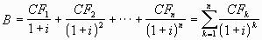
where B represents the price of the bond and CF_{k} represents the kth cash flow which is made up of coupon payments. The Cash Flow (CF) for the last year includes both the coupon payment and the Principal.
- What would be the bond price for a 3-Year, Rs.100 principal, bond when the interest rate (i) is 10% and the Coupon payments are Rs.5 annually?
- Would the bond price increase/decrease if the coupon is reduced? What would be happen to bond price if the interest rates came down?

Now what we have learnt is the theoretical calculation of a bond rate. There is a slight error in the previous calculation. Can you guess what it is?
In the previous example we have assumed that the bond is being priced at the start of the year i.e. the time left for the next coupon to come is exactly on year. In other words we have not considered for the trading in the secondary market but practically, the calculations are not so simple. The bonds can be traded on any trading day. So, to calculate the price of the bond, we need to know the number of days of interest already accrued.

E.g., you may have a bond that pays semi annual coupon of 100 Rs coupon on Dec 31st and June 31 every year. A person buying the bond on Jan 1st will only receive the next coupon on June 31st, but if he/she buys it on 25th December he will get the coupon for 31st December as well. However the seller of the bond is the actual beneficiary of the coupon till the 25th December. Thus when the buyers buys the bond he has to pay the seller not only the bond price but the interest that has accrued on the bond from the last coupon payout till the sale date and this determines the actual price of the bond
The bond price and hence the yields are influenced by day count conventions that differ from one market to the other. Day count conventions differ in assumptions on the number of days in a year as well as the number of days in a month. The most common conventions are:

Convention | Rules
Actual/actual | The actual number of days between two dates is used.
Actual/actual | Leap years count for 366 days, non-leap year’s count for 365 days.
Actual/365 fixed | The actual number of days between two dates is used as the numerator.
Actual/365 fixed | All years are assumed to have 365 days.
Actual/360 | The actual number of days between two dates is used as the numerator. A year is assumed to have 12 months of 30 days each.
30/360 | All months are assumed to have 30 days, resulting in a 360-day year.
30/360 | If the first date falls on the 31st, it is changed to the 30th.
30/360 | If the second date falls on the 31st, it is changed to the 30th, but only if the first date falls on the 30th or the 31st.
30/360 | If the second date falls on the 31st, it is changed to the 1st and the month is increased by one.

Now lets go back to the previous example to determine the actual price of the bond.
Example
Lets assume that the date today is 31st December and that the bond pays an annual coupon of 100 $ on August 31st. Moreover the face value of the bond is 100$. The spot rate is 5% for first year and 7 % for two year and 8 % for three-year period.
Thus if use the 30/360 convention then the NPV then for year 1
- PV for first year is: 10/(1+r)^{(240/360)} = 10/1.05 ^{0.75} = 9.64
- PV for second year is: 10/(1+r)^{(600/360)} = 10/1.07 ^{1.75} = 8.88
- PV for third year is: 110/(1+r)^{(960/360)} = 110/1.08 ^{2.75} = 89.01
Thus the price is a sum of the three years:10753$

Year | Returns | Investment | NPV
First year | 10$ | 0 | 9.64$
Second Year | 10$ | 0 | 8.88$
Third Year | 110$ | 0 | 89.01$
 | Price (Add 2,3,4 rows) |  | +107.53$

Effect of term to maturity on volatility of a bond
Bonds having longer maturities will be more sensitive to changes in interest rates. Shorter-term bonds are more stable and more predictable, because you are more likely to hold it to maturity.
The reason can be explained in the following example.
Example
Suppose you have two bonds of 2 years and 5 years maturity having similar coupon rate. Now if we fluctuate the interest rate from 10% to 20% we get the following NPV

 | Short term Bond1 | NPV at r- 10% | NPV at r- 20% | Long term Bond2 | NPV at r- 10% | NPV at r- 20%
Price | 100 | 100 |  | 100 | 100 | 100
Year 1 coupon | 10 | 9.09 | 8.333333 | 10 | 9.09 | 8.333333
Year 2 coupon | 110 (coupon: 10 + principal : 100) | 90.90 | 76.38889 | 10 | 8.264463 | 6.944444
Year 3 coupon | - | - | - | 10 | 7.513148 | 5.787037
Year 4 coupon | - | - | - | 10 | 6.830135 | 4.822531
Year 5 coupon | - | - | - | 110 (coupon: 10+ principal: 100) | 68.30135 | 44.20653
Total NPV | - | 99.99 | 84.72222 | - | 100 | 70.09388

Thus If you notice the change of r from 10% to 20% has created a difference of 15 $ for the short-term bond and a difference of 30$ for long-term bond. Thus a long-term bond is inherently more susceptible to interest rate changes.
Yield
The yield of a bond is, roughly speaking, the return on the bond. The yield is expressed as the annual rate based on the par value. There are several types of yield: nominal yield, current yield, and yield to maturity.
Nominal yield is the same as the coupon rate. It is the rate of income that you receive based on the par values of the bond. Supposing you buy a bond with par value of 1000 Rs. and a coupon of 100 Rs Annually. Then the nominal yield is 100/1000 = 10 %.
Current yield is a measure of the return on the bond based on the current price. Since the current price of a bond fluctuates the current yield of a bond also fluctuates. If the par value of a bond is 1000 Rs with a coupon of 120 Rs (i.e. 12%), and the current price is 1200 Rs then the current yield is 10%.
Yield to maturity is the overall return on the bond if it is held to maturity. It reflects all the interest payments that are available through maturity and the principal that will be repaid, and assumes that all coupon payments will be reinvested at the current yield on the bond. This is the most valuable measure of yield because it reflects the total income that you can receive. If you purchase the bond at a discount, yield to maturity will reflect the fact that at maturity you will have additional income because of the difference between the price paid and the principal returned. For example, if you purchase a $1,000 par value bond for $800, you have $200 extra in income at maturity. The calculation is slightly different if the bond is purchased at a premium, but it takes into account the extra amount paid for the bond.
Now lets calculate the different yields for the previous question. The table is provided below:
 | Returns | Investment | Total yearly Return
Present Year | 0 | 100$ | -100$
First year | 10$ | 0 | 10$
Second Year | 10$ | 0 | 10$
Third Year | 110$ | 0 | 110$

Nominal Yield:
The nominal yield is the coupon rate, which is
Coupon value/ original price of bond
= 10/100 = 10 %
Current Yield
Current yield is:
Coupon value/ Current market price
=10/112.37 = 8.89%
Yield to Maturity
YTM for the bond is the rate at which the NPV of the bond is zero. Thus the YTM is when “r” when:
112.37 = 10/(1+r) + 10/(1+r)^2 + 110/(1+r)^3
Hence YTM is 5.4%
Yield Curve
Yield curve is a graphical representation of the relationship between maturity and yield to maturity. Normally as the time to maturity of bonds gets longer, the returns associated with them are also higher. Thus a 10-year government bonds normally pays much higher than a 5-year government bond. Can you understand why this is so?
The reason is pretty simple. The risk of any individual/organization defaulting on its obligations increases with time. In other words chances that Reliance will go bankrupt in 5 years is lesser compare to the chances of Reliance going bankrupt in 10 years. It is so because longer duration exposes Reliance to more risks. Thus if HSBC lends Reliance for 5 years, there is lesser chance for Reliance to default. Similarly if HSBC lends Reliance for 10 years the chances of default are much higher. Obviously HSBC will ask for a higher return for the ten-year period.
Thus if yield to maturity is on the vertical axis and time to maturity is on the horizontal axis, the normal yield curve slopes upward because as maturity increases yield usually increases.
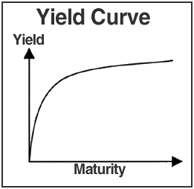
Figure 1: Yield Curve
So when do you think the yield curve will slope downwards?
The yield curve will slope downwards when the longer-term bonds offer less return. This will happen only when a recession or low inflation is anticipated; but it is not very common. Can you tell why? Think for a while.
Well the answer lies in the fact that if you expect a recession, then the inflation of the economy will go down. This will in turn mean that the interest rates will also dip (recollect from the foundation course that the nominal interest rate = real interest rate * inflation). Thus the dip in the interest rates means that the yield of those bonds will also reduce.
Lets take an example to clear the fundamentals
Example
Suppose the economy is growing by 10% but after 5 years you expect the economy to dip to go in recession for 5 years with a negative inflation (called deflation) of -3% p.a. Thus the bond till 5 years maturity will have increasing yield (due to 10% growth p.a.) but a bond with 6 years maturity will provide lesser yield than the bond of 6 years maturity due to deflation. This will lead to a dip in yield curve.

Floating Rate Bonds:
There is another type of bond in which the rate is not fixed. In such bonds the interest rate is fixed relative to a pre-defined index.

There are varieties of fixed income instruments that have not been discussed here.

    - Hybrids
Hybrids are securities, which combine the characteristics of equity and debt.

Convertible bonds
Convertible Bonds are instruments that can be converted into a specified number of shares of stock after a specified number of days. However, till the time of conversion the bonds continue to pay coupons.
Case Study
Tata Motors Ltd. (previously know as TELCO) recently issued convertible bond aggregating to $100 million in the Luxemburg Stock Exchange. The effective interest rate paid on the issue was just 4% which was much lower than what it would have to pay if it raised the money in India, where it is based out of. The company would use this money to pay-back existing loans borrowed at much higher interest rates.
- Why doesn’t every company raise money abroad if it has to pay lower interest rates?
- Will there be any effect on existing Tata Motors share-holders due to the convertible issue? If ‘Yes’, when will this be?

Warrants
Warrants are a type of security that gives the holder the option to buy a preferred or a common stock at a specified price within a specified time. Warrants are call options – variants of equity. They are usually offered as bonus or sweetener, attached to another security and sold as a Unit. For example, a company is planning to issue bonds, but the market dictates a 9% interest payment. The issuer does not want to pay 9%, so they “sweeten” the bonds by adding warrants that give the holder the right to buy the issuers stock at a given price over a given period of time. Warrants can be traded, exercised, or expire worthless.
In case, warrants are exercised, new securities are issued which is not the case when an option is exercised. Options are generally settled in cash.
Example
Okay simple isn’t it? It’s more like a paper, which says:
You can buy 1 share of CTS at a price 100$ anytime in next 10 years. Great isn’t it. So how does one get it? Easy you buy it for a small price. Sounds too good!!! So where is the catch?
Well consider this. You buy a warrant to buy stock of CTS at a price of 100 $ within next 3 years. The price of the warrant is 4 $. The price of CTS stock is 50 $ today. Assume that, probability that the stock will cross 100 $ sometime in 3 years is 70 %. So if the stock crosses 100 $ then you will buy the stock at 100 $. If the stock is lets say 110 $ then you will exercise your option and buy the stock at 100 $. A profit of 10 $.
What if the stock is at 90 $? Then there is no point in exercising your warrant. In case the prices never crosses 100 $ in next 3 years you will have to let the warrant go waste and lose the $4 that you paid.
In case price is 102 $ what will you do? Obviously you will buy it. A profit of 2 $… right? Not actually. You had spent 4 $ initially to buy this warrant. So you have finally incurred a loss of 2 $.

    - Derivatives
A derivative is a product whose value is derived from the value of an underlying asset, index or reference rate. The underlying asset can be equity, foreign exchange, commodity or any other item. For example, if the settlement price of a derivative is based on the stock price, which changes on a daily basis, then the derivative risks are also changing on a daily basis. Hence derivative risks and positions must be monitored constantly.
Options
An option is a contract, which gives the buyer the right, but not the obligation to buy or sell shares of the underlying security at a specific price on or before a specific date.
As mentioned before it means that their value depends on the value of an underlying investment. The underlying investment can be a stock, an index, a currency, a commodity, or any number of other securities. There are two kinds of options: Call Options and Put Options.
Call options
Call options are options to buy a stock at a specific price on or before a certain date (Expiration Date). Call options usually increase in value as the value of the underlying instrument rises. The price paid, called the option Premium, secures the investor the right to buy that certain stock at a specified price (Strike price) on or before the expiration date. If he/she decides not to use the option to buy the stock, the only cost is the option premium. The following example will make it easier to understand:
Example
Suppose you buy a call option on 1st Jan 2006 for 0.5$ with a strike price of 6$ and an expiration date of 31st March 2006. Thus, on expiration date if the time price is less than 6$ the person will not exercise the option and the loss will be 0.5£. As the price become greater than 6£ your profit will be:
Actual Price – Strike price – cost of option
= Actual price – 6.5£
Thus as you can see in the pay off diagram below, for less than 6£, the loss is 0.5£ and thereon the profit is a linear function.
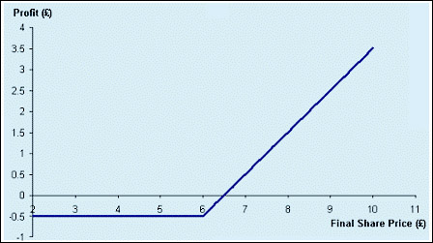
Figure 2: Payoff to buyer of Call Option
Guess what will be the pay off of the seller of the option?
The pay off for seller of the option is given below. If you notice the sum of the sellers pay offs and the buyers pay off is zero for any price. Can you guess why?
Seller of the options are also called writer of the options.
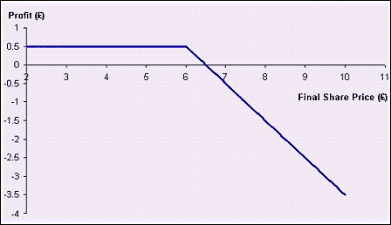
Figure 3: Payoff to seller of Call Option
Put option
A put option provides the holder with the right to sell shares of the underlying stock at the strike price at the maturity date.
Example
Suppose you buy a put option for 0.5 £ with a strike price of 6 £, then you will sell the stock if the price is less than 6£ and will not sell the stock if it is greater than 6£. Thus for price greater than 6£, your initial investment of 0.5£ will go waste. Also the profit that you will get if price is less than 6£ is:
6£ – price of stock – 0.5£

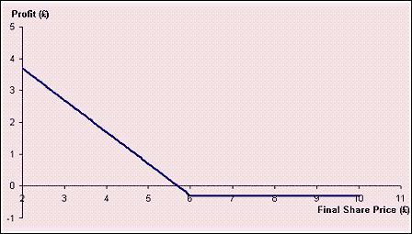
Figure 4: Payoff to buyer of Put Option
Similar to the call option, the pay offs of seller of the put option will also be exactly opposite to that of buyer of put option.

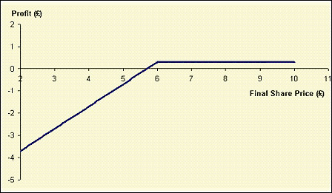
Figure 5 : Payoff to seller of Put Option
For the holder, the potential loss is limited to the price paid to acquire the option. When an option is not exercised, it expires. No shares change hands and the money spent to purchase the option is lost. The upside, however, is unlimited. Options, like stocks, are therefore said to have an asymmetrical payoff pattern. For the writer, the potential loss is unlimited unless the contract is covered, meaning that the writer already owns the security underlying the option. It is also called covered option writing. An option, which is not a covered option, is called, as naked option writing is very risky.
Options are most frequently used by individual investors as either leverage or insurance. As leverage, options allow the holder to control equity in a limited capacity without paying the full price of buying shares up front. The difference can be invested elsewhere until the option is exercised. As insurance, options can protect against price fluctuations in the near term because they provide the right to acquire the underlying stock at a fixed price for a limited time.

Example
If you think that the stocks of CTS are going to rise in next three months. You have 100 million dollars (in your dreams!!!) and you want to invest the money in CTS shares. But you also feel that the interest rates will dip in coming three months, thus sending the prices high. The stock of CTS is trading at 100$ but you feel it will be 150$ after 3 months. You can buy a call option for CTS at 4$ with a strike price of 110$. Thus rather than buying the stocks, you will prefer to buy the call options for 100million $. That is you will buy 1,000,000 (100,000,000 / 100) options. The cost of these options will be 1,000,000 * 4 = 4 million $. The rest 96 million $ you can invest in bonds.
After three months, if the CTS price does go above 110$ (preferably 150$ as you predicted) then you can exercise the option at 110$. Also if the interest rate does go down then you will earn money in the 96 million dollars that you invested. So you have been able to invest your money in both stocks and bonds by using the options.
Stock options also form the basis for more complicated trading strategies that will be discussed only briefly here.
It is important to remember that options can be an extremely risky investment, and they are certainly not appropriate for naive investors. Only the most experienced investors should include options in their investment strategy, and even the most knowledgeable investors should prepare for the possibility of substantial losses.
Advantages and Disadvantages of Options
Advantages
- An investor can gain leverage in a stock without committing to a trade.
- Option premiums are significantly cheaper on a per-share basis than the full price of the underlying stock.
- Risk is limited to the option premium (except when writing options for a security that is not already owned).
- Options allow investors to protect their positions against price fluctuations.
Disadvantages
- The costs of trading options (including both commissions and the bid/ask spread) is significantly higher on a percentage basis than trading the underlying stock, and these costs can drastically eat into any profits.
- Options are very complex and require a great deal of observation and maintenance.
- The time-sensitive nature of options leads to the result that most options expire worthless. Making money by trading options is extremely difficult, and the average investor will fail.
- Some option positions, such as writing uncovered options, are accompanied by unlimited risk.

Option Classification
Options are classified as in-the-money, out-of-the-money or at-the-money.
A call option is in-the-money when the stock price is above the strike price and out-of-the-money when the stock price is below the strike price. For put options, the reverse is true. When the stock price and strike price are equal, both types of options are considered at-the-money.
Of course, when calculating profit and loss, the premium, as well as taxes and commissions must be factored in. Therefore, an option must be far enough in-the-money to cover these costs in order to be profitable.
Also Options are classified based on their underlying assets:
- Stock option
A stock option is a contract that guarantees the investor, who has purchased it the right, but not the obligation, to buy or sell shares of the underlying stock at a fixed price prior to a certain date. The buyer of an option is known as the holder and the seller is called the writer. If the option contract is exercised, the writer is responsible for fulfilling the terms of the contract by delivering the shares to the appropriate party or settling in cash.
- Index Options
An Index option is a contract that guarantees the investor, who has purchased it the right, but not the obligation, to buy or sell the underlying index at a fixed price prior to a certain date. The settlement is always on cash basis.

Valuing and Pricing Options
The price of an option is composed of two parts:
Intrinsic value
The intrinsic value of an option is the difference between the price of the underlying asset and the strike price. Basically if you buy a call option with a strike price of 50$ and the stock price is 30$, then even if you exercise your option today you will earn the 20 $ today. Thus this 20$ is intrinsic value of the option
Time value
It is the amount of money options buyers are willing to pay for an option in anticipation that over time a change in the underlying price will cause the option to increase in value. In general, an option premium is the sum of time value and intrinsic value. Any amount by which an option premium exceeds the option's intrinsic value can be considered time value. It can also referred to as Extrinsic Value.
For example if you own a call option with expiry 5 months from now and the strike price of 50$ and the stock price is also 50$, the intrinsic value is zero. But there is a chance that the stock price may go above 50$ in next 5 months. Thus you will not sell this option for free. This chance is the basis for the time value of an option contract.
Option pricing is done by Black Scholes formula. The prices of option are based on the following:
- Strike Price
- Price of underlying asset
- Volatility of underlying asset
- Time left for expiry.
- Risk free rate
The actual Black Scholes formula is outside the scope of this course.

Exercising Options
Exercising an option consists of buying (in the case of a call option) or selling (in the case of a put option) shares of the underlying stock at the strike price.
Based on the methods of exercising the options, they are divided into following two parts:
- American options: The holder may exercise an American style option at any point between the time of purchase and the expiration date.
- European options: A European style option, on the other hand, cannot be exercised until expiration.
- Asian options: These options can be exercised only on few selective dates as agreed upon.
Most stock options are American style, but some index options are European style.

Straddles and Strangles
A straddle provides the opportunity to profit from a prediction about the future volatility of the market. Long straddles are used to profit from high volatility. Such a straddle can be effective when an investor is confident that a stock price will change dramatically, but cannot predict the direction of the move. Short straddles represent the opposite prediction that a stock price will not change.

Long Straddle
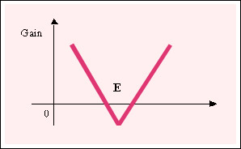
Figure 6: Long Straddle

- Technique: Purchase a call and a put at the same striking and at the same maturity date.
- To be used when a sharp movement of the underlying security price is expected but the direction unknown (higher volatility).
- Maximum risk: Limited to premium paid.
- Maximum profit: Unlimited.

Long Strangle
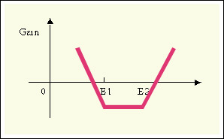
Figure 7: Long Stangle
- Technique: Purchase a call (E2) and a put at a lower striking (E1) and at the same maturity date. This is a less expensive variant of the straddle.
- To be used when a sharp movement of the underlying security price is expected but the direction unknown (higher volatility).
- Maximum risk: Limited to premium paid.
- Maximum profit: Unlimited.

Short Straddle
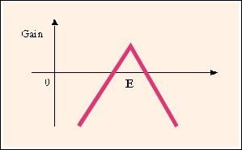
Figure 8: Short Straddle
- Technique: Sell a call and a put at the same striking and at the same maturity date.
- To be used when no movement of the underlying security price is expected.
- Maximum risk: Unlimited.
- Maximum profit: Limited to premium received.

Short Strangle
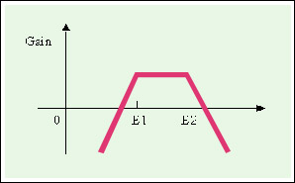
Figure 9: Short Strangle

- Technique: Sell a call (E2) and a put at a lower striking (E1) and at the same maturity date.
- To be used when a limited movement of the underlying security price (between E1 and E2) is expected.
- Maximum risk: Unlimited.
- Maximum profit: Limited to premium received.

Spreads
A spread is made up of two or more options in the same stock where the strike price, the expiration date or both are different. Spreads can limit or alter risk while returning a profit when the gains from one or more option offset the losses from the rest.

Bull Spread
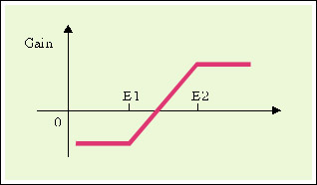
Figure 10: Bull Spread
- Technique:
  - With Call: purchase a call at strike E1 and sell a call at a higher strike E2 and at the same maturity date.
  - With put: purchase a put at strike E2 and sell a put at a lower strike E1 and at the same maturity date.
- To be used when moderate increase of the underlying security price is expected (between E1 and E2).
- Maximum risk: Limited to net premium paid.
- Maximum profit: Difference between strike E2 and strike E1 minus the net premium paid.

Bear Spread
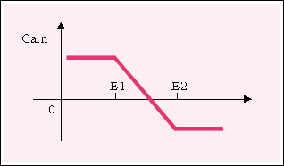
Figure 11: Bear Spread

- Technique:
  - With Call: purchase a call at strike E2 and sell a call at a lower strike E1 and at the same maturity date.
  - With put: purchase a put at strike E1 and sell a put at a higher striking E2 and at the same maturity date.
- To be used when moderate decrease of the underlying security price is expected (between E1 and E2). Call in red, Put in black.
- Maximum risk: limited to net premium paid.
- Maximum profit: difference between strike E2 and strike E1 minus the net premium paid.

Options are volatile and risky instruments. The link between probability theory and investment risk makes it possible to quantify option investment risk in very precise ways. Any change in the variables used in the valuation model (risk free rate, asset price, days to expiration, and volatility) will affect the options' prices. These variables represent risks to an option portfolio. In the above section, we will define briefly most of the fundamental risks.

Greeks
Greeks are used to represent and measure the risks associated with options.
Delta Risk
- The delta risk measures, the impact on the option's price for a unit change in the price of the underlying asset (generally quoted in cent for a change of 1 in the underlying price).
- DELTA = (change in option price) / (absolute change in asset price)
- Example: Delta of 0.40 USD means that the option's price will increase by 0.40 USD if the underlying asset price increases by 1 USD.
- This risk indicator gives you an idea of the speed of reaction of the option.
- A deep in the money option will usually have a delta close to +/- one, a far out of the money option will have a delta close to zero.
Gamma Risk
- As the delta is not a constant and changes with the price of the underlying asset, the impact on the DELTA risk for each change in the underlying asset is called GAMMA risk. GAMMA can be positive as well as negative. The highest value is found close to the strike price.
- A GAMMA of USD 0.05 means that the DELTA will increase by USD 0.05 for each dollar change in the underlying price.
Lambda Risk
- Very close to the GAMMA, the LAMBDA is defined as the percent change in the option price for a percent change in the underlying price.
- LAMBDA is always greater (or close to) one.
Theta Risk
- The THETA risk measure the impact on the option's price for a one day change in time remaining to expiration
Kappa/Vega Risk
- The option's price is affected by changes in the market's valuation of implied volatility. This very important risk is referred to as KAPPA or VEGA risk.
- The KAPPA / VEGA risk is defined as Dollar change in option price for one positive point of implied volatility change
Rho Risk
- The last variable in the Black and Scholes model is the risk free interest rate. The impact on the option's price of a change in the risk free interest rate is referred to as RHO risk.

Warrants
A warrant is a certificate, usually issued along with a bond or preferred stock, entitling the holder to buy a specific amount of securities at a specific price, usually above the current market price at the time of issuance. Expirations range anywhere from a few years to forever. The warrant may be sold separately from the underlying security. It increases in value as the price of the underlying stock rises.

LEAPs
LEAPs is an acronym for Long-term Equity AnticiPation Securities. LEAPs are very similar to standard options except for the fact that they expire much further in the future. They can be safer than traditional options because it is somewhat easier to predict stock movement over longer periods. Like options, they allow an investor to lock in a fixed price for the underlying security. Therefore, like options, they can be effective for both leverage and insurance purposes. Expiration generally occurs 36 months after purchase, and LEAPs are American style, so they can be exercised at any time before expiration. Strike prices usually range around 25% above or below the price of the underlying stock when the LEAP is first offered.

Forwards and Futures
Financial Futures
A futures contract is a standardized, transferable, exchange-traded contract that requires delivery of a commodity, bond, currency, or stock index, at a specified price, on a specified future date. Generally, the delivery does not occur. Instead, before the contract expires, the holder usually settles his position by paying or receiving the difference between the current market price of the underlying asset and the price stipulated in the contract.
Unlike options, futures contracts convey an obligation to buy. The risk to the holder is unlimited. Because the payoff pattern is symmetrical, the risk to the seller is unlimited as well. Dollars lost and gained by each party on a futures contract are equal and opposite. In other words, futures trading is a zero-sum proposition.
Futures contracts are forward contracts, meaning they represent a pledge to make a certain transaction at a future date. The exchange of assets occurs on the date specified in the contract. Futures are distinguished from generic forward contracts in that they contain standardized terms, trade on a formal exchange, are regulated by overseeing agencies, and are guaranteed by clearinghouses. Also, in order to insure that payment occurs, futures have a margin requirement that must be settled daily. Finally, by making an offsetting trade, taking delivery of goods, or arranging for an exchange of goods, futures contracts can be closed.
Futures are risky investment vehicles that are appropriate for only the smallest percentage of highly advanced investors. They are sometimes used as a hedge by investors with the resources to devote a small percentage of their assets to such a dangerous venture. Futures trading should almost never be attempted by individual investors.

Futures Trading
Futures contracts are purchased when the investor expects the price of the underlying security to rise. This is known as going long. Because he has purchased the obligation to buy goods at the current price, the holder will profit if the price goes up, allowing him to sell his futures contract for a profit or take delivery of the goods on the future date at the lower price.
The opposite of going long is going short. In this case, the holder acquires the obligation to sell the underlying commodity at the current price. He will profit if the price declines before the future date.
Hedgers trade futures for the purpose of keeping price risk in check. Because the price for a future transaction can be set in the present, the fluctuations in the interim can be avoided. If the price goes up, the holder will be buying at a discount. If the price goes down, he will miss out on the new lower price. Hedging with futures can even be used to protect against unfavourable interest rate adjustments.
While hedgers attempt to avoid risk, speculators seek it out in the hope of turning a profit when prices fluctuate. Speculators trade purely for the purpose of making a profit and never intend to take delivery on goods. Like options, futures contracts can also be used to create spreads that profit from price fluctuations.
Accounts used to trade futures must be settled with respect to the margin on a daily basis. Gains and losses are tallied on the day that they occur. Margin accounts that fall below a certain level must be credited with additional funds.

Pricing Futures
Futures prices are presented in the same format as cash market prices. Therefore, they are listed in dollars and cents per quantity. When these prices change, they must change by at least a certain minimum amount, called the tick. The tick is set by the exchange.
Prices are also subject to a maximum daily change. These limits are also determined by the exchange. Once a limit is reached, no trading is allowed on the other side of that limit for the duration of the session. Both lower and upper limits are in effect. Limits were instituted to guard against particularly drastic fluctuations in the market.
In addition to these limits, there is also a maximum number of contracts for a given commodity per person. This limit serves to prevent one investor from gaining such great influence over the price that he can begin to control it.

The Cost of Carry Model
The cost of carry refers to the lost opportunity cost of purchasing a particular security rather than an alternative. For most investments, the cost of carry generally refers to the risk-free interest rate that could be earned by investing currency in a theoretically safe investment vehicle such as a money market account minus any future cash-flows that are expected from holding an equivalent instrument with the same risk (generally expressed in percentage terms and called the convenience yield). Storage costs (generally expressed as a percentage of the spot price) should be added to the cost of carry for physical commodities such as corn, wheat, or gold.
Cost-of-carry model is an arbitrage-free pricing model. Its central theme is that futures contract is so priced as to preclude arbitrage profit. In other words, investors will be indifferent to spot and futures market to execute their buying and selling of underlying asset because the prices they obtain are effectively the same. Expectations do influence the price, but they influence the spot price and, through it, the futures price. They do not directly influence the futures price. According to the cost-of-carry model, the futures price is given by.
F=S+C
where:
- F: Futures price
- S: Spot price
- C: Holding costs or carry costs
This can also be expressed as:
F=S(1+r)^{T}
where:
- r: Cost of financing
- T: Time till expiration

If F < S(1+r)^{T} or F > S(1+r)^{T} arbitrage opportunities would exist
i.e. whenever the futures price moves away from the fair value, there would be chances for arbitrage.
For e.g.
- When F > (S + C): Sell the (overpriced) futures contract, buy the underlying asset in spot market and carry it until the maturity of futures contract. This is called "cash-and-carry" arbitrage.
- When F < (S + CC - CR): Buy the (under priced) futures contract, short-sell the underlying asset in spot market and invest the proceeds of short-sale until the maturity of futures contract. This is called "reverse cash-and-carry" arbitrage.
We know what the spot and futures prices are, but what are the components of holding cost? The components of holding cost vary with contracts on different assets. At times the holding cost may even be negative. In the case of commodity futures, the holding cost is the cost of financing plus cost of storage and insurance purchased etc. In the case of equity futures, the holding cost is the cost of financing minus the dividends returns.

Pricing futures contracts on commodities
Example
Let us take an example of a futures contract on a commodity and work out the price of the contract. The spot price of silver is Rs.7000/kg. If the cost of financing is 15% annually, what should be the futures price of 100 gms of silver one month down the line? Let us assume that we’re on 1st January 2002. How would we compute the price of a silver futures contract expiring on 30th January? From the discussion above we know that the futures price is nothing but the spot price plus the cost-of-carry. Let us first try to work out the components of the cost-of-carry model.
1. What is the spot price of silver? The spot price of silver, S= Rs.7000/kg.
2. What is the cost of financing for a month? (1+0.15)^{30/365}
3. What are the holding costs? Let us assume that the storage cost = 0.
In this case the fair value of the futures price, works out to be = Rs.708.
F= S(1+r)T +C = Rs 708
In case of silver there was no holding cost. But in cases of commodities like coffee, oil etc, the cost of holding the commodity will be high.

Forward Contracts
The mechanism of forward contract is the same as the ones of a futures contract. The only difference is that the forward contract is not traded on an exchange. A forward contract is a direct agreement between two investors. A forward contract is more flexible than the futures contract because the two parties can agree on all the characteristics of the contract (underlying amount, delivery date, delivery place,etc.) but these contracts are more difficult to close in advance (because one has to negotiate with ones original counterpart who may not want to close the position) and are therefore less liquid. Follow up of credit risks is also more difficult. As they are not traded on an exchange, these contracts are known as OTC (over the counter). Due to the above, forward contract are usually reserved to institutional investors and large corporate. The most popular forward contracts are contract on currencies foreign exchange and interest rates (FRA).

Commodity forward contracts
In this type of contract, the underlying is a commodity. A commodity is any physical substance, such as food, grains, and metals, which is interchangeable with another product of the same type, and which investors buy or sell, usually through futures contracts. The term is sometimes used more generally to include any product, which trades on a commodity exchange; this would also include foreign currencies and financial instruments and indexes. The price of the commodity is subject to supply and demand factors. Risk is actually the reason exchange trading of the basic agricultural products began. For example, a farmer risks the cost of producing a product ready for market at sometime in the future because he doesn't know what the selling price will be. A speculator can pay the farmer or anyone else producing commodities because the speculator wants to make a profit.

Swaps
Swaps are agreements between at least two counter-parties to exchange cash flows in the future according to a pre-specified formula. They can therefore be regarded as portfolios of forward contracts. The most common one is an agreement on the exchange of a fixed rate for a floating rate contract.
Interest Rate Swaps
Interest rate swap is the exchange of one set of cash flows for another. A pre-set index, notional amount and set of dates of exchange determine each set of cash flows. The most common type of interest rate swap is the exchange of fixed rate flows for floating rate flows.

Example
CTS comes up with a deal with ICICI bank in which CTS pays ICICI bank an Interest of 7% fixed on 100 crore rupees. In turn ICICI promises to pay CTS a monthly interest of inflation rate + 1% on 100 crore rupees. Thus assuming that for 6 months the inflation rate was 5%, 5.25%, 6%, 6.75%, 5.5%, 5.5% then the pays offs would be as follows:

 | Month I | Month 2 | Month 3 | Month 4 | Month 5 | Month 6 | Total
Inflation rate | 5 | 5.25 | 6 | 6.75 | 5.5 | 5.5
ICICI pays | 6 | 6.25 | 7 | 7.75 | 6.5 | 6.5 | 40
CTS pays | 7 | 7 | 7 | 7 | 7 | 7 | 42
So CTS pays 42 crores whereas ICICI pays 40 crores. Do you think CTS went in loss? Well actually it has, but if you see that the loss of 2crore has helped CTS transfer the risk of inflation rate volatility. Thus ICICI has in a way bought the inflation rate risk for Rs 3 crores.
In case the inflation rate would have increased to 8 or 9 % then ICICI would have had to pay the additional money to CTS, and CTS would have been completely protected from the high inflation rates.
Note: In case you haven’t noticed, the 100 crores of principal amount have NOT been exchanged. The only exchange is of the interests and the principal is just a notional amount.

Currency Swaps
Currency swap is a swap contract in which two counterparties agree to exchange principal and interest denominated in different currencies based on an agreed-upon currency exchange rate.
In an interest rate swap, we were concerned exclusively with the exchange of cash flows relating to the interest payments on the designated notional amount. However, there was no exchange of notional at the inception of the contract. The notional amount was the same for both sides of the currency and it was delineated in the same currency. Principal exchange is redundant.
However, in the case of a currency swap, principal exchange is not redundant. The exchange of principal on the notional amounts is done at market rates, often using the same rate for the transfer at inception as is employed at maturity.
For example, consider the US-based company Amex that has raised money by issuing a French Franc-denominated Eurobond with fixed semi-annual coupon payments of 6% on 100 million French Francs. Upfront, the company receives 100 million French Francs from the proceeds of the Eurobond issue (ignoring any transaction fees, etc.). They are using the French Francs to fund their US operations.
Because this issue is funding US-based operations, we know two things straightaway. Amex is going to have to convert the 100 million French Francs into US dollars. And Amex would prefer to pay its liability for the coupon payments in US dollars every six months.
Amex can convert this French Franc-denominated debt into a US dollar-like debt by entering into a currency swap with the Bank.
Amex agrees to exchange the 100 million French Francs at inception into US dollars, receive the French Franc coupon payments on the same dates as the coupon payments are due to Amex's Eurobond investors, pay US dollar coupon payments tied to a pre-set index and re-exchange the US dollar notional into French Francs at maturity.
Amex's US operations generate US dollar cash flows that pay the US-dollar index payments.

Equity Swaps
Having discussed interest rate swaps and their cross-currency extension to currency swaps as exchanges of cash flows predicated on pre-set indices, it is natural for us to think of structuring swaps involving non-interest indices. Equity swaps are exchanges of cash flows in which at least one of the indices is an equity index. An equity index is a measure of the performance of an individual stock or a basket of stocks. Common equity indices with which the general investor is probably familiar include the Standard & Poor's 500 Index, the Dow Jones Industrial Average or the Toronto Stock Exchange Index.
Valuation of swaps is beyond the scope of this course.

Swaptions
A swaption is an option to enter into an interest rate swap. The contract gives the buyer the option to execute an interest rate swap on a future date, thereby locking in financing costs at a specified fixed rate of interest. The seller of the swaption, usually a commercial or investment bank, assumes the risk of interest rate changes, in exchange for payment of a swap premium.

Credit derivatives
It is a contract between two parties that allows for the use of a derivative instrument to transfer credit risk from one party to another. The party transferring risk away has to pay a fee to the party that will take the risk.
A credit derivative is a financial instrument used to mitigate or to assume specific forms of credit risk by hedgers and speculators. These new products are particularly useful for institutions with widespread credit exposures.
Example
Mr Musicwala gives a loan of 40 crore rupees to Miss Rockwali. He gets scared that Miss Rockwali is not that great a singer after all and may not return the money back. So he goes to Goldman Sachs and cuts a deal in which Goldman Sachs will pay Mr Musicwala the amount that Miss Rockwali defaults. Of course Goldman Sachs takes an upfront payment of Rs 2 crore from Mr Musicwala.
In a way Goldman Sachs has sold the risk associated with the loan for Rs 2 crore. It is very much like insurance in fact.

Securitization
Securitization is the process of financing a pool of similar but unrelated financial assets (usually loans or other debt instruments) by issuing to investors security interests representing claims against the cash flow and other economic benefits generated by the pool of assets.

Asset Based Securities
Asset based securities are based on Securitization. Asset-backed securities are bonds that are based on underlying pools of assets. These assets are usually illiquid and private in nature. A securitization occurs to make these assets available for investment to a much broader range of investors.
To make things simpler consider the following example:
Example
A 1000 people take loans from ICICI bank with a combined value of 100 crore Rs. ICICI bank decides to get money based on these loans. So it groups together the loans worth 100 crores Rs. and starts selling them as securities. Now the investors buy the securities. The dividends that they get are nothing but the interest payments form these investors. Of course some of the investors may not pay the interests and some may default altogether. This will fluctuate the price of the ABS. Also the change in the interest rates will change the price of the underlying loans, thus changing the value of the assets.

Mortgage Based Securities
An example of ABS is MBS. Before the development of the mortgage-backed securities market in the early 1980s, each residential mortgage underwritten was a unique transaction. Joe Q. Public would walk into his bank or trust company and enter into a mortgage. By way of example, Joe chooses Lack Trust Company. Joe enters into a mortgage on a specific real estate property, 100 Easy Street in the Hills of Richmond, with the good people of Lack Trust. Sounds easy. But think of what has to happen for this mortgage to be underwritten. Lack Trust must check Joe's credit (salary, assets, etc.) and establish the worth of the property through an appraisal. Joe and Lack Trust then negotiate and establish the terms. This includes the amount and interest rate of the mortgage, the amortization of principal, as well as the prepayment terms. Lack Trust then has to hire a lawyer to register the mortgage against the property with a property registry office.
It can easily be seen that Joe's mortgage is an unique thing. There are no other mortgages on 100 Easy Street with Joe as the borrower on those terms and conditions. That is why most mortgages were held by the financial company that originated them. Trading was awkward, as the mortgages had to each be evaluated and administered differently. The originating organization usually kept the servicing and were loath to part with their mortgages. Only very large institutional investors participated in this market. Smaller investors did not have the expertise to evaluate the mortgages, or a large enough portfolio to properly diversify. If a single mortgage was in the $200,000 range, a maximum 10% position would require a total portfolio of over $2,000,000 to be properly diversified. Therefore, for an individual investor, if their portfolio was to be properly diversified, a mortgage was an awkward asset to own.
If we combine Joe and five hundred other borrowers in a mortgage "pool" we have something that is bigger, which makes it more economical to issue, and better in credit quality, because of the diversification from the large number of mortgages. In a total pool of $100 million, no one mortgage of $200,000 is more 5% and not a large enough part of the pool to "skew" the pool's characteristics in any one aspect. If, for example, Easy Street turns out to be the site of a former radium factory, the fact Joe's house is worth less than we expected is not a fatal issue for the pool of assets as a whole.

- Financial Markets
In the foundation program you were briefly introduced to the various financial markets, including the primary and secondary financial markets. Financial markets are usually classified based on the type of financial instruments that are traded.

  - Types Of Financial Markets
Primary Markets
Primary market is one where new financial instruments are issued for the first time. They provide a standard institutionalized process to raise money. The public offerings are done through a prospectus. A prospectus is a document that gives detailed information about the company, their prospective plans, potential risks associated with the business plans and the financial instrument.
Secondary markets
Secondary Market is a place where primary market instruments, once issued, are bought and sold. An investor may wish to sell the financial asset and encash the investment after some time or the investor may wish to invest more, buy more of the same asset instead, the decision influenced by a variety of possible reasons. They provide the investor with an easy way to buy or sell.

Some of the financial markets are:
- Stock Markets
- Bond Markets
- Derivatives Markets
- Money Markets
- Forex Markets
- Commodity Markets

    - Stock Markets
Stock markets are a place where organized trading of stocks is done through exchanges. Stock markets are most commonly known among all financial markets because of the large participation of ‘retail investors’ i.e. common people who invest from their own savings.
Stock exchanges provide a system that accepts orders from both buyers and sellers for shares that are traded on a particular exchange. Exchanges then follow a mechanism to automatically match these orders based on the ‘quoted price’, ‘time when the order was placed’, ‘order quantity’ and the ‘order type’. A successful match of a buy order with a sell order is known as a trade. As in any other market the price of the stock depends on the demand and supply of the stock.

The exchange also provides information on all ‘open’ orders with their price quotes and all trades with traded prices. Thus the market information is transparent and available in real time to all, making the trading efficient and reliable. Earlier, before the proliferation of computers and networks, the trading usually took place in an area called a ‘Trading Ring’ or a ‘Pit’ where all brokers would shout their quotes and find the counter party. This was called the ‘Open Outcry’ system. The trading ring is now replaced in most exchanges by advanced computerized and networked systems that allow online trading, so the members can log in from anywhere to carry out trading. E.g. Super Dot of NYSE, NEAT from NSE etc.
The modern stock markets are basically the stock exchanges like the London stock exchange (UK), New York stock exchange (USA), Euronext (Europe) National Stock Exchange (India) etc.

    - Bond Markets
Bond markets, as the name implies are financial markets where bonds and other debt instruments are issued and traded. Government bonds constitute the major bulk of the bonds issued and traded in these markets. The different bonds traded in the bonds market are treasury bonds (Government bonds with maturity>10 years), treasury bills (maturity < 1 year) and treasury notes (1-10 years), municipal bonds (Bonds issued by local Government and Government bodies) and corporate bonds (Bonds issued by companies).
Bond markets are also called Fixed Income markets because the promised return on a bond i.e. interest rate is generally fixed. While some of the bonds are traded on the exchange, most of the bond trading is conducted over-the-counter (OTC) i.e. by direct negotiations between dealers.

    - Derivatives Markets
Derivatives markets are one in which trading can be done in derivative instruments like futures and options. A futures contract is a type of derivative instrument, or financial contract, in which two parties agree to transact a set of financial instruments or physical commodities for future delivery at a particular price. An option is a contract giving the buyer the right, but not the obligation, to buy or sell an underlying asset at a specific price on or before a certain date.
In recent years, the market for financial derivatives has grown tremendously in terms of variety of instruments available, their complexity and also turnover. In the class of equity derivatives, futures and options on stock indices have gained more popularity than on individual stocks, especially among institutional investors, who are major users of index-linked derivatives. Even small investors find these useful, due to the high correlation of popular indexes with various portfolios and ease of use. The lower costs associated with index derivatives vis-à-vis derivative products based on individual securities is another reason for their growing use. Some of the exchanges that offer trading in derivative instruments are Chicago Board Options Exchange (CBOE) and London International Financial Futures and Options Exchange (LIFFE).

    - Money Market
A money market is a market for short-term debt instruments such as negotiable certificates of deposit, Treasury bills, commercial paper, repos (repurchase agreements), bankers’ acceptances, etc. Instruments that are traded in money markets are typically of a short maturity (from as less as 1-7 days to less than a year.
Money market securities are relatively safe instruments but usually offer a lower rate of interest. The value of individual transactions in this market is usually very high and hence most of the trades are of institutional nature. Many institutions including banks use the money markets for the treasury and cash management activities wherein they could borrow or lend money for short-term time horizon.

    - Forex Market
A forex market is not what may be termed as a securities market but it is an important financial market nevertheless, accounting for extremely large financial transactions in terms of volume and value.

- Players in the Securities Industry

  - Key Entities
The securities industry is made up of a variety of firms and organizations that bring together buyers and sellers of securities, manage investments, and offer financial advice. The industry is undergoing substantial change because of improvements in technology, deregulation of financial services, regulatory changes, globalization of the marketplace, and changing demographics.

The different players in the investment arena are:
Investor
An investor is an individual who commits money to investment products with an expectation of financial returns. Generally, the primary concern of an investor is to minimize risk while maximizing return, as opposed to a speculator, who is willing to accept a higher level of risk in the hopes of collecting higher-than-average profits.

Broker-Dealers
One needs membership of a stock exchange to access the exchange trading system. These members are called by various names such as Brokers, Dealers, market-makers, Specialists etc based on the type of membership or services offered. Investors who are not members of the exchanges have to open trading accounts with a member firm. Member firms accept and route orders, send notifications and take care of settlement of the trade in exchange for a fee.
A broker is a person or firm that facilitates trades between clients. It charges a fee or commission for executing buy and sell orders submitted by an investor. A broker acts as a go-between, and, in doing so, does not assume any risk for the trade. When the broker is a firm, it is also called a brokerage house or a brokerage.
A dealer is a person or firm that buys and sells for his or her own inventory of securities. A dealer differs from an agent in that the dealer acts as a principal in a transaction. A dealer therefore assumes risk for the transactions. Dealers may mark securities up or down to make a profit on their transactions.
Brokers, when authorized by the client, may set up discretionary accounts. These accounts allow brokers to buy and sell securities for a client's account without contacting the client for each transaction. The authorized broker may determine the security traded, how much of it may be traded, the price and the time of transaction.

Brokers may lend funds to clients who have margin accounts. With margin accounts, clients can buy additional securities with money borrowed from a broker.

To be involved in the buying, selling or trading of securities, a person or firm must be registered with the National Association of Securities Dealers (NASD). The NASD is a self-regulatory organization created by the Securities and Exchange Commission (SEC). Brokers and dealers must follow all rules of the NASD and SEC, including the NASD's Conduct Rules and its rules for arbitration, complaints and dealings with the public.

Market Makers
Market makers are firms that maintain a firm bid and offer price in a given security by standing ready to buy or sell at publicly-quoted prices. Market makers process orders for their own clients, and for other broker/dealers. Market makers also buy securities from issuers for resale to clients or other broker/dealers.
A broker/dealer may become a Market Maker if the firm meets capitalization standards set down by the NASD.

Specialists
Specialists keep markets for securities orderly and continuous. This means that they must buy when there are others selling without buyers, and they must sell when others are buying without sellers. They maintain their own inventories of securities that are large enough for sizable trades. Specialists both buy and sell out of these inventories and mediate between other clients.

Investment Bank / Merchant Bank
An investment bank is an institution which acts as an underwriter or agent for corporations and municipalities issuing securities. Most investment banks also maintain broker/dealer operations, maintain markets for previously issued securities, and offer advisory services to investors. Investment banks also have a large role in facilitating mergers and acquisitions, private equity placements and corporate restructuring. Unlike traditional banks, investment banks do not accept deposits from and provide loans to individuals.
An investment bank that deals mostly in international finance is referred to as a Merchant Banks. Their knowledge in international finances makes merchant banks specialists in dealing with multinational corporations.

Mutual Funds
A mutual fund is a fund operated by an investment company, which raises money from shareholders and invests in a group of assets, in accordance with a stated set of objectives.
Mutual funds raise money by selling shares of the fund to the public. Mutual funds then take the money they receive from the sale of their shares (along with any money made from previous investments) and use it to purchase various investment vehicles, such as stocks, bonds and money market instruments. In return for the money they give to the fund when purchasing shares, shareholders receive an equity position in the fund and, in effect, in each of its underlying securities.
For most mutual funds, shareholders are free to sell their shares at any time, although the price of a share in a mutual fund fluctuates daily, depending upon the performance of the securities held by the fund.
Benefits of mutual funds include diversification and professional money management. Mutual funds offer choice, liquidity, and convenience, but charge fees and often require a minimum investment.

Pension Funds
A pension fund is a fund established by an employer to facilitate and organize the investment of employees' retirement funds contributed by the employer and employees. The pension fund is a common asset pool meant to generate stable growth over the long term, and provide pensions for employees when they reach the end of their working years and commence retirement.
Pension funds are commonly run by financial intermediaries for the company and its employees, although some larger corporations operate their pension funds in-house. Pension funds control relatively large amounts of capital and represent the largest institutional investors in many nations.

Hedge Funds
A hedge fund is a fund, usually used by wealthy individuals and institutions, which takes positions in both safe and speculative opportunities. A hedge fund uses aggressive strategies, including selling short, leverage, program trading, swaps, arbitrage, investing in asset classes such as currencies or distressed securities, and derivatives to achieve stringent investing goals. Hedge funds seek positive absolute returns, regardless of the performance of an index or sector benchmark.
Hedge funds are exempt from many of the rules and regulations governing other mutual funds, because it is assumed that the people investing in them are sophisticated and high net worth investors. This allows them to accomplish these aggressive goals. They are restricted by law to a maximum of 100 investors per fund. As a result, most hedge funds set extremely high minimum investment amounts, ranging anywhere from $250,000 to over $1 million.
Typically, Hedge Funds provide for the payment of an Incentive Allocation or Performance Fee to the hedge Fund Manager/General Partner. Performance Fees range from 20% to 40% depending on the strategy employed by the Hedge Fund Manager. Additionally, typical Hedge Funds include a traditional management fee of 1% to 2% of all assets under management.

Prime Broker
A prime broker is a broker which acts as settlement agent, provides custody for assets, provides financing for leverage, and prepares daily account statements for its clients, who are money managers, hedge funds, market makers, arbitrageurs, specialists and other professional investors. The prime brokerage option was started to cater to the hedge funds, as the hedge funds place large trades and need special attention from brokerages.

  - Facilitating Institutions
Custodian
Custodian is a financial institution, which holds stocks, bonds and other securities on behalf of an investor for guaranteed safekeeping. Related services include the collection of income on custodial securities, the settlement of transactions, the investment of cash overnight and the provision of accounting reports. Additional services may include performance evaluation and analysis, on-line reporting, global custody and securities lending.

Exchange
Any organization, association or group which provides or maintains a marketplace where securities, options, futures, or commodities can be traded. The NYSE and Nasdaq are some prominent examples of exchanges.

Clearing Firms
Clearing firm is an organization that works with the exchanges to handle confirmation, delivery and settlement of transactions. It is also called a clearinghouse or clearing corporation
Clearing firms act as a central counter party in all exchange initiated trades guaranteeing the settlement of transaction between market participants and ensuring that sellers are paid and buyers receive their securities in a manner that reduces risk, cost and post-trade uncertainties. In USA, The National Securities Clearing Corporation (NSCC) id the clearinghouse for all trades done on the New York Stock Exchange and Nasdaq. The clearing firms work in conjunction with the depository.

Clearing Banks
Funds settlement takes place through clearing banks. For the purpose of settlement all clearing members are required to open a separate bank account with the clearing firm designated clearing bank.

Depository Trust Company
Depository Trust Company is a central repository through which members electronically transfer stock and bond certificates (a clearinghouse facility). The Depository Trust Company was set up to provide an infrastructure for settling trades in municipal, mortgage-backed and corporate securities in a cost-efficient and timely manner. It is also the world's largest securities depository, holding about $20 trillion of assets in custody at any time. It is a member of the Federal Reserve System, registered with the Securities and Exchange Commission (SEC) and owned by the Depository Trust and Clearing Corporation (DTCC). The DTCC in turn is owned by several banks, brokerages, trading houses and trading exchanges, with the NYSE being one of its largest shareholders.

  - Buy Side and Sell Side of Securities Industry
Broadly all the market participants can be divided into the buy side and the sell side. The buy side and sell side are described as follows:

Buy Side
Buy side is the side of Wall Street comprising the investing institutions such as mutual funds, pension funds and insurance firms, that tend to buy large portions of securities for money-management purposes.
A buy-side analyst typically works in a non-brokerage firm (i.e. mutual fund or pension fund) and provides research and recommendations exclusively for the benefit of the company's own money managers. A buy-side analyst would only be interested in analyzing whether the investment is suitable for the firm's investment strategy and portfolio. Buy-side recommendations are not available to anyone outside the firm.
Buy-side analysts often source research from sell-side analysts, and then use this information as a base for their own research.

Sell Side
The sell side entities comprise brokerage firms, investment bankers and research departments that sell securities and make recommendations for brokerage firms' customers. These entities provide recommendations for upgrades, downgrades, target prices and opinions to the public market.
Sell-side analysts are employed by brokerage firms, and the sell-side recommendations are meant for the general investing public. A sell-side analyst's focus when analyzing possible investments is to see whether the investment should be recommended to the firm's clients.
Sell-side analysts are those who issue the often-heard recommendations of "strong buy", "outperform", "neutral" or "sell". These recommendations help clients make decisions to buy and / or sell certain stocks.
Sell side firms also directly interact with the exchange by placing orders in securities. It’s the responsibility of the sell side to ensure the best execution price for an order from the buy side. They also help firms raise money from the market by creating new securities.
Thus a buy side firm like a mutual fund would design a portfolio of securities in which investment needs to be made and contact the sell side brokerage firm that would in turn place orders on the exchange on behalf of buy side. If an institutional portfolio manager changes jobs and becomes a registered representative, he or she has moved from the buy side to the sell side.

  - Role of Technology
The Internet, along with high-speed computer systems, has dramatically altered the way in which securities and commodities are bought and sold, almost completely automating the transaction process. At the same time, the number of financial services being offered is rising as firms look for new ways to attract the business of an increasingly wealthy and investment-savvy public.
Traditionally, the securities industry has used manual processes for many of their operational activities. However, market trends are pushing the industry to review the way that they now operate. Manual processes are labor intensive, at a time when companies are looking to reduce their cost base, rather than increase it. Clearly, such companies will be viewing technology as one way to reduce overheads and increase efficiency.
Historically settlement in three to five days has been acceptable. Now, the drive to settle in less than three days is forcing the industry to consider automating the majority of their core processes.
Global and cross border trading means that participants in the securities industry - fund managers, custodians and investment bankers - also need to standardize on message formats to communicate effectively. Indeed, there are many initiatives being formed in the industry to agree standardized and secure financial messaging.
Technology itself is forcing the pace of change. Straight Through Processing (STP) which was a dream in the last decade is fast moving towards becoming a reality with several processes and entities already well integrated using technology. The internet opens up new opportunities for the industry, as a fast cost-effective message delivery mechanism. But clearly it is not without its own issues - security and reliability are key considerations for the financial services. Where a financial services organization operates a global intranet this is clearly not an issue. However, for smaller brokers and fund managers wanting to communicate with other parties across the web, the risks of non-secure messages are high. With the increasing volume of securities business being handled, and the need to settle faster, processes and methods of transactions with organizations need to be reviewed. We shall discuss the impact of technology in the Investment banking and Brokerage industry in detail in Section IV

SECTION II

INVESTMENT BANKING AND BROKERAGE

- Investment Banking & Brokerage Sub-Vertical

  - Overview
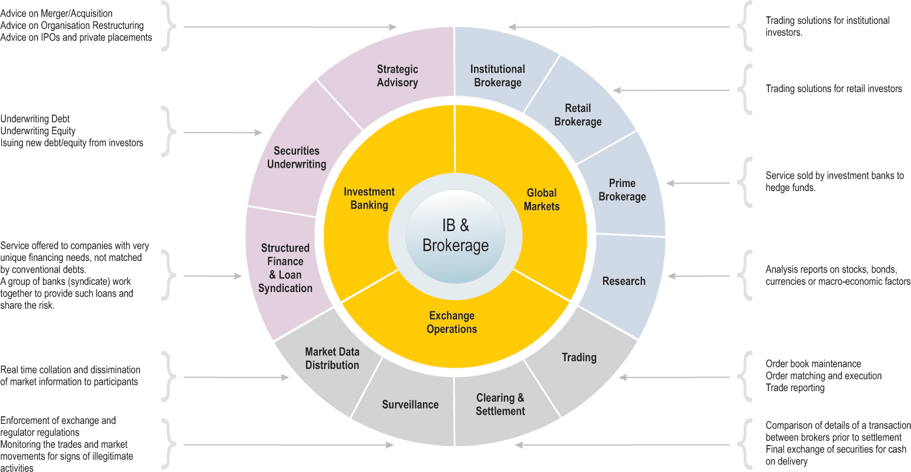

Investment Banking and Brokerage is a sub-vertical within BFS practice. At Cognizant, this vertical comprises broadly of Investment Banking, Global Capital Markets and Exchange Operations. Cognizant has worked with some of the largest banks/financial institutions in the Investment Banking & Brokerage sub-vertical and some of the engagements are strong, long-term, ongoing partnerships. The projects executed by Cognizant cover the entire spectrum of IT value chain - consulting, application development, application integration, product configuration, re-engineering, data warehousing and application value management; and also the entire spectrum of the industry across front, middle and back offices.

  - What is an Investment Bank?
An investment bank, simply put, is an intermediary organization that uses its expertise and financial knowledge to make it possible for companies, institutions and governments to take advantage of business or investment opportunities. More specifically:
- Investment banks link companies that need money to grow with other companies, institutions or investors willing to provide them with that money via a variety of forms, be it loans, stocks, bonds or hybrid financing arrangements. The investment bank structures these transactions and is capable of bringing them to market in the case of stock and bond offerings.
- Investment banks use financial expertise to provide corporate finance advice. For example, the banks can help clients manage their business and investment risks, buy other companies, divest themselves of unwanted operations or finance their expansion into new countries or industries. Often, the investment bank will identify opportunities for clients, using its regional or industry expertise and business contacts. Investment banks also provide many of these services for governments of all sizes—they help them raise money through bond offerings, assist them in obtaining loans for financing projects and advise them in other financial matters.
- Sales and Trading areas of investment banks link investors with the world’s financial markets, including stock (equity) markets, bond (fixed income) markets, derivative markets, foreign exchange, commodities and more. Research areas (equity and fixed income) may contribute expertise to these market activities by monitoring companies, industries, market sectors and key economic factors, then providing the investment bank’s traders and clients with information that helps them to invest intelligently.

  - How is a I-Bank different from a commercial bank?
There are at least four broad product categories that define the domain of commercial banking. These are:
- Deposit-taking in domestic markets, markets abroad, and off-shore markets: This asset gathering involves demand and time deposits of residents and non-residents, including those of individuals, corporations, governments, and other banks (redeposits).
- Loan syndication is a key wholesale commercial banking activity. It involves the structuring of short-term loans and “bridge” financing, credit backstops and enhancements, longer-term project financing, and standby borrowing facilities for corporate, governmental, and institutional clients.
- Treasury activities, comprising trading and dealing in deposits to help fund the bank, foreign exchange contracts, financial futures and options, and so forth. These operations are functionally linked to position the institution to profit from shifts in markets within acceptable limits of exposure to risk.
- Transactions financing and cash management: These functions involve financial transfers, collections, letters of credit, and acceptances.

On the other hand, a typical global Investment Bank provides advice on corporate strategy and structure, raising and placing capital, making markets in financial instruments and offering sophisticated risk management services. An investment bank does not have an inventory of cash deposits to lend as a commercial bank does. In essence, an investment bank acts as an intermediary, and matches sellers of stocks and bonds with buyers of stocks and bonds.
It has strong relationships with more than 90% of Fortune 1000 companies in the U.S. and equivalent penetration in emerging markets. The key functions are:
- Originating ad Underwriting
- Selling and Distributing financial assets through brokerage and acting as dealers of specific assets
- Advising clients on M&A, Financial restructurings etc
- Asset Based Lending / Syndication
- Research
Some of these activities are described in detail in the next chapters.

The biggest investment banks include Goldman Sachs, Merrill Lynch, Morgan Stanley Dean Witter, Citigroup (after the acquisition of Salomon Smith Barney), Donaldson, Lufkin & Jenrette, JPMorgan and Lehman Brothers, among others. Of course, the complete list of investment banks is more extensive, but the firms listed above compete for the biggest deals both in the U.S. and worldwide.

The Glass Steagal Act 1933 and its repeal
The Glass Steagal act, also known as the ‘Banking Act 1933’ separated the activities of commercial banks and securities firms. This meant that commercial banks were prohibited from owning brokerages. The act was passed because it was perceived that a conflict of interest was inherent in the above situation. A commercial bank which had non-performing loans from a firm would be tempted to market the common stock of the same firm so that its loans could be paid back with the proceeds. There was a perception that this kind of activity was partly responsible for the stock market crash in the 1930s.

However, in later years, as the investment banking business became more competitive, it was realized that the above argument was not really valid. Any firm which would try to sell bad quality securities would lose credibility in the market and would be unable to maintain its position in future. Finally in 1999, the Gramm-Leach-Bliley Financial Services Modernization Act of 1999 repealed the Glass-Steagal Act opening up competition among banks, securities companies and insurance companies
The above consolidation also reduced the cyclical risk in the financial services industry as it was perceived that investors usually parked their savings in securities during ‘good economic times’ and in savings bank accounts when the economy does badly. The consolidation among commercial and investment banks thus served as a hedge and allowed the industry to become more competitive.

A typical Investment Bank
The Investment Banking division of a global bank typically consists of a corporate finance advisory division and a brokerage division. The corporate finance advisory division earns fee income by providing M&A advisory or capital raising services. The brokerage division earns revenues by way of commissions for trades executed on behalf of clients.

- Investment Banking
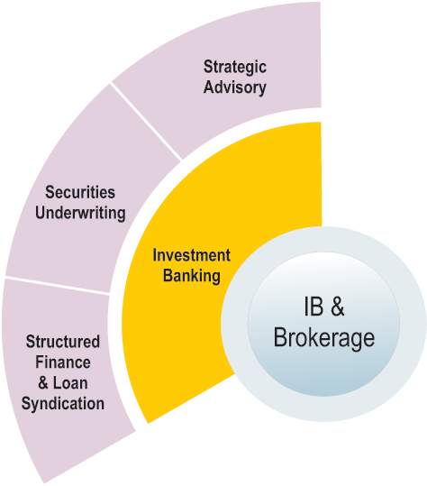
  - Strategic Advisory
    - Mergers and Acquisition (M&A)
Acquisition
When a company takes over another one and clearly becomes the new owner, the purchase is called an acquisition. From a legal point of view, the target company ceases to exist and do does it stock and the buyer "swallows" the business, and stock of the buyer continues to be traded. The buyer may either buy out the shares from the stock holders or issue stocks of the buying company at an appropriate ratio.
Merger
In the pure sense of the term, a merger happens when two firms, often about the same size, agree to go forward as a new single company rather than remain separately owned and operated. This kind of action is more precisely referred to as a "merger of equals." Both companies' stocks are surrendered, and new company stock is issued in its place. For example, both Daimler-Benz and Chrysler ceased to exist when the two firms merged, and a new company, DaimlerChrysler, was created.

In practice, however, actual mergers of equals don't happen very often. Often, one company will buy another and, as part of the deal's terms, simply allow the acquired firm to proclaim that the action is a merger of equals, even if it's technically an acquisition. Being bought out often carries negative connotations. By using the term "merger," dealmakers and top managers try to make the takeover more palatable. But when the deal is unfriendly--that is, when the target company does not want to be purchased--it is always regarded as an acquisition.
So, whether a purchase is considered a merger or an acquisition really depends on whether the purchase is friendly or hostile and how it is announced. In other words, the real difference lies in how the purchase is communicated to and received by the target company's board of directors, employees and shareholders
Investment banks provide advisory services to clients on a wide range of strategic transactions like mergers, acquisitions, purchase and disposition of assets, restructuring and reorganization, etc. Most large banks only become involved in deals worth at least $ 150 million.

M&A Advisory
M&A bankers provide advice to clients on all aspects of buying, selling, and merging with other companies. They assist with everything from suggestions about the timing of a sale or purchase, to the identity of potential buyers or sellers, and negotiating a favorable price. If a client company is subject to an unwanted takeover bid, M&A bankers will also offer advice on repelling unwanted advances.
Process:
- Deal origination: Bankers maintain close relationships with senior managers of prospective clients and keep track of any planned M&A activity. Originators often develop industry or geography specific expertise.
- Pitching: A banker must then convince company management that his or her bank is best placed to assist in the planned M&A activity. The crux of the pitch is usually a combination of expertise and price. Typical M&A advisory fee charged by investment banks is 1 to 2% of the transaction value.
- Pitchbook: Apart from negotiating on price, bankers attempt to impress company management with their suggestions on how to go about the specific transaction involved. This is described in a document known as a pitchbook. A pitchbook will typically contain detailed background information on the client and prospective takeover targets, various options for financing the deal, financial analysis of the deal in different scenarios and a description of the possible strategic benefit that could accrue to the client from the deal. The bulk of the work on pitchbooks is usually done by the junior M&A analysts while associates and senior bankers do a check and suggest changes to the pitchbook. The pitchbook is thus a compact compilation of the advice being provided by an investment bank and plays a central part in securing the deal.
- Deal closure: Each investment bank that is trying to get into the deal makes a presentation to the client and showcases its pitchbook. The client then decides whether the deal is worth doing and if yes, which investment bank to use. If an investment bank is rejected at this stage, all the work they have done so far including on the pitchbook has been in vain. If, however, an investment bank succeeds in bagging a deal, their work now shifts into the ‘execution’ mode. It is only now that the bank actually becomes mandated to work on the deal and is guaranteed a fee for their work.
- The process of execution of the deal depends on the nature of M&A activity that the client is planning. If the client is interested in buying a company, the investment bank is said to be involved in a ‘buyer representation’ activity. The precise target company needs to be first established and this process involves further careful investigation of the companies already covered in the pitchbook. Once the target is identified, the bankers approach the company and initiate negotiations with them regarding the price of the possible deal.
- The execution process can also involve adherence to a whole lot of regulatory guidelines especially if the target company has publicly floating securities.
- Investment bank can also be involved in ‘seller representation’ activity in cases where the client intends to sell. In this case, an information memorandum about the client firm is circulated among potential buyers so as to generate interest without actually mentioning the name of the client. The identified potential buyers are then invited to give price bids and the most appealing offer is accepted.
- In case of public companies, the procedure for sale is similar although sometimes there may be unwanted advances, known as hostile bids, from some buyers. The investment bank, in such cases, works with the client firm to repel such bids or negotiate the best price with them.

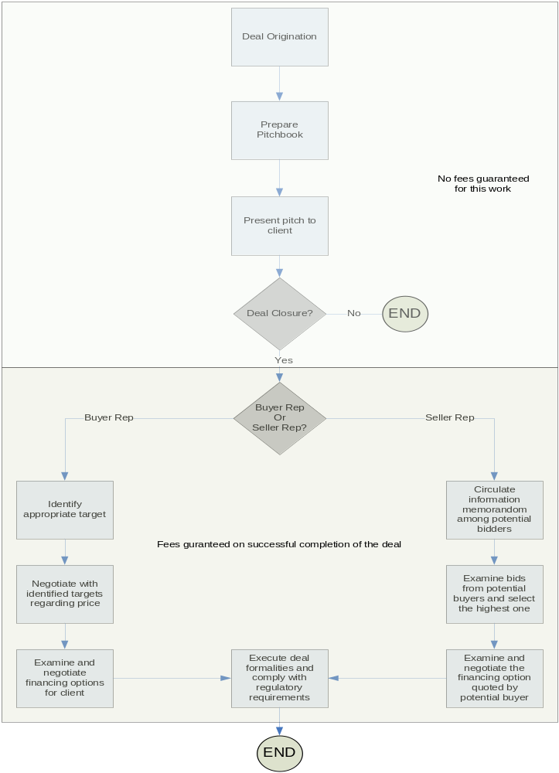Typically, deals between $50 million and $ 1 billion are charged investment banking fees equivalent to between 1% and 2% of the transaction value. Deals worth more than $ 1 billion are usually charged a base fee of $ 10 million plus additional costs based on the amount of work involved.
Leading players in M&A advisory and the value of deals done by them in 2005 are:
- Goldman Sachs ($ 603 bn)
- Morgan Stanley ($ 510 bn)
- JPMorgan ($ 478 bn)
- Citigroup ($ 421 bn)
- Merrill Lynch ($ 419 bn)
2005 has been one of the best years in terms of M&A activity since 2000. The year’s total for M&A activity has crossed the $2 trillion mark. 2005 has so far seen 25725 deals deals globally (7272 deals in the US) and the average deal size has been $115.2 million. Some of the big ticket deals this year have been:
- Acquisition of Gillette Co. by Proctor & Gamble (Deal size $ 57.2 billion)
- Acquisition of British mobile phone operator O2 by Spain’s Telephonica ($ 31.5 billion)
Some notable previous deals are the merger of Exxon and Mobil ($81 bn) and the acquisition of BankOne by JPMorgan ($58 bn).

    - Financial Restructuring
When a company cannot pay its cash obligations - for example, when it cannot meet its bond payments or its payments to other creditors (such as vendors) - it goes bankrupt. In this situation, a company can, of course, choose to simply shut down operations and walk away. On the other hand, it can also restructure and remain in business.
The restructuring process can be thought of as two-fold: financial restructuring and organizational restructuring. Restructuring from a financial viewpoint involves renegotiating payment terms on debt obligations, issuing new debt, and restructuring payables to vendors. Bankers provide guidance to the firm by recommending the sale of assets, the issuing of special securities such as convertible stock and bonds, or even selling the company entirely.
From an organizational viewpoint, a restructuring can involve a change in management, strategy and focus. I-bankers with expertise in "reorgs" can facilitate and ease the transition from bankruptcy to viability.

Fees in restructuring work
Typical fees in a restructuring depend on whatever retainer fee is paid upfront and what new securities are issued post-bankruptcy. When a bank represents a bankrupt company, the brunt of the work is focused on analyzing and recommending financing alternatives. Fees are usually a structured as fixed percentage of the size of the transaction. A common restructuring fee is 5 percent of the size of the equity/debt sold/bought. I-bankers not only work in securing financing, but may assist in building projections for the client (which serve to illustrate to potential financiers what the firm's prospects may be), in renegotiating credit terms with lenders, and in helping to re-establish the business as a going concern.
Because a firm in bankruptcy already has substantial cash flow problems, investment banks often charge minimal monthly retainers, hoping to cash in on the spread from issuing new securities. Like other public offerings, this can be a highly lucrative and steady business.
    - Securitized Products
Securitization is the process of converting whole assets into smaller tradable securities through appropriate structuring. The most commonly securitized assets are mortgage loans and credit card receivables.
Investment banks often have a separate group that includes finance, capital markets, trading and research activities of their commercial mortgage financing and credit card business. The securitized products group acts as an underwriter and provides innovative structuring and skilled distribution capabilities to institutional users of commercial mortgage backed securities. The activities of the group involve CMBS structuring and underwriting, mortgage origination, interim principal financing, mortgage portfolio acquisition and CMBS and whole loan sales and trading.
The bank uses securitization to convert loans and other financial assets in securities for clients or the bank itself.

  - Securities Underwriting
When an organization needs money, it has two options. It can either directly go to someone who has the money (like a bank), or go to a “broker” (an Investment Bank) which would help it raise the money from lenders/investors. The money may be raised in form of stocks (equity) or bonds (debt).
The Investment Bank, acting as the broker, prices the security and sells it to the target customers, usually guaranteeing the sale of a certain number of securities. This process is called underwriting.
To ensure a good price and popular issue, I-Banks may spend a lot of effort in marketing the security. That is the reason for the hype created for many companies around their IPO.

    - Equity Underwriting
Equity Underwriting is the concept of securing the price and sale of a new issue of stocks. If a firm has taken the risk and responsibility to sell a specific amount of stocks, and it can't sell them as planned, they may have to buy them themselves.
Typically, there are two types of underwriting offers, firm commitment and best efforts. With a firm commitment offering, the underwriter is obligated to purchase security if they cannot find anyone else to buy it. With a best efforts offer, they are not.
Some of the largest players in Equity Underwriting are:
  - Morgan Stanley
  - UBS
  - Citibank
  - Meyll Lynch
  - JPMC
  - Goldman Sachs
  - Lehman Brothers

Equity Underwriting Market
Demand for Equity Origination (IPOs) has been declining since Q4 2004. So, revenues and profit margins plunged in Q2 2005.
There had been growth in this space from Q1/2003 to Q1/2004, before the market steadied and then grew again in Q4/2004. While Asia had provided a large proportion of the initial growth, to even equal the European and American IPOs, Europe had a sustained growth right unto Q4/2004 and is currently the largest market.

Fees
I-Banks charge an upfront fee as a percentage of the total offer. This is referred to as the underwriting discount. The underwriting discount on an average is around 0.5% (2004 figure), though it is lower in emerging markets like China.

    - Debt Underwriting
Debt underwriting is the same as equity underwriting, except that the securities being issued are debt instruments (bonds), instead of equities.
Some of the largest players in Debt underwriting are
  - Lehman Brothers
  - Citibank
  - Deutche Bank
  - JPMC
  - Barclays
  - Merrill Lynch
  - Credit Suisse - First Boston

Debt Underwriting Market
The overall debt issuance had peaked in Q2/03, and after a sharp fall has recovered since. Corporate Bond issuance has, however, remained nearly flat after that fall. Continent wise, Asia still has very few bond issues, but the numbers have begun to rise lately. US bond issues have remained robust, while Europe is staging a recovery.

Fees
I-Banks charge an upfront fee as a percentage of the total offer. This is referred to as the underwriting discount. The underwriting discount on an average is around 0.5% (2004 figure), though it is lower in emerging markets like China.

    - IPO
A company can sometimes decide to raise money from the public through an offer of stocks or bonds. If a privately held firm decides to raise money from the public for the first time, the offering is referred to as an IPO (Initial Public Offering) while non-first time offerings are called follow-on offerings.

Some strategic reasons for which a company may decide to go public are:
- The company cannot reasonably expect to raise venture capital from institutional funds.
- The company needs to raise a very large amount of capital (greater than $15 million) and it is difficult or time consuming to raise this amount through private placement alone
- The company requires a significant amount of capital permanently that it won't have to pay back to a bank or other lender.
- A company seeks growth through acquisitions, and needs a "currency" other than cash to attract and consummate deals.
There could be other benefits too of raising funds through public offers:
- Public companies have direct access to the capital markets and can raise more capital by issuing additional stock in a secondary offering. Public companies also find it easier to raise funds from private sources.
- Public companies can use their common stock to attract and retain good employees.
- A public listing improves the visibility of a firm through and thereby can improve its business prospects
- Going public provides promoters an opportunity to cash out a part of their holdings through selling some of their stake
- Empirical evidence shows that public companies obtain higher valuations than comparable private companies.
Investment banks offer their services to companies to handle all aspects of the IPO process from filing of regulatory documents to marketing of the issue. An important additional service is that of underwriting of the issue which essentially means that in case the company’s issue does not get subscribed, the investment bank promises to buy the issue on its own. Underwriting thus is a guarantee that the client firm will indeed raise the capital. The IPO process consists of three phases:

- Hiring the Managers
A company wishing to go public must first hire the managers who would be involved with its stock offering. This process of choosing the lead investment bank is also referred to as a ‘beauty contest’. Typically, the process involves meetings with bankers from various investment banks and discussing the firms reason for going public. The investment banks then come up with a valuation for the company which is essentially the price at which they feel they would be able to sell the stock of the company. For an investment bank, the process of arriving at valuations is of prime importance because a higher valuation would involve more difficulty in selling the client’s stock but would entitle them to higher fees since it is typically a percentage of the total capital raised. The investment banks also suggest whether the company should go for a fixed price offer (where all bids are at a fixed pre-determined price) or a book building offer (In this case a price band is specified and investors need to bid at a specific price within the band). After the company has finished discussions and received valuation quotes from various investment banks, it finally chooses the lead bank that would handle its offering. Quite understandably, it is often the bank which quotes the highest valuations for the company’s shares. Usually along with the lead bank, the company also chooses one or two more banks who would work alongside the lead bank in the offering process

- Due Diligence and Drafting

In this phase, investment banks need to understand the company’s business, possible future scenarios and the risk factors and then draft and file the legal documents as required by the regulator (SEC in the US). The S-1 is a legal form that is required to be filed with the SEC by an company wishing to go public. This is a very detailed form regarding the company’s business and takes a fair amount of effort on part of the company management, bankers and the legal team to draft.

- Marketing
After the SEC approves the S-1 (also called prospectus), the bankers and the company management begin the marketing phase which essentially involves traveling across the country and making presentations and pitches to institutional fund managers as to why they should invest in the public offering of the company. These presentations and meetings are crucial as they can influence decision makers to invest millions of dollars in the company.

After the marketing phase ends, the bidding process of the IPO begins and if everything goes well, the stock or bond offering is successfully placed. For its efforts, the investment bank earns a fee, called the underwriting discount, which is usually a percentage of the capital raised, usually 5-8%.

Pricing of an IPO
The investment bank and the client must agree upon a price or a price band at which the shares or bonds would be sold to the investor public. This is done through various kinds of financial modelling and valuation methodologies. Some of the commonly used methodologies for arriving at fair value of equity are:
- Discounted Cash Flow (DCF) model: This model estimates the fair value of a firm by discounting the estimated free cash flow streams from a company by the weighted average cost of its capital. The fair value of equity is then determined by subtracting the value of the firm’s debt from the fair value of the firm. The free cash flow is defined as the cash flow available for both debt and equity holders and does not include inflow or outflow of new equity or debt capital or interest.

- Relative value valuation: Here the approach is to look at the valuations of already listed comparable firms and use that as a basis for arriving at the fair value of the firm’s equity. The most commonly compared valuation measure is the P/E or the price-earnings ratio. For example, if the price of an equity share of a listed firm is $100 and its EPS for the latest year is $10, its P/E ratio is 10. The argument is that since the P/E ratio is essentially a measure of the projected growth in future, a comparable business should have a similar P/E ratio. Hence the fair value of an unlisted firm can be estimated as EPS times the average P/E ratio of its listed comparables.
The P/E ratio is not, however, the only measure used. Often, it is more suitable to use other comparable ratios such as price-book value, price-sales, EV-EBITDA, etc.

- Dividend growth model: The model estimates the fair value of an equity share by discounting the projected future dividends by the return required by the holders of that stock. The required return is commonly estimated using the Capital Asset Pricing Model (CAPM).

Apart from these three commonly used methodologies, other approaches are also occasionally followed depending on their suitability. Adjusted net asset value and replacement value techniques are such approaches.
It should be noted that most of the valuation techniques require detailed forecasts of the company’s earnings and balance sheet and hence require a careful evaluation of the industry growth prospects, management capability and possible macroeconomic scenarios.
The checks and balances for the investment bank to do a fair valuation are taken care of since their compensation is usually a percentage of the proceeds raised. On the other hand, the temptation to arrive at too high valuations is curbed by the risk of inability to sell the shares to investors.

Fixed price offer vs. Book Building
The client firm and the investment bank must also decide whether to opt for a fixed price offer or a book building price discovery process. In a fixed price offer, the company offers are its shares to investors at a fixed prices determined by it. In contrast, book building and auction processes involve a price band and investors are asked to bid at a specific price.
A typical Book- Building process consists of following steps:
- The Issuer (client firm) who is planning an IPO nominates a lead merchant banker as a 'book runner'.
- The Issuer specifies the number of securities to be issued and the price band for orders.
- The Issuer also appoints syndicate members with whom orders can be placed by the investors.
- Investors place their order with a syndicate member who inputs the orders into the 'electronic book'. This process is called 'bidding' and is similar to open auction.
- A Book should remain open for a minimum of 5 days.
- Bids cannot be entered less than the floor price.
- Bids can be revised by the bidder before the issue closes.
- On the close of the book building period the 'book runner evaluates the bids on the basis of the evaluation criteria which may include -
  - Price Aggression
  - Investor quality
  - Earliness of bids, etc.
- The book runner and the company conclude the final price at which it is willing to issue the stock and allocation of securities.
- Generally, the number of shares is fixed; the issue size gets frozen based on the price per share discovered through the book building process.
- Allocation of securities is made to the successful bidders.
Book building is useful as it ends up pricing IPOs according to the market demand and sentiment and instances of IPO ‘mispricing’ are minimized.

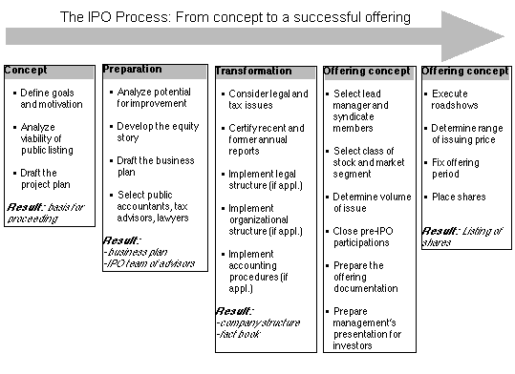

Follow-on offering
A further offering of shares or bonds by an already public company is called a follow-on offering. The process of a follow-on offering is simpler since the prospectus has earlier been drafted and only needs updating. Also the valuation exercise is simpler since the stock already trades in the market and has a quoted value.

Stock offering vs. Bond offerings
The basic process is similar for bond offerings except that the prospectus focuses more on stability of cash flows rather than growth in earnings. Also, the credit rating agency comes into picture and the rating achieved by the company influences the spread over the risk free rate that the company will need to pay its potential bond investors. The better (higher) the credit rating, which means the lower the perceived risk of default of the company, the lower the spread over the risk free rate that the company will need to pay in order to attract investors to buy its bonds.

Notable IPO deals
Some of the biggest IPOs took place in 1999-2001.
- ENEL Spa ($16.5 bn, Underwriter: Merrill Lynch)
- AT&T Wireless Group ($10.6 bn, Underwriter: Goldman Sachs)
- Kraft Foods ($8.6 bn, Underwriter: CSFB)

Some of the recent large IPOs have been:
- Huntsman ($1.3 bn, Underwriter: Citigroup)
- PanAmSat ($900 mn, Underwriter: Morgan Stanley)

Example
When Cognizant Technology Solutions came out with its Initial Public Offering on NASDAQ in June 1998, the Public Offering Price (POP) was set at $10 per share. The stock was split twice, 2-for-1 in March-2000 and 3-for-1 again in April 2003. As of Dec 6, 2003, the Current Market Price stood at $46.26. However, if the stock-splits are taken into consideration the actual market price would stand at 6 times the Current Market Price at whopping $253.56!!

Some IPO glossary
ADRs: ADRs are securities offered by non-U.S. companies who want to list on an American exchange. Each ADR represents a certain number of a company's regular shares.

Best Efforts: Arrangement whereby investment bankers acting as agents agree to do their best to sell an issue to the public. Instead of buying the securities outright these agents have an option to buy and an authority to sell the securities.

Co-manager: Most initial public offerings and secondary offerings have more than one underwriter. The manager controlling the offering is called the lead manager. Other underwriters are co-managers. The names of these underwriters appear on the bottom of the front page of the prospectus, with the most important manager appearing on the top left, and the co-managers arrayed from left to right in order of importance.

Cooling-off period: The time period, usually about 20 days, between the filing of the registration statement with Securities and Exchange Commission (SEC) and the offer of those securities to the public. During the cooling off period, the syndicate and selling group members distribute notifications announcing the new issue, send preliminary prospectuses to qualified investors for review, and take indications of interest from interested customers

Green shoe: Part of the underwriting agreement which allows, in the event the offering is oversubscribed, the issuer to authorize additional shares (typically 15 percent) to be distributed by the syndicate Also called the overallotment option.

Lead Underwriter: The underwriter who, among other things, is in charge of organizing the syndicate, distributing member participation shares and making stabilizing transactions. The lead underwriter's name appears on the left side of a prospectus cover.

Lock-up period: The time period after an IPO when insiders at the newly public company are restricted by the lead underwriter from selling their shares in the secondary market.

Red herring Prospectus: This is another name for the preliminary prospectus. This is the offering document printed by the issuer containing a description of the business, discussion of strategy, presentation of historical financial statements, explanation of recent financial results, management and their backgrounds and ownership.

Syndicate Manager: Also referred to as the lead underwriter or managing underwriter who, among other things, is in charge of organizing the syndicate and distributing member participation shares to other members of the syndicate.

Underwriter: This is a brokerage firm that raises money for companies using public equity and debt markets. Underwriters are financial intermediaries that buy stock or bonds from an issuer and then sell these securities to the public. The underwriter provides an assurance to buy the issuer’s shares in case it is unable to sell them to the public.The process through which this is accomplished is highly regulated by the SEC and the National Association of Securities Dealers.

Venture Capital: A source of money for start up companies. This is typically raised by venture capital firms who invest in private companies that need capital to develop and market their products. In return for this investment, the venture capitalists generally receive significant ownership of the company and seats on the board.

    - Private Placements
A private placement involves selling debt or equity to private investors rather than to the public. The securities of a firm that places its debt or equity privately do not trade publicly on a stock exchange. The distinction between seller representation by an ‘M&A’ team and a private placement is that of controlling stake. In an M&A, the buying firm typically buys more than 50% of the acquired firm and thus obtains a controlling stake in the acquirer. A private placement also sells securities but it is less than 50% and hence control of the firm does not change hands post a private placement.

The Investment Bank’s role
The distinction between private placement and M&A was explained above yet the process that the investment bank is involved in is quite similar to sell side M&A representation. The bankers draft the private placement memorandum and then attempt to sell the client firm’s securities to potential buyers.
Typical buyers are venture capitalists rather than buyout firms. Since private placements are typically with a single investor, the terms (price) of the deal is negotiated directly with the investor with the investment bank as a mediator. Fees in private placements too are usually a percentage of the total deal with 5% being a ballpark level.

  - Structured Finance and Loan syndication

    - Syndicate lending

Difference between Syndicate Lending and Corporate Lending
Commercial Lending refers to various forms of loans extended by banks to corporate bodies like proprietorship, partnership, private limited companies or public limited companies. Banks lend to such entities on the strength of their balance sheet and business cash flows. Banks provide corporate loans for various purposes like new projects, capacity expansion or plant modernization, daily cash flow requirements (working capital) etc. Depending on the nature of the requirement, loans may be long-term or short-term in nature.
Loans can be either secured or unsecured in nature. In case of secured loans, if the corporate defaults on payment of principal or interest on the loan, the bank can take possession of the security and sell off the same to meet principal or interest payment on the loan. Security is usually in the form of land, buildings, plant and machinery, physical stock of the raw material, goods for sale etc.
Borrowers often request to borrow an amount greater than any one lender is willing to lend. In such a scenario, it is common for a group of lenders to share in lending to a borrower.

Lead Syndicator:
- The bank that manages loan syndication. The lead syndicator is the bank that commits to structure, arrange and distribute a loan
- Activities of a lead syndicator may include modeling, organizing bank meetings, performing the sell-down, and ensuring all activities are completed prior to syndication funding/closing date.
- Lead syndicator may also be known as "bookrunner" or "lead advisor

Participation
- A contract under which the loan purchaser receives the right to principal and/or interest payments on a loan or portion thereof
- The borrower may not be aware that more than one bank has participated in the total loan (i.e., the loan participation may be either on a silent or disclosed basis).
- The participant must rely on the seller to enforce the loan agreement
- Participations may be sold on terms that differ from the original loan terms.

Syndicate lending process:
In a syndicated loan, two or more banks agree jointly to make a loan to a borrower. Every syndicate member has a separate claim on the debtor, although there is a single loan agreement contract. The creditors can be divided into two groups. The first group consists of senior syndicate members and is led by one or several lenders, typically acting as mandated arrangers, arrangers, lead managers or agents. These senior banks are appointed by the borrower to bring together the syndicate of banks prepared to lend money at the terms specified by the loan. The syndicate is formed around the arrangers – often the borrower’s relationship banks – who retain a portion of the loan and look for junior participants. The junior banks, typically bearing manager or participant titles, form the second group of creditors. Their number and identity may vary according to the size, complexity and pricing of the loan as well as the willingness of the borrower to increase the range of its banking relationships. Thus, syndicated credits lie somewhere between relationship loans and disintermediated debt.

Figure I below shows, in decreasing order of seniority, the banks that participated in a simple syndicate structure to grant a loan to Starwood Hotels & Resorts Worldwide, Inc in 2001.
Senior banks may have several reasons for arranging a syndication. It can be a means of avoiding excessive single-name exposure, in compliance with regulatory limits on risk concentration, while maintaining a relationship with the borrower. Or it can be a means to earn fees, which helps diversify their income. In essence, arranging a syndicated loan allows them to meet borrowers’ demand for loan commitments without having to bear the market and credit risk alone. An international syndicated loan is defined in the statistics compiled by the BIS as a facility for which there is at least one lender present in the syndicate whose nationality is different from that of the borrower.
Syndicated loans are widely used to fund projects in these sectors, in industrial and emerging market countries alike. A feature article on page 91 of this BIS Quarterly Review explores the nature of credit risk in project finance. Interestingly, for most of the 1990s, emerging market borrowers were granted longer-maturity loans, five years on average, than industrialised country ones (three–four years). These bank roles, enumerated here in decreasing order of seniority, involve an active role in determining the syndicate composition, negotiating the pricing and administering the facility.
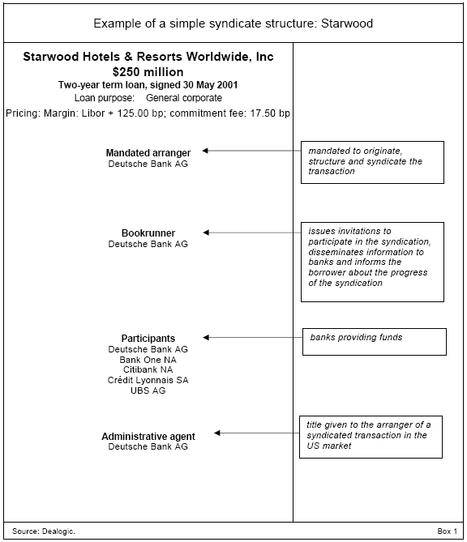
Figure I

For junior banks, participating in a syndicated loan may be advantageous for several reasons. These banks may be motivated by a lack of origination capability in certain types of transactions, geographical areas or industrial sectors, or indeed a desire to cut down on origination costs. While junior participating banks typically earn just a margin and no fees, they may also hope that in return for their involvement, the client will reward them later with more profitable business, such as treasury management, corporate finance or advisory work

Pricing Structure for a Syndicated Loan: Spreads and Fees
As well as earning a spread over a floating rate benchmark (typically Libor) on the portion of the loan that is drawn, banks in the syndicate receive various fees (Allen (1990), Table 1). The arranger and other members of the lead management team generally earn some form of upfront fee in exchange for putting the deal together. This is often called a praecipium or arrangement fee. The underwriters similarly earn an underwriting fee for guaranteeing the availability of funds.

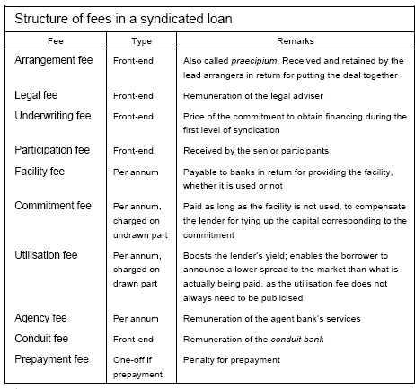
Other participants (those at least on the “manager” and “co-manager” level) may expect to receive a participation fee for agreeing to join the facility, with the actual size of the fee generally varying with the size of the commitment. The most junior syndicate members typically only earn the spread over the reference yield. Once the credit is established and as long as it is not drawn, the syndicate members often receive an annual commitment or facility fee proportional to their commitment (largely to compensate for the cost of regulatory capital that needs to be set aside against the commitment). As soon as the facility is drawn, the borrower may have to pay a per annum utilisation fee on the drawn portion. The agent bank typically earns an agency fee, usually payable annually, to cover the costs of administering the loan. Loans sometimes incorporate a penalty clause, whereby the borrower agrees to pay a prepayment fee or otherwise compensate the lenders in the event that it reimburses any drawn amounts prior to the specified term. Box 1 above provides an example of a simple fee structure under which Starwood Hotels & Resorts Worldwide, Inc has had to pay a commitment fee in addition to the margin. At an aggregate level, the relative size of spreads and fees differs systematically in conjunction with a number of factors. Fees are more significant for Euribor-based than for Libor-based loans. Moreover, for industrialised market borrowers, the share of fees in the total loan cost is higher than for emerging market ones. Arguably this could be related to the sectoral composition of borrowers in these segments. Non-sovereign entities, more prevalent in industrialised countries, may have a keener interest, for tax or market disclosure reasons, in incurring a larger part of the total loan cost in the form of fees rather than spreads. However, the total cost (spreads, front- end and annual fees)9 of loans granted to emerging market borrowers is higher than that of facilities extended to industrialised countries (Graphs 3 and 4).
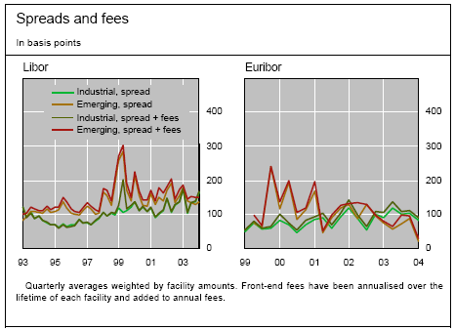
Graph 3
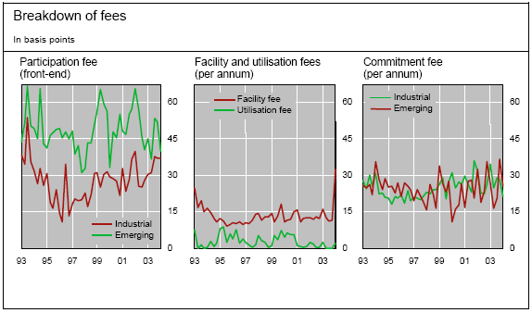
Graph 4

There is also more variance in commitment fees on emerging market facilities. In sum, lenders seem to demand additional compensation for the higher and more variable credit risk in emerging markets, in the form of both spreads and fees.
Spreads and fees are not the only compensation that lenders can demand in return for assuming risk. Guarantees, collateral and loan covenants offer the possibility of explicitly linking pricing to corporate events (rating changes, debt servicing). Collateralisation and guarantees are more often used for emerging market borrowers (below in Table 2), while covenants are much more widely used for borrowers in industrialised countries (possibly because such terms are easier to enforce there).

Loan Syndication market size, Key players
US banks, whose outstanding syndicated loan commitments are regularly monitored by the Federal Reserve Board, have transferred some of their syndicated credits, including up to one quarter of their problem loans, to non-bank investors (Table 3). Buyers of loans on the secondary market can acquire exposure to sectors or countries, especially when they do not have the critical size to do so on the primary market. While growing, secondary trading volumes remain relatively modest compared to the total volume of syndicated credits arranged on the primary market. The biggest secondary market for loan trading is the United States, where the volume of such trading amounted to $145 billion in 2003. This is equivalent to 19% of new originations on the primary market that year and to 9% of outstanding syndicated loan commitments. In Europe, trading amounted to $46 billion in 2003 (or 11% of primary market volume), soaring by more than 50% compared to the previous year (Graph 5). Distressed loans continued to represent a sizeable fraction of total secondary trading in the United States, and gained in importance in Europe.

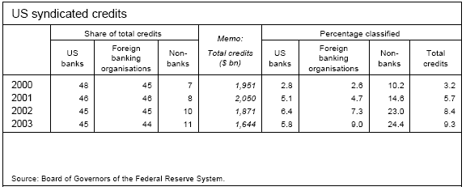
Table 3
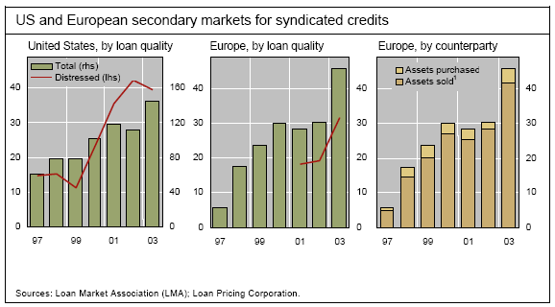
Graph 5

    - Structured products
Structured products refer to combinations of individual financial instruments, such as bonds, stocks and derivatives. At first glance, most of these composite products are very similar to plain vanilla coupon bonds. Structured products tend to involve periodical interest payments and redemption at maturity. What sets them apart from bonds is that both interest payments and redemption amounts depend in a rather complicated fashion on the movement of stock prices, indices, exchange rates or future interest rates.
Since structured products are made up of simpler components, they are usually broken down into their integral parts for valuation or assessment of their risk profile and any hedging strategies. This facilitates analysis and pricing of the individual components.
The portfolio of these simpler products must have the same payoff profile as the structured product and, given the (assumed) absence of arbitrage opportunities in financial markets, must thus also have the same market value. The merits of this approach are that, first, simple valuation rules can be used to calculate fair market prices for the simpler products. Second, risk control is more efficient since the replicated parts either are directly tradable or may be hedged more easily.
It is not possible to break all products down into simple components. In cases where the structured product has to be depicted as a combination of instruments which are themselves complex in nature and thus difficult to valuate and to hedge on the capital market, numerical procedures have to be employed in order to valuate the products and assess the risks involved.

    - Leveraged Finance

Leveraged Finance Defined
Leveraged finance is funding a company or business unit with more debt than would be considered normal for that company or industry. More-than-normal debt implies that the funding is riskier, and therefore more costly, than normal borrowing. As a result, levered finance is commonly employed to achieve a specific, often temporary, objective: to make an acquisition, to effect a buy-out, to repurchase shares or fund a one-time dividend, or to invest in a self-sustaining cash-generating asset.
Although different banks mean different things when they talk leveraged finance, it generally includes two main products - leveraged loans and high-yield bonds. Leveraged loans, which are often defined as credits priced 125 basis points or more over the London interbank offered rate, are essentially loans with a high rate of interest to reflect a higher risk posed by the borrower. High-yield or junk bonds are those that are rated below "investment grade," i.e. less than triple-B.
A key instrument is much leveraged finance, particularly in leveraged buy-outs, is mezzanine or "in between" debt. Mezzanine debt has long been used by mid-cap companies in Europe and the US as a funding alternative to high yield bonds or bank debt. The product ranks between senior bank debt and equity in a company's capital structure, and mezzanine investors take higher risks than bond buyers but are rewarded with equity-like returns averaging between 15 and 20 per cent.
Companies that are too small to tap the bond market have been the traditional users of mezzanine debt, but it is increasingly being used as part of the financing package for larger leveraged acquisition deals. Although mezzanine has been more expensive for companies to use than junk bonds, the low coupons coupled with high returns often makes some sort of mezzanine or hybrid debt an essential buffer between senior lenders and the equity investors.

Leveraged Acquisition Finance
Leveraged Acquisition Finance is the provision of bank loans and the issue of high yield bonds to fund acquisitions of companies or parts of companies by an existing internal management team (a management buy-out), an external management team (a management buy-in) or a third party (an acquisition).
The leverage of a transaction refers to the ratio of debt capital (bank loans and bonds) to equity capital (money invested in the shares of the target company). In a leveraged financing, this ratio is unusually high. As a result, the level of debt service (payment of interest and repayment of principal) absorbs a very large part of the cashflow produced by the business. Consequently, the risk of the company not being able to service the debt is higher and thus the position of the lenders is riskier than in a conventional acquisition. The interest rate on the debt will be high.

Leveraged Recapitalizations
A technique whereby a public company takes on significant additional debt with the purpose of either paying an extraordinary dividend or repurchasing shares, leaving the public shareholders with a continuing interest in a more financially-leveraged company. This is often used as a "shark repellent" to ward off a hostile takeover.

Leveraged Corporate Credit
Leveraged corporate credit involves the provision and management of credit products, including bank loans, bridge loans and high-yield debt, for below investment grade companies that rely heavily on debt financing.

Leveraged Asset-Based Finance
Leveraged asset-based finance entails raising debt capital for companies where the physical assets or a defined, contractual cash flow form the basis for highly levered non- or limited-recourse funding of assets or projects. Leasing, project financing and whole business securitization are examples of these techniques.
Leveraged finance, like other parts of structured finance, primarily involves identifying, analysing and solving risks. These risks can be arranged into the following groups:
- Credit risks and financial risks
Credit risks are concerned with the business and its market. Financial risks which lie within the economy as a whole, for instance, interest rates, foreign exchange rates and tax rates.
- Structural risks
These are risks created by the actual provision of finance including legal, documentation and settlement risks. There are often different layers of finance involved in leveraged financing. These range from a senior secured bank loan or bond to a subordinated loan or bond. A large part of the role of leveraged financiers is to calculate how each type of finance should be raised. If they overestimate the ability of the company to service its debt, they may lend too much at a low margin and be left holding loans or bonds they cannot sell to the market. If the value of the company is underestimated, the deal may be lost

- Global Capital Markets

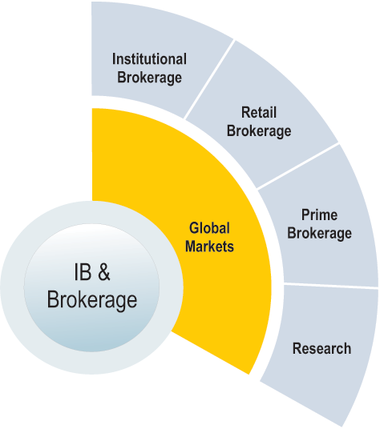
Case Study
- The World Bank borrows funds internationally and loans those funds to developing countries. It charges its borrowers a cost plus rate and hence needs to borrow at the lowest cost.
- In 1981 the US interest rate was at 17 percent, an extremely high rate due to the anti-inflation tight monetary policy of the Fed. In West Germany the corresponding rate was 12 percent and Switzerland 8 percent.
- IBM enjoyed a very good reputation in Switzerland, perceived as one of the best managed US companies. In contrast, the World Bank suffered from bad image since it had used several times the Swiss market to finance risky third world countries. Hence, World Bank had to pay an extra 20 basis points (0.2%) compared to IBM
- In addition, the problem for the World Bank was that the Swiss government imposed a limit on the amount World Bank could borrow in Switzerland. The World Bank had borrowed its allowed limit in Switzerland and West Germany
- At the same time, the World Bank, with an AAA rating, was a well established name in the US and could get a lower financing rate (compared to IBM) in the US Dollar bond market because of the backing of the US, German, Japanese and other governments. It would have to pay the Treasury rate + 40 basis points.
- IBM had large amounts of Swiss franc and German deutsche mark debt and thus had debt payments to pay in Swiss francs and deutsche marks.
- World Bank borrowed dollars in the U.S. market and swapped the dollar repayment obligation with IBM in exchange for taking over IBM's SFR and DEM loans.
- It became very advantageous for IBM and the World Bank to borrow in the market in which their comparative advantage was the greatest and swap their respective fixed-rate funding.

  - Trading and Brokerage Function

    - Introduction
The brokerage function is to bring a buyer and seller together. The other functions of trading and brokerage in the Secondary Market include:
- Dealer function – buying (bid) and selling (ask) from an inventory of securities owned by the seller.
- Providing loans to customers, who invest the margin proportion and borrow the rest.
Dealer security inventories and customer credit are financed by bank call loans and repurchase agreements, the sale and later repurchase of securities held by the dealer.

    - Full-Service Brokerage
A traditional broker can serve a wide variety of business units. They are not focused on any one particular unit as much as the discount brokers or online brokers. Typical classification of business units is as below:
- Retail trading
- Institutional trading
- Program trading
- Arbitrage trading
- Derivatives, fixed income, futures, options
- Commodities trading
- Currency trading

In other words traditional brokers offered their clients a wide variety of products and services at a fee.
The full-service brokerages use their in-house research staffs to generate proprietary investment information and recommendations. To ensure that they gained the most from the high-cost information activities, the full-service brokerages limited distribution of proprietary investment information by distributing it only through its brokers who work out of their physical offices. Since the informational activities and brokerage distribution channels were very costly, the full-service brokerage firms charged high commissions for stock trades to cover their costs and to earn a profit.
Major value added offerings from a full service broker include:
- Advisory networks
- Full time portfolio management with advice from independent investment advisors
- Access to stock screening tools based on the clients investment needs
- Access to streaming Level II quotes
- Dedicated support and services for any investment related queries or transaction related queries.
- Support to various instruments including derivatives, options and funds
The above service comes at a cost though. Depending on the clients account category the access to various services including research is enabled or disabled. Given below are sample account categories:
- Account categories
  - Premium: Where clients get access to premium research by the company as well as third party research. Priority phone routing to experienced investment professionals. Portfolio monitoring tools and quarterly portfolio profit/loss statements with suggested rebalance. This comes at a cost though. Some brokerage firms need a minimum of $100,000 in assets to invest.
  - Gold: Access to stock screening tools based on your investment options. Research recommendations like stock advice for the portfolio. This for those who are willing to invest $10,000-$50,000
  - Silver: Very basic facilities like, stock screening and a limited access to instruments available to trade. The minimum assets required to invest are $5000.
Although, the online brokerage trend was caught on by the discount brokers and focused online brokers, traditional full-service firms were a little late to latch on. They were focusing on incumbent technologies such as network upgrades, OS upgrades, data warehouse development and broker workstation enhancements. After seeing the decrease in market share, the traditional brokerage houses announced plans to compete online in the form of discount brokerage.
A typical information flow schematic is show below.
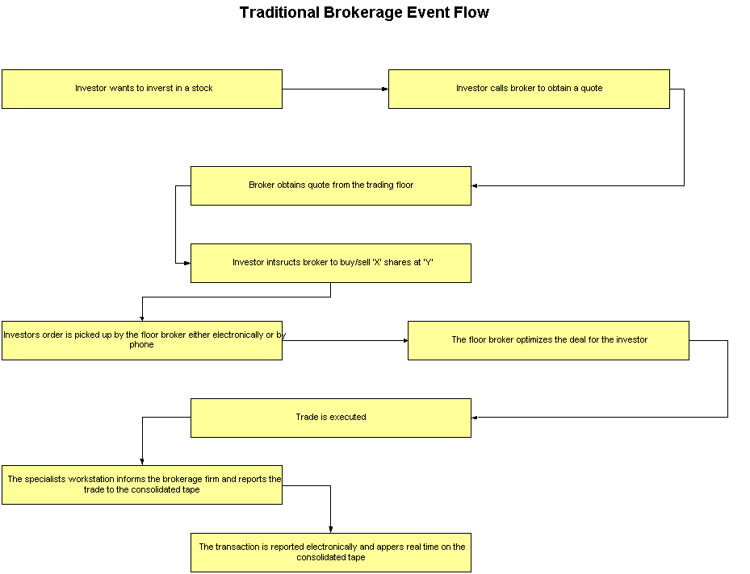

    - Online Brokerage
Although, online brokerage was caught on to by the entire industry in the 90s, there were specialty brokers who operated only in an online mode. For example E*TRADE which only has an online presence, unlike Schwab which has about 300+ branches all over the US. This online only presence curtails the cost of firms like E*TRADE and Ameritrade and hence they can offer lowered commission rates. On top of this cost saving strategy they do not offer investment products or advice. Customers need to do their own research and stock screening and use E*TRADE or Ameritrade for trading only purposes. Even the support provided by these firms was of the minimal nature. Once a trade has been locked-in it was very difficult for the clients to call in to cancel or modify the trade price, if a discrepancy occurred. In other words the online-only firms provided a trading platform and nothing more. Major offerings from online brokers:
- Access to delayed quotes
- A platform for order entry and portfolio tracking
A typical event flow for online/discount brokerage has been shown below.
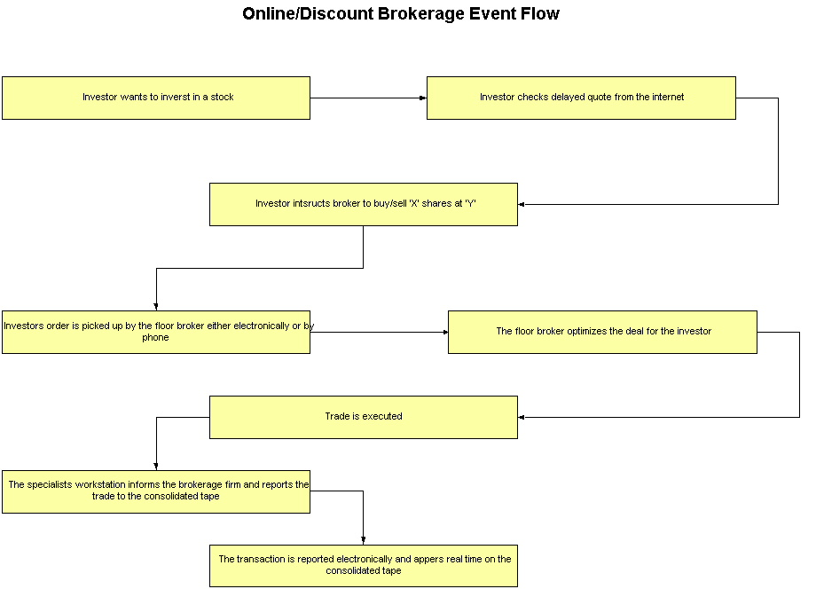
The trend of service offering changed after the bear markets of 2000-2001. Due to the sudden reduction in trading volume survival of the online brokers was at crossroads. Those who chose to provide the same functionality eventually perished or were bought over by their larger counterparts or larger full-service firms, thus inheriting their customer base. The stronger once who were bold enough to change their business strategy survived through this period of bear market by enhancing their service base. The E*TRADE’s and Ameritrade’s started offering a range of products from mutual funds to retirement accounts for a slight increase in commissions. From online trading to wireless trading; from delayed quotes to streaming quotes; was a tremendous change in strategy.

    - Discount Brokerage
The discount brokerages focused upon providing general investment information and stock trades to its customers. Since the discount brokerages did not provide investment recommendations, they did not have to employ high-cost personal brokers to serve the retail investors. Instead they leveraged technology to serve as many retail investors as possible. As more and more retail investors became increasingly comfortable directing their own stock investments, they have turned to the discount brokerages.

The 70s brought a revolution in the form of discount brokerage. The commissions, although steep, were re-structured and ranged from USD100+. The next revolution online trading was quickly absorbed by the discount brokers in an effort to further reduce costs. This started a price war of reduced commissions Ameritrade introduced its online trading by lowering its commissions to USD8. This triggered a price war, where commissions offered ranged from USD5 a trade. From a flat fee commission it went to the size of the order to the liquidity of the stock etcetera. As opposed to the full-service firms which had a variety of investment products and access to their research, the discount brokers like Schwab offered very little value addition to their clients in terms of product offerings or research. This helped them sustain the low commission rates.

The 90s really changed the nature of discount brokerage, where the discounters had to enhance their product base as well as value added features in order to survive. From delayed quotes to streaming quotes, from research papers to recommendations from online trading to wireless trading (PDAs), was the norm for the retail investor. Until the bubble burst in early 2001 (March ’01) every day was a new day for the investor.

Few of the offerings by the discount brokers:
- Online trading
- Stock screening
- Stock advice
- Support services
- Few product offerings

    - Institutional Brokerage Business
An Institutional broker or firm is defined as the one who caters to larger clients who need to buy/sell in bulk, typically known as an institution. Institutions consist of mutual fund companies, banks, portfolio managers trading on behalf of clients who have invested in a fund.

How Does A Brokerage Firm Look Like?

A brokerage firm has the following departments:
- Sales
- New Accounts
- Order Room
- Purchase and Sales
- Cashiering
- Margin
- Corporate Actions
- Accounting
- Compliance

Sales
Sales team is responsible for canvassing business. They are staffed with Account Executives/Account Managers who solicit business from retail and wholesale customers.

New Accounts
New Account department is responsible for receiving customer account opening applications and documenting the customer data. They are the custodians for various documents like New account form, Signature cards, Margin Agreements, Lending Agreements and Option Trading Agreements. Only when the required documents are received, the account can legally operate.

New accounts can be of one of the following types:
- Individual Cash Account – Only cash transactions are permitted. No margin trading is permitted.
- Margin Account
- Joint Account
- Power of Attorney Accounts

Order Room
Orders are taken by dealers in order room and they are executed in the best possible manner. Every order has detailed instructions like:
- Buy/Sell
- Quantity
- Limit/Market
- Security details etc.
The relationships among the various departments can be pictorially represented as below:

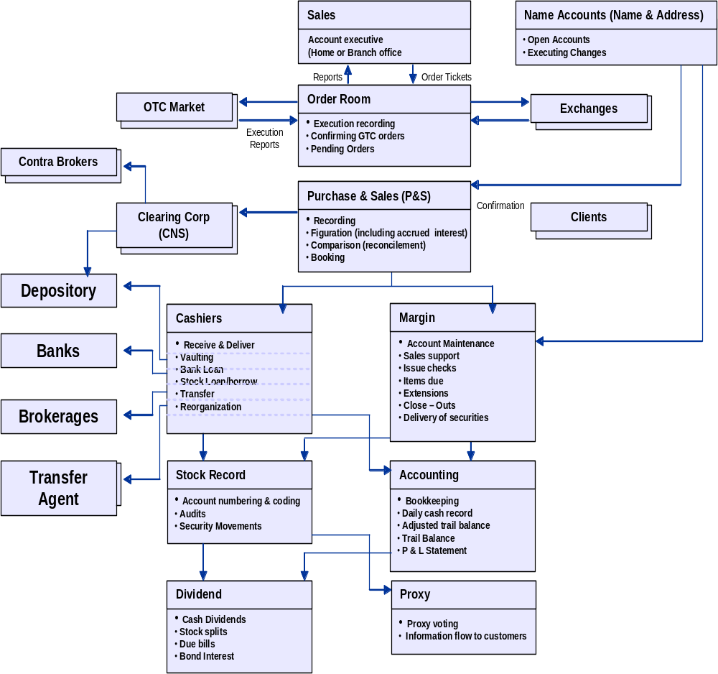

Purchase and Sales
This department is responsible for the following activities:
- Recording the trade with a unique number using codes and tickets.
- Figuration to calculate the monetary value of the transaction
- Reconciliation of customer trades with counter-party transactions
- Customer Confirmation in a legally binding form.

Margin
Margin or Credit Department monitors the status of the customer accounts. As explained in the previous pages, they are also responsible for margin calls. The typical activities of this department are:
- Account Maintenance
- Sales Support
- Clearing Checks
- Items pending (Money due, stocks due)
- Closing out

Cashiering
They are responsible for movement of securities and funds within the brokerage firm. They take care of the following functions:
- Receiving and delivering
- Vaulting
- Hypothecations
- Security Transfers
- Stock Lending

Corporate Action
Corporate Action refers to dividend declarations, stock splits etc. The Corporate Action department makes sure that the rightful owners (as on the Record Date) receive the dividends, Splits etc.

Accounting
The Accounting department records, processes and balances the movement of money in the brokerage firm. They produce the Daily Cash Records and Trial Balance, Balance Sheet and Profit & Loss statements on a periodic basis.

Compliance
The Brokerage firms are regulated by SEC, by state regulatory agencies and industry wide Self Regulatory Organizations. The compliance department is responsible for ensuring that all the rules and regulations are complied with and reported on time.

They also make sure that the newer regulations like Anti Money Laundering Act are implemented inside the firm.

    - Proprietary Trading
A principal transaction represents a purchase or sale on a proprietary basis, i.e. on a company’s own behalf, rather than on behalf of the client. When a company purchases or sells securities on behalf of a client the resulting transactions are considered to be agency transactions.

    - Retail Brokerage
Some facts about the retail brokerage industry:
- Overall retail trading peaked in 2000, the height of the dot-com bubble. Retail trading is 21 percent below the 2000 peak, according to Celent, a research and advisory firm focused on financial services.
- Online retail traders account for around 10 percent of the trading volume on the NYSE and NASDAQ -- against its peak in early 2000 when online retail traders accounted for nearly one-third of volume.
- The number of daily average revenue trades (DARTs) has declined substantially since the 2000 peak and the average price paid per trade has also declined, according to Celent.
- Retail investors have been steadily reducing their holdings in individual equities, and turning instead to mutual funds, savings accounts and mortgages. Fixed income securities, foreign deposits, Exchange Traded Funds and options are also growing more popular, according to Celent.
- The trends saw brokers slash prices. Among those who cut were Fidelity, Schwab and E*Trade.
- There are two factors driving consolidation -- the potential for cost-saving by sharing technology and advertising, and the possibility of increasing traffic over brokers' networks without substantially increasing cost.
- The way the industry has evolved has helped the individual investor, who benefits from lower fees, lower commissions and higher execution speed.

Risks Factors in the industry
- Stock Market Volatility and Other Securities Industry Risks
- The market price of Common Stock Could Fluctuate Significantly
- Substantial Competition could reduce market share and harm financial performance
- Systems failures and delays could harm the business
- A loss of clients or a reduction in the growth of client base
- Increased operating expenses
- Financial losses
- Additional litigation or other client claims
- Regulatory sanctions or additional regulatory burdens
- Capacity constraints of the systems could harm the business
- Regulatory & Legal uncertainties could harm the business
- The success of business will depend on Continued Development & Maintenance of the Internet Infrastructure
- The players in the industry would need to introduce new products and services to remain competitive
- Networks may be vulnerable to security risks
- Failure to comply with net capital requirements could adversely affect the business
- The industry is exposed to credit risks
- Acquisitions involve risks that could adversely affect the business

Major Business Entities
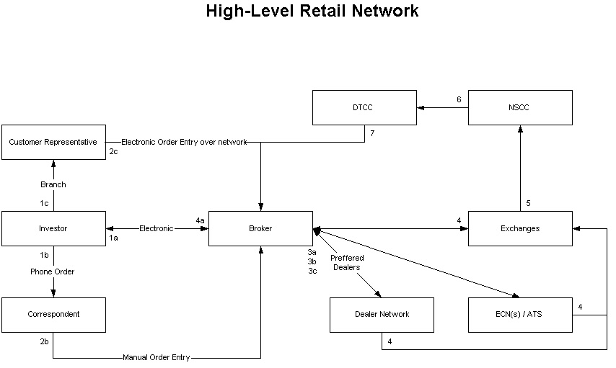
Figure 12: Retail Network

Who is a Retail Investor?
An individual who purchases small amounts of securities for him/her, as opposed to an institutional investor. Also called individual investor or small investor.

Before the introduction of discount brokers, trading was meant only for the affluent investor who had the time and money to research and pay high commission fees per transaction. The commissions used to be anywhere from USD500+ depending on the agreements with the brokers.

Classification of retail traders:
- Day traders: During the bull markets years there was a huge surplus of day traders on the market. A typical day trader opens an account with one of the online/discount brokers and uses their platform to trade proprietarily. A day trader can be categorized as any other trader hired by a market making firm except that he is self-employed, in most cases, and trades only on his behalf. As opposed to a market maker who trades on behalf of customers as well as proprietarily. The bear market saw the day traders disappear almost completely.
- Individual Investor: Who, trades at an average 10+ times in a quarter. Such investors are employed, but trade from an investment perspective rather than self-employment perspective.

Who is a Broker/Dealer?
A retail broker or firm is defined as the one who caters to the average investor or in other words the non-institutional investors also known as retail investor. A typical setting in the simplest is shown below:

Order information to Broker
Broker routes to Exchange
Exchanges transmits Execution Report
Broker informs the investor
Of exchange actions
Typically a retail broker has categorized trading desks based on business units. Business units consist of Retail, Institutional, Program Trading, Derivatives and so on.
The basic difference between retail and institution are highlighted below:
- Trading strategies are entirely different
- Average institutional order size if 50,000 and upwards, while the average retail order size if 400
- A typical retail order has a HELD instruction which flows through a different processing logic. An institutional order is typically entered with a NOT HELD instruction
- Due to certain attributes of the order different rules apply to these orders. As an example limit order display rules do not apply to institutional orders

Retail Brokerage Products
- Common and preferred stock: Clients can purchase common and preferred stocks and American Depository Receipts traded on any United States exchange or quotation system
- Option trades: full range of option trades, including spreads, straddles and strangles. All options trades, including complex trades.
- Mutual funds: clients can compare and select from a portfolio of over 11,000 mutual funds. Clients can also easily exchange funds within the same mutual fund family.
- Treasury, corporate, government and municipal bonds: Clients access to variety of treasury, corporate, government and municipal bonds as well as collateralized mortgage obligations

Retail Brokerage Services
The players in the industry endeavor to optimize highly rated client service by:
- Expanding their use of technology to provide automated responses to the most typical inquiries generated in the course of clients’ securities trading and related activities;
- Ensuring prompt response to client service calls through adequate staffing with properly trained and motivated personnel in client service departments;
- Tailoring client service to the particular expectations of the clients of each of client segments.
The players in this industry also provide client service support through a variety of access points, including web sites, emails and client service representatives

  - Prime Brokerage Business

Hedge Funds
A hedge fund is a fund, usually used by wealthy individuals and institutions, which takes positions in both safe and speculative opportunities. A hedge fund uses aggressive strategies, including selling short, leverage, program trading, swaps, arbitrage, investing in asset classes such as currencies or distressed securities, and derivatives to achieve stringent investing goals. Hedge funds seek positive absolute returns, regardless of the performance of an index or sector benchmark.
Unlike Hedge Funds, Mutual Funds raise money publicly; are highly regulated by the agencies; and offer investment diversification and are restricted from purchasing many types of derivative instruments, leveraging, short selling and other kinds of transactions. Unlike the Mutual Fund Managers, the Hedge Fund Manager generally invests in the fund that they manage and participate in profits as well as risks with their investors. Unlike the Mutual Fund fee structure (which is determined on assets under management), the Hedge Fund Manager receives incentive allocations on performance.

Hedge Fund Industry – Assets Under Management

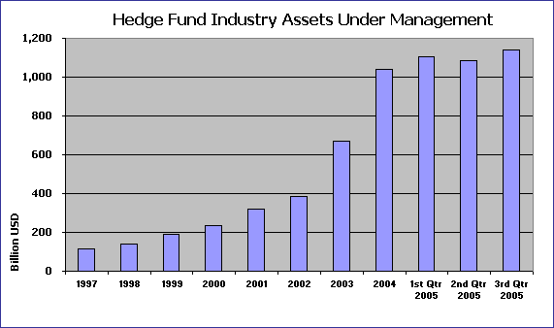

As the chart shows, the hedge fund industry has seen an exponential rise in assets under management. The assets under management have grown from around US$ 120 Billion in 1997 to US$ 1140 Billion in 2005.
A survey conducted by Celent also predicts that global hedge fund assets would grow at an average annual rate of 16.5 % over the next five years, reaching US$2.1 trillion by 2009.

Prime Brokerage

With increasing assets under management, have come interesting challenges. The hedge funds now need systems that can handle rapid-fire order flow. They also demand ease of usage from the front-end tools.
Traditionally, investment firms often broke up their business into silos along product lines, such as equities, foreign exchange, and fixed income, with different technology platforms and databases serving each silo. But the hedge funds operate across product lines. Therefore, the key to servicing the hedge fund market is to provide “seamless processing of trades”, from pre-trade to post-trade process. The investment firms need to provide not just asset servicing, execution, and back-office & administrative functions, but also independent research, strategy consulting, helping hedge fund managers evaluate the technology choices for direct market access, and deal with the changing regulatory and trading environment.
A prime broker acts as settlement agent, provides custody for assets, provides securities lending, provides cash management services, provides financing for leverage, and prepares daily account statements for its clients.

Hedge funds may utilize more than one broker for the execution of trading strategies, but they use a prime broker to maintain a single set of books and records, which also provides efficient cross-margining as well as consolidated position reporting.
Prime brokerage services are provided by most of the large brokers, such as Bear Stearns, Goldman Sachs and Morgan Stanley Dean Witter.

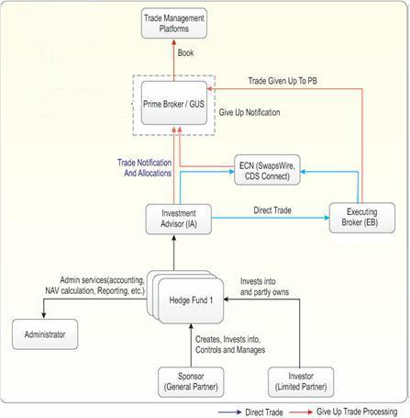

Services and Offerings Provided by Investment Banks

As prime brokers, the services and offerings provided by investment banks to hedge funds are:
- Clearing
- Settlement
- Custody
- Dividends and Cash Management
- Securities lending
- Capital accounting
- Margin lending
- Multi-currency financing
- Research
- In-depth customized analysis
- Start-Up services
- Web-based systems
- Fully integrated systems
- Integrated customized reports

Margins and Size of Prime Brokerage Opportunity for Investment Banks
Hedge fund clients have a variety of service providers to choose from, and it is a struggle for prime brokers to create new and differentiating services. Fund administrators, technology providers, and new trading networks and services are presenting alternatives to the hedge fund community. Strong investor interest from the institutional, private wealth, and even retail sectors will mean an increasing number of distribution channels for hedge products, and ultimately less dependence on prime brokers.
The long-standing leaders in prime brokerage are under siege. There are about 30 prime brokers worldwide. Overall the top three firms—Goldman Sachs, Morgan Stanley, and Bear Stearns—represent about 55 to 65 percent of the market. All these firms have well developed infrastructure worldwide, with market dominance outside their country of origin.
Typical prime brokerage profit margins are purported to be in the range of 15 to 25 percent. Estimates suggest hedge funds account for a third of investment banks’ trading commissions. Banks have suffered in other business areas, such as mergers / acquisitions and initial public offerings, so double-digit margins have reinforced or inspired new commitment to the prime brokerage business.
Global hedge fund assets hit the US$1 trillion mark in 2004. A survey conducted by Celent predicts that global hedge fund assets will increase at an average annual rate of 16.5 percent over the next five years, doubling to US$2.1 trillion by 2009. This growth will fuel continued demand for prime brokerage services at all points of the hedge fund life cycle.
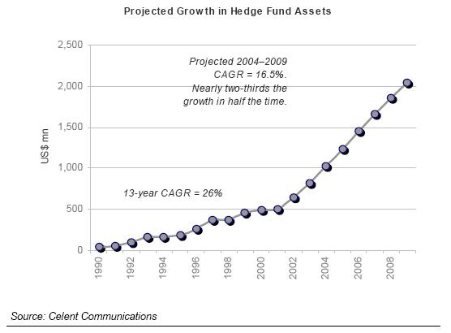

Prime brokers are offering more and more services. Their primary sources of revenue, though, is financing and securities lending.
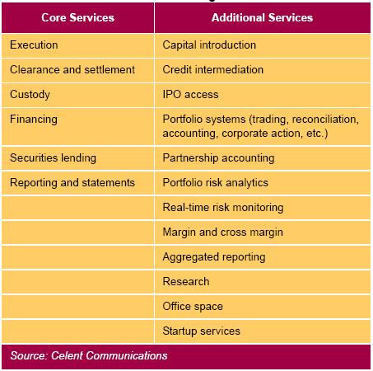

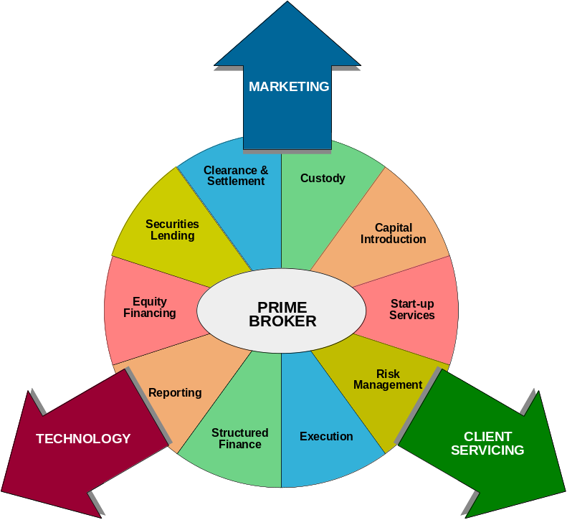

Technology and Prime Brokerage
Hedge funds regard operational efficiency as the key criteria in their selection of prime brokerage services. Research has found that prime brokers are currently working with poorly integrated systems, with slightly over 30% of hedge funds having global straight-through processing (STP) between themselves and their prime brokers in some key areas such as trade confirmations, trading and execution.
Hedge funds increasingly want risk analytics as well as portfolio management and reporting systems, so that they can monitor and analyze their portfolios on an active basis.
Many claim that deep pockets and strong brand identity are what keeps a prime broker at the top. However, technology is leveling the playing field. Prime brokers should not underestimate the importance of STP. Without it, prime brokers would miss opportunities to reduce both their costs and their level of operational inefficiency, and so would be unable to provide their hedge fund clients with the accurate information they need.
In addition to the technology investment, the prime broker of tomorrow will be able to give a hedge fund an integrated package of products. In an ideal world, all the services used should be accounted for in one statement, posting margin once for all transactions. It will be the prime broker that can offer the hedge fund error-free access to everything it needs, with the required level of personal relationship, that will be the victor in the competition to win business in an increasingly crowded market.

  - Research
Research products
Typical products of the research group of an investment bank are pieces of analysis on stocks, bonds, commodities, currencies or macroeconomic factors. Research reports are not typically sold to clients in return for money but are offered free as a valued added service in addition to other services like trading, execution, clearing and settlement. Research reports help an investment bank create awareness among its clients that it follows the industry closely and thus contributes by way of sales and trading commissions as well as increased investment banking business.

Structure of Equity Research group in an I-bank
The equity research group of an investment bank consists of various teams each specializing in particular industry sectors. Each team covers stocks of 10-15 companies in their sector and their work consists of closely tracking events affecting the companies in their sector and their implications on the earnings of the companies. Equity research teams maintain earnings models which are spreadsheets used for generating earnings forecasts based on the assumptions and views of the analyst.
A typical equity research team consists of a senior analyst who is an expert in the sector and generates most of the research ideas. The other members of the team are associates and research analysts. Most of the number crunching and data gathering is done by the research analysts while the associates supervise their work and provide guidance. Senior analysts spend the bulk of their time talking to client in order to answer their queries regarding the covered stocks and thus marketing the team’s research reports.

Chinese wall
Between corporate finance and research, firms build in a restriction known as a Chinese Wall separating research analysts from both bankers and sales & trading. The rationale is that bankers are often privy to inside information at a company because of ongoing or potential M&A business, or because they know that a public company is in registration to file a follow-on offering. Either transaction is considered material non-public information and research analysts privy to such information cannot change ratings or mention it, as doing so would effectively enable clients to benefit from inside information at the expense of existing shareholders. When it comes to certain information, a Chinese Wall also separates salespeople and traders from research analysts. The reason is that analyst reports often move stock prices significantly. Thus, a salesperson with access to research information prior to it being published would give clients an unfair advantage over other investors. Research analysts, sometimes, even disguise the name of the company on a report until immediately before it is published. This ensures that even if the report falls into the wrong hands, the information remains somewhat confidential.

The contribution of equity research in an investment bank
As was mentioned earlier, the equity research group does not generate revenues for the bank directly through its research reports, which are distributed to clients free of charge. However, the effort of the group does get paid for in the form of commissions (brokerage) from trades which clients route through the bank’s sales and trading desk. Also senior equity research analysts accompany bankers in capital raising roadshows for investment banking clients in order to take advantage of the respect that the senior analysts commands in the market for his views of the industry.
- Exchanges and ECNs
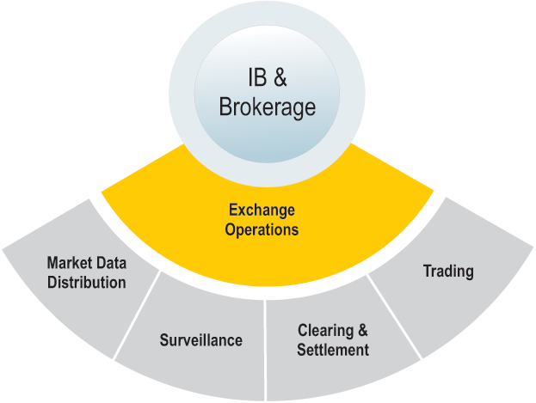
  - Exchanges
To be traded, every stock must list on an exchange, a central "flea market" where buyers and sellers meet. The two big U.S. exchanges are the esteemed NYSE and the fast-growing Nasdaq; companies listed on such exchanges must meet various minimum requirements and baseline rules concerning the "independence" of their boards.

Registered bodies
There are currently nine securities exchanges registered with the SEC under Section 6(a) of the Exchange Act as national securities exchanges:
- American Stock Exchange [http://www.amex.com/]
- Boston Stock Exchange [http://www.bostonstock.com/]
- Chicago Board Options Exchange [http://www.cboe.com/]
- Chicago Stock Exchange [http://www.chx.com/]
- International Securities Exchange [http://www.iseoptions.com/]
- National Stock Exchange (formerly the Cincinnati Stock Exchange) [http://www.cincinnatistock.com/]
- New York Stock Exchange [http://www.nyse.com/]
- Pacific Exchange [http://www.pacificex.com/]
- Philadelphia Stock Exchange [http://www.phlx.com/]

Other Exchanges:
- NASDAQ [http://www.nasdaq.com/]
- Chicago Climate Exchange [http://www.chicagoclimatex.com/]
- Chicago Board of Trade [http://www.cbot.com/]
- Chicago Mercantile Exchange [http://www.cme.com/]
- New York Mercantile Exchange / Commodities Exchange [http://www.nymex.com/jsp/index.jsp]
- Boston Options Exchange [http://www.bostonoptions.com/index.php]

    - Basic Function
The primary function of an exchange is to provide liquidity; in other words, to give sellers a place to "liquidate" their share holdings. The exchange tracks the flow of orders for each stock, and this flow of supply and demand sets the price of the stock.
The functions of an exchange generally are to:
- Provide its members with the premises, systems and mechanisms which furnish them with clear information on the purchase and sales bids of the securities, the impartial execution of the respective instructions and the efficient settlement of their operations.
- Promote the trading of securities, carrying out the necessary activities and offering the appropriate services for such purposes to ensure permanent growth of the market.
- Register, in accordance with the legal provisions and regulations, the stock and securities to be traded and the respective operations.
- Offer information to the general public regarding stockbrokerage houses, stock brokers and market transactions.
- Divulge and keep the general public up to date on the information concerning stock values, and the financial situation and other circumstances of the equity issuers.
- Supervise that its members or their representatives act in accordance with the accepted commercial ethics, and the respective legal dispositions, regulations and statutes.
- Publish information on the Stock Market and any other information related to stock broking activities.
- Certify the value of the securities traded on the Exchange.
- Investigate new facilities or products which may be offered to either current investors or potential investors and equity issuers.
- Establish and implement other complementary and compatible services.
- Carry out all other acts necessary to comply with the objectives of the Exchange.

Kinds of exchanges
Exchanges may be of two kinds:
- Auction Exchanges
- Electronic Exchange

    - Auction Exchanges
An auction exchange is where stocks are traded and priced through auction or open out cry. The NYSE and AMEX are both primarily auction based, which means specialists are physically present on the exchanges’ trading floors. Each specialist "specializes" in a particular stock, buying and selling the stock in a verbal auction. These specialists are under competitive threat by electronic-only exchanges that claim to be more efficient (that is, execute faster trades and exhibit smaller bid-ask spreads) by eliminating human intermediaries.

NYSE - The NYSE is the largest and most prestigious exchange. Listing on the NYSE affords companies great credibility because they must meet initial listing requirements and also comply annually with maintenance requirements. For example, to remain listed, NYSE companies must keep their price above $1 and their market capitalization (number of shares x price) above $50 million.
AMEX is a smaller but quite prestigious exchange. AMEX also has a history of innovating: it pioneered the concept of exchange traded funds (ETFs) and it has the second largest options trading market.
The Trading Floor resembles a beehive of activity where market professionals cluster around computer screens calling out buy and sell orders. In addition to the main room of the Trading Floor, where the opening and closing bell is rung, four other trading rooms comprise a total of 48,000 square feet. While the Trading Floor may be a hectic place, the activity is closely monitored to maintain a fair and orderly market. The NYSE is governed by a precise set of rules and regulations that ensure smooth and efficient trading of billions of shares of stock every day.
Market professionals supported by advanced technology represent the orders of buyers and sellers to determine stock prices according to the laws of supply and demand.
Floor Brokers
Brokers receive orders from the public to buy or sell shares. Two main types of floor brokers work on the Trading Floor: house brokers and independent brokers. House brokers are employed by brokerage houses that are members of the NYSE. These highly trained market professionals buy and sell securities for their institutional customers. The majority of independent brokers are “direct access” brokers who deal with the institutional public at low commission rates. Both house brokers and independent brokers receive trading orders electronically on the Trading Floor either at their booth location or on mobile, wireless handheld computers. One way the public places its orders is through stockbrokers of a brokerage house. These sales professionals are “financial consultants,” since they must be licensed and pass a qualifying examination and be registered with the exchange and the Securities and Exchange Commission. Investor orders are transmitted from a branch office of a brokerage house to the exchange

Specialists
Market professionals called specialists are the contact point between brokers with buy and sell orders in the NYSE’s agency auction market. Each stock is allocated to a specialist, who acts as an auctioneer in specific stocks at a designated location. All buying and selling of a stock occurs at that location, called a trading post. The number of stocks traded by an individual specialist varies according to the total activity of the stocks. High-definition post display units above the trading posts contain a variety of information about each stock that is traded at that location.
Although 95% of orders are delivered directly to the trading post by electronic means, they represent 65% of the share volume. The remaining 5% of orders, which represents 35% of share volume, are represented by the floor brokers who meet openly at the trading post to find the best price for a security by interacting with a specialist.
The people who gather around the specialist’s post are referred to as the trading crowd. Bids to buy and offers to sell are spoken aloud so that anyone present has an opportunity to participate in the buying and selling. This enhances the competitive determination of prices. When the highest bid meets the lowest offer, a trade is executed.
The specialist is responsible for maintaining the market’s fairness, competitiveness, and efficiency. Specifically, the specialist performs four vital functions:
- Auctioneer: At the start of each trading day, specialists establish a fair market price for each of their stocks. They base that price on the supply and demand for the stock. Then, during the day, specialists quote the current bids and offers in their stocks to other brokers, acting as auctioneers.
- Agent: A specialist is the agent for all orders routed electronically through the SuperDOT® System, and for orders with special instructions on them left with the specialists by floor brokers to be executed at the best price available.
- Catalyst: Specialists are called upon to maintain “orderly markets” in their assigned stocks. That is, they ensure that trading in their stocks moves smoothly during the day with minimal fluctuation in price so that the public is protected.
- Dealer: If there are temporarily more buy orders than sell orders in a specialist’s assigned stocks — or if there are more sell orders than buy orders — then the specialist is required to step in and sell or buy stock using his own firm’s money or reserves of that stock. This is done by buying or selling against the trend of the market, until a price is reached at which public supply and demand are once again in balance. In this role, the specialist acts as principal or dealer.

Trading Floor Technology
At the NYSE, orders are routed directly to trading posts, booths, or handheld computers on the Floor in the following ways:
SuperDOT® (Designated Order Turnaround System): More than 95% of orders to buy or sell stock reach the specialist’s workstation directly at the trading post through this electronic order-routing system. After the order has been executed in the auction market, a report of execution is returned directly to the member firm office over the same electronic circuit that brought the order to the Trading Floor. SuperDOT® handles most of the smaller orders. It is the larger orders that are represented personally by floor brokers via BBSSSM, e-BrokerSM, and other systems.
Broker Booth Support SystemSM (BBSSSM): This highly sophisticated computer system is used to receive orders on the Trading Floor. The system is connected to the specialist’s post and the broker’s handheld computer.

    - Electronic Exchanges
An electronic exchange is where stocks are traded through a network of computers. Unlike an auction exchange, prices are matched electronically. Instead of brokers calling out orders, market makers place their name on a list of buyers and sellers, which is then distributed by the exchange in a split second to thousands of other computers.

NASDAQ - The Nasdaq, an electronic exchange, is sometimes called "screen-based" because buyers and sellers are connected only by computers over a telecommunications network. This is a virtual trading floor and all trading is done through a computer and network of dealers. There are no floor brokers and no central location around the action moves. On the NASDAQ exchange the brokerage behaves as a "market maker" for certain stocks. The market maker asks for what is known as a continuous bid and requests prices that fit between a determined percentages spread for shares that are on the market that day. Usually an inventory of shares is kept on hand to meet the demands of buyers but sometimes buyers and sellers are directly matched up.
Nasdaq has listing and governance requirements that are similar but slightly less stringent than those of the NYSE. For example, a stock must maintain a price of $1 and the value of the public float (number of traded shares multiplied by stock price) must be at least $1.1 million. If a company does not maintain these requirements, it can be "de-listed" to one of the OTC markets.

    - Market Makers vs. ECNs
There are over 530 market makers currently operating on NASDAQ. The market maker holds inventory in certain securities and stands ready to buy/sell to the market at all times. The premium for taking large positions in stocks is gained through the bid/ask spread where the market maker earns his coupon. Spreads can range from $0.0625 per share for very liquid stocks and up to $1.00 on illiquid shares.
In 1997, the United States Securities and Exchange Commission (SEC) introduced new "order handling rules". The new rules obligated market makers to display quotes better than their own. The new rules opened the door for the growth of ECNs. ECNs allow institutional traders/investors a field to access shares in traded equities and post their own prices to attract buyers or sellers. The ability to show ones price without having to go to a market maker is the key to the ECNs success.
ECNs  Order-driven market  Two-sided market  Participants do not hold inventory  Post Bids or Offers | NASDAQ - Market Makers  Quote-driven market  One-sided market  Required to maintain stock positions  Required to display both Bid/Ask prices

    - NYSE and Nasdaq – A comparative Study
Both the NYSE and the Nasdaq markets accommodate the major portion of all equities trading in North America, but these exchanges are by no means the same. Although the NYSE has a far greater total market capitalization, Nasdaq has surpassed the NYSE in the number of both listed companies and shares traded. They can be compared on the following lines:

Location
On the NYSE, all trades occur in a physical place, on the trading floor of the NYSE. The Nasdaq, on the other hand, is located not on a physical trading floor but on a telecommunications network. People are not on a floor of the exchange matching buy and sell orders on the behalf of investors. Instead, trading takes place directly between investors and their buyers or sellers, who are the market-makers, through an elaborate system of companies electronically connected to one another.

Dealer vs. Auction Market
The fundamental difference between the NYSE and Nasdaq is in the way securities on the exchanges are transacted between buyers and sellers. The Nasdaq is a dealer's market, wherein market participants are not buying from and selling to one another but to and from a dealer, which, in the case of the Nasdaq, is a market maker. The NYSE is an auction market, wherein individuals are typically buying and selling between one another and there is an auction occurring; that is, the highest bidding price will be matched with the lowest asking price.

Traffic Control
Each exchange requires people who are at the "intersection" where buyers and sellers "meet," or place their orders. The traffic controllers of both exchanges deal with specific traffic problems and, in turn, make it possible for their markets to work. On the Nasdaq, the traffic controller is known as the market maker, who, we already mentioned, transacts with buyers and sellers to keep the flow of trading going. On the NYSE, the exchange traffic controller is known as the specialist, who is in charge of matching buyers and sellers together.
The definitions of the role of the market maker and that of the specialist are technically different as a market maker "creates a market" for a security whereas the specialist merely facilitates it. However, the duty of both the market maker and specialist is to ensure smooth and orderly markets for clients. If too many orders get backed up, the traffic controllers of the exchanges will work to match the bidders with the askers to ensure the completion of as many orders as possible. If there is nobody willing to buy or sell, the market makers of the Nasdaq and the specialists of the NYSE will try to see if they can find buyers and sellers and even buy and sell from their own inventories.

Perception and Cost
One thing that we can't quantify but must acknowledge is the way in which the companies on each of these exchanges are generally perceived by investors. The Nasdaq is typically known as a high-tech market, attracting many of the firms dealing with the Internet or electronics. Accordingly, the stocks on this exchange are considered to be more volatile and growth oriented. On the other hand, the companies on NYSE are perceived to be more well established. Its listings include many of the blue chip firms and industrials that were around before our parents, and its stocks are considered to be more stable and established.
Whether a stock trades on the Nasdaq or the NYSE is not necessarily a critical factor for investors when they are deciding on stocks to invest in. However, because both exchanges are perceived differently, the decision to list on a particular exchange is an important one for many companies. A company's decision to list on a particular exchange is affected also by the listing costs and requirements set by each individual exchange. The maximum listing fee you can pay on the NYSE is $250,000 while on the Nasdaq, the maximum is only $150,000. The maximum continual yearly listing fees are also a big factor: they are $500,000 and $60,000 respectively. So we can understand why the growth-type stocks (companies with less initial capital) would be found on the Nasdaq exchange.

Public vs. Private
The final major difference between these two exchanges is their type of ownership. Most of the time we think of the Nasdaq and NYSE as markets or exchanges, but these entities are both actual businesses providing a service to earn a profit for shareholders. The Nasdaq exchange is a publicly traded corporation whose shares, like those of any public company, can be bought and sold by investors on an exchange. (Incidentally, Nasdaq trades on itself.) As a public company, the Nasdaq must follow the standard filing requirements set out by the SEC. In contrast, the NYSE is not a public corporation. It is a private one owned by its private shareholders and is therefore not required to maintain the same filings as the Nasdaq. This ownership difference between the two exchanges, however, should not affect how they function as marketplaces for equity traders and investors.

  - Electronic Communication Networks (ECNs)
Electronic Communications Networks or ECNs are part of a class of exchange called alternative trading systems (ATS). ECNs trade Nasdaq and other listed stocks, but they connect buyers and sellers directly. Because they allow for direct connection, ECNs bypass the market makers. There are several innovative and entrepreneurial ECNs, and they are generally good for customers because they pose a competitive threat to traditional exchanges, and therefore push down transaction costs. Currently, ECNs do not really serve individual investors; they are mostly of interest to institutional investors.
ECNs as defined in Exchange Act Rule 11Ac1-1(a)(8), are electronic trading systems that automatically match buy and sell orders at specified prices. ECNs register with the SEC as broker-dealers and are subject to Regulation ATS. Subscribers, which are typically institutional investors, broker-dealers, and market-makers — can place trades directly with an ECN. Individual investors must currently have an account with a broker-dealer subscriber before their orders can be routed to an ECN for execution. When seeking to buy or sell securities, ECN subscribers typically use limit orders. ECNs post orders on their systems for other subscribers to view. The ECN will then automatically match orders for execution. An ECN may choose to facilitate compliance by a market-maker with its obligations under the Commission's Quote Rule by transmitting the ECN's best bid/offer to a national securities exchange or registered securities association for public display.

Common Features
Features common to ECNs are:
- The trading process is order-driven; buy and sell orders are allowed to directly interact with each other.
- Direct interaction means that there is no need for human intervention to match these orders. Computerized algorithms—and not specialists, floor traders, or market makers—are used to execute trades.
- These systems allow investors to trade anonymously. Orders can be placed directly with the order book where the identity of the investor is not revealed to other traders in the market.
- Some systems allow investors to directly submit their orders to the market; others (and this normally applies to smaller investors) require that orders be routed through brokers.
ECNs have a wide variety of subscribers, including retail investors, institutional investors, market makers, and other broker-dealers. ECNs provide many market services to these subscribers. For example, ECN subscribers can enter limit orders into the ECN, usually via a custom computer terminal or a direct dial-up. The ECN will post those orders on the system for other subscribers to view. The ECN will then match contra-side orders for execution. In most cases, the buyer and seller remain anonymous to each other, with the trade execution reports listing the ECN as the contra-side party. In addition, subscribers may use such features as negotiation or reserve size, and may have access to the entire ECN book (as opposed to the "top of the book") that contains important real-time market data regarding depth of trading interest.

Advantages of ECNs
- Increased Market Share - ECNs offer brokers an alternative to market makers and compete mainly on price and the speed of trading execution.
- Lower Spreads - After the implementation of order handling rules regarding ECNs, bid-ask spreads have shrunk dramatically. The Nasdaq system identifies the brokers. But ECNs do not. So prima facie, the anonymity offered has encouraged competitive quotes from market makers and, in the process, led to a lowering of spreads.
- Improved Information Flow - ECNs operate following the principle of open order books. This means that they provide their users with information on the various buying and selling interests submitted to the order book. But they do not reveal the identity of their users. Investors are thus allowed to trade in relative anonymity. An interesting feature of this is that it provides a trader with information on the depth of Island’s order book. By comparison, the electronic order display system proposed by Nasdaq will publish only the three best bids and offers. A trader who wants to sell a large number of shares has access to enough information to price his or her offer so as to clear the appropriate number of bids in the book.

Registered bodies
The roster of firms that offer ECN services keeps changing frequently. Few of the ECNs in the securities markets are:

- Reuters’ Instinet* [http://www.instinet.com/]
- Datek Securities’ Island* [http://www.island.com/]
- Bloomberg’s Tradebook [http://www.bloombergtradebook.com/]
- Archipelago [http://www.tradearca.com/]
- REDIBook, backed by Charles Schwab, Donaldson, Lufkin & Jenerette,
- and others [www.redi.com]
- All-Tech Investment Group’s Attain [http://www.dom-sec.com/ecn/ecnFeatures.cfm]
- NexTrade, operated by PIM Global Equities, Inc. [http://www.nextrade.com/]
- Market XT [http://www.marketxt.com/]
- Brut, owned by SungGard Data Systems, Inc.

* Instinet ECN and Island ECN INET consolidated in early 2004.

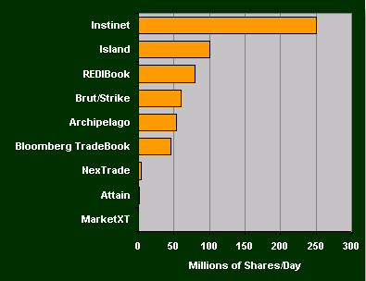
Instinet
Instinet, short for Institutional Network, is the oldest electronic trading network operated by Instinet Corporation, a subsidiary of Reuters Group. Instinet was the first ever ECN, founded in 1969. It just happens to be the largest one of its type, enjoying more than a 60 percent share of the ECN market.
It was originally a way for brokerages to display bid and ask prices for practically every stock in North America and abroad and was first used by institutions to transact with each other. Today it also includes a select group of smaller brokerages. Instinet is used to execute a large proportion of orders on Nasdaq and is primarily entered by market makers. Because of this exclusive access many of the large block orders on Nasdaq stocks are traded through Instinet. More recently Instinet has tried to level the playing field by lowering access fees and allowing individual investors and small firms to access its orders.

Island
This ECN is popular among smaller traders because everyone placing an order on Island is on equal ground. Island puts all active orders in the "Island Order Book," which lists all of the bid and ask orders for each individual stock. Island is considered very easy to use and relatively inexpensive compared to other ECNs. In short, Island allows anybody to access the Nasdaq in a way that was not possible in the past without becoming a member firm. Island was the first ECN to publish real-time information from its order book over the Internet.

NexTrade
NexTrade has developed proprietary software, Pro-Trade, which allows retail clients of sponsoring firms to enter trades for execution on NexTrade ECN. The basic software to connect to NexTrade can be downloaded over the Internet. Some of NexTrade’s largest customers are Brown & Co. and Dreyfus Brokerage Services. In 1999, NexTrade developed the world’s first Internet-based spot foreign currency trading platform, Matchbook FX, of which it is one-third owner. In January 2000, the firm formerly applied to the SEC for exchange status.

Brut
Brut is a subsidiary of SunGard Data System, which sells order-routing systems to brokerage firms and institutional investors. In early 2000, Brut merged with Strike, another ECN. The new company is named Brut ECN. About 130 brokerage firms use its services to route orders and settle trades. Offering trading services in the form of Brut is part of the company’s strategy to enhance a dominant position in one segment of the trading process.

Archipelago
Archipelago is one of the first four ECNs approved by the SEC. It was launched in 1997.Trading volumes in Archipelago are much smaller than at Instinet and Island.

ECNs and Nasdaq
Despite their recent entry, the role of ECNs is already evolving into a more complex one. In particular, the decision by Nasdaq that requires ECNs to publicize their quotes over the Nasdaq quote montage via SelectNet has pushed what was initially a private club into the glare of the broader market. Consequently, many ECNs have a symbiotic relationship with Nasdaq, which both collaborate and compete with each other. The highest bids and offers on every ECN are displayed over Nasdaq level II screens. With SuperMontage, ECNs can choose to send their top three quotes for display.
In 1997, the SEC implemented the order handling rules that require market makers to reflect in the Nasdaq quote the price of any orders they placed in an ECN if that price is better than their public quotation. Previously, market makers could post public quotes in private ECNs that were better than the quotes they posted in Nasdaq.
The order handling rules had an immediate impact on the securities markets. The spreads between bids and offers have narrowed significantly.

  - Regulation Of Capital Markets
There are many reasons why the financial markets are regulated by governments:
- Since the capital markets are central to a thriving economy, Governments need to ensure their smooth functioning.
- Governments also need to protect small or retail investors’ interests to ensure there is participation by a large number of investors, leading to more efficient capital markets.
- Governments need to ensure that the companies or issuers declare all necessary information that may affect the security prices and that the information is readily and easily available to all participants at the same time.

Typically the government designates one or more agencies as regulator(s) and supervisor(s) for the financial markets. Thus India has Securities and Exchange Board of India (SEBI) and the US has Securities and Exchange Commission (SEC). These regulatory bodies formulate rules and norms for each activity and each category of participant. For example,
- Eligibility norms for a company to be allowed to issue stock or bonds,
- Rules regarding the amount of information that must be made available to prospective investors,
- Rules regarding the issue process,
- Rules regarding periodic declaration of financial statements, etc.
Regulators also monitor the capital market activity continuously to ensure that any breach of laws or rules does not go unnoticed. To help this function, all members and issuers have to submit certain periodic reports to the regulator disclosing all relevant details on the transactions undertaken.

Below we briefly discuss the structure and scope of SEC.

    - SEC
The Securities and Exchange Commission was established in 1934 in order to correct some of the problems in the securities industry that had led to the Crash of 1929 and the resulting Great Depression. Before this time, there was no central regulatory agency responsible for enforcing securities legislation (granted, there was not much legislation to enforce). The SEC of today, however, is responsible for enforcing a wide variety of securities laws and ensuring that all market participants are playing by the rules.

The SEC is an independent, quasi-judiciary regulatory agency. It has five commissioners, each appointed for a five year term that is staggered so that one new commissioner is being replaced every year. In order to keep partisan politics to a minimum, no more than three members of the commission can be of a single political party. The commissioners are primarily responsible for enforcing the following pieces of securities legislation:
- Securities Act of 1933: Prohibits fraud in the sale of securities and requires proper disclosure of information about public securities to investors.
- Securities Exchange Act of 1934: Extends the Securities Act of 1933 to include securities traded on exchanges and over-the-counter markets (see InvestorGuide University: Stock Exchanges).
- Investment Advisor Act of 1940: Requires that investment advisors and investment advising firms register with the SEC and adhere to its standards.
Of course, there are other pieces of legislation that the SEC enforces; these are just three of the most important ones. Recently, with the rash of accounting, mutual fund, and analyst scandals, there has been a significant amount of new reform legislation aimed at ensuring fair dealings. Eliot Spitzer, SEC watchdog, uncovered ample evidence in 2002 that analysts were doctoring their reports to win business for their banks' investment arms or to downgrade companies that don't play ball. It is to be hoped that the new regulatory crackdown on such activities will curb the publishing of misleading stock information, but the individual investor should beware.

The job of enforcing regulations is divided between four basic divisions of the SEC. The Division of Corporate Finance is in charge of making sure all publicly traded companies disclose the required financial information to investors. The Division of Market Regulation oversees all legislation involving brokers and brokerage firms. The Division of Investment Management regulates the mutual fund and investment advisor industries. And finally, the Division of Enforcement enforces the securities legislation and investigates possible violations.

  - Stock Indices
Stock indices are benchmarks that are used to gauge the performance of a group of stocks. There are many different types of indices and each of them is unique in its own way. In the case of financial markets, an index is essentially an imaginary portfolio of securities representing a particular market or a portion of it. Each index has its own calculation methodology and is usually expressed in terms of a change from a base value. Thus, the percentage changes is more important that the actually numeric value. For example, knowing that a stock exchange is at, say, 5,000 doesn't tell you much. However, knowing that the index has risen 30% over the last year to 5,000 gives a much better demonstration of performance.

This section will take a look at the major stock indices that investors use and why they use them.

Dow Jones Industrial Average
The Dow Jones Industrial average is by far the most famous of all the stock indices. It is composed of 30 widely traded blue chip stocks (large, well-established companies that are leaders in their respective industries). The 30 stocks are chosen by the editors of the Wall Street Journal (which is published by Dow Jones & Company), a practice that dates back to the beginning of the century. The Dow was officially started by Charles Dow in 1896, at which time it consisted of only 11 stocks.
The Dow is computed using a price-weighted indexing system. Simply put, the editors at WSJ add up the prices of all the stocks and then divide by the number of stocks in the index. (In actuality, the divisor is much higher today in order to account for stock splits that have occurred in the past.) The Dow is highly regarded for its simplicity and its history.
However, there are some disadvantages in using the Dow as a benchmark. First of all, the Dow only includes prices for 30 stocks, yet there are thousands of publicly traded stocks on the market. Critics of the Dow therefore question whether or not the Dow is a representative snapshot of the market as a whole. Another problem with the Dow is that it is weighted by price, instead of market capitalization. So, for example, a stock that trades at $100 but has a market cap of only $1 billion will receive more weight than a stock that trades at $50 but has a market cap of $5 billion. Most experts agree that market capitalization-weighted indices better reflect the market's performance than price-weighted indexes.

Nasdaq Composite
Not surprisingly, the Nasdaq Composite tracks all of the stocks listed on the Nasdaq exchange. The index dates back to 1971, which is when the Nasdaq exchange was first formalized. The index is used mainly to track technology stocks, and thus it is not a good indicator of the market as a whole. Unlike the Dow, the Nasdaq is market capitalization-weighted, so it takes into account the total market value of the companies it tracks and not just their prices. Since the index tracks all of the 5000+ stocks listed on the Nasdaq, it includes more than just a representative sample of the technology industry. Critics charge, however, that the index tracks too many small companies whose performance increases the index's volatility.

S&P 500
The S&P 500 index dates back to 1957 in its modern version (although it has been extrapolated backwards to several decades earlier for performance comparison purposes). This index provides a broad snapshot of the overall US equity market; in fact, over 70% of all U.S. equity is tracked by the S&P 500. The index selects its companies based upon their market size, liquidity, and sector. Most of the companies in the index are solid mid cap or large cap corporations. Like the Nasdaq Composite, the S&P 500 is a market-weighted index, so it provides a fair assessment of the stocks that it tracks. Most experts agree that the S&P 500 is one of the best benchmarks available to judge the market. Its only possible fault is that it does not include foreign stocks (except for a handful that have traditionally been included).

SECTION III

SECURITIES INDUSTRY PROCESSES
- Trade Lifecycle
The workflow of the securities trading industry is depicted in the diagram below:

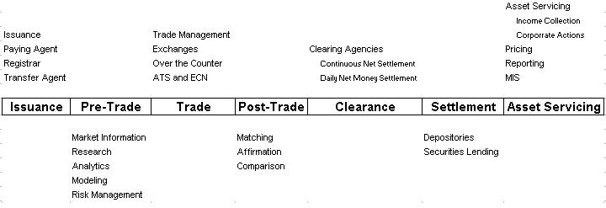
Figure 12: the capital market value chain
Let’s have a quick look at the different steps of the life cycle.
- Issuance: The life cycle starts with the creation of an instrument through a process called issuance. This often involves the creation of a new security that is sold to investors through an Initial Public Offering (IPO). Other securities like Government securities may be issued through auctions. Once a security is issued, if it meant to be publicly traded, it is usually listed on one or more exchanges.
- Pre-Trade: The security is available for trading in the secondary market after it is issued. Investors examine the security in the pre-trade phase of the value chain. They gather information, conduct research, and perform analytics or modelling to evaluate the overall risk of their portfolio and the impact of the trade under consideration. All the activities before a buy side firm or an investor reaches a decision to place an order to buy or sell a particular security is typically classified as Pre-trade activities.
- Trade: To buy or sell a security the investor has to find a counter party. This happens in the trading phase. Trading may be facilitated by an exchange or electronic communication network where the security is listed. In case of certain securities, trading may happen Over The Counter. In this case the securities are not listed and most of the trading happens over the telephone or through computer networks that directly connects dealers.
- Post-Trade: After the trade is made, both the counter parties need to confirm that the trade they made was identical to the one the counter party thought was accomplished. The process of Matching and Confirming/Affirming the trades is usually facilitated by the Exchange and the Clearing House associated with the exchange.
- Clearing: The procedure by which an organization acts as an intermediary and assumes the role of a buyer and seller for transactions in order to reconcile orders between transacting parties. It involves deciding the amounts of cash and securities that trade participants would receive or deliver. This process requires a huge infrastructure and connectivity between all the participants and is supported by Clearing Agencies.
- Settlement: This is the process of final exchange of securities for cash and is usually facilitated by the depository and clearing banks of the broker dealers.
- Asset Servicing: This includes all activities conducted by the issuer as well as the investor after the security is delivered to the investor. Examples of such activities are preparing reports and statements, processing corporate actions such as dividend distribution and stock splits, securities lending, collateral management etc.

  - Trade Cycle: Retail investors
Retail investors are usually individuals who buy or sell securities on their personal account. Typically, the amount of investment is small resulting in trades of small quantities. Traditionally, in order to buy or sell securities retail investors had to open an account with a broker and place buy or sell orders with a representative (trader) at the broker. Sometimes these brokerages were full service brokerages that offered investment advice to the investor. But with the proliferance of the Internet several discount brokers offer online trading facilities to retail investors. Thus, by opening a trading account with an Internet broker, the investor can directly view the prices of various securities and can directly place the order without having to speak to a trader or any other intermediary. Harrisdirect, E*Trade, ICICIDirect etc. are examples of discount brokerages offering online trading facilities.
    - Trading
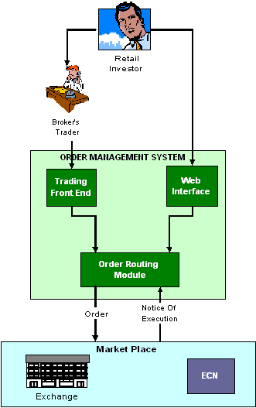
Figure 13: Trade cycle- Retail investor

- As shown in the diagram above, retail trades are either initiated by the customer calling his or her broker or, increasingly, by using the electronic forms of order entry such as the internet.
- In case the retail investor is transacting through a trader (broker’s representative), the trader would place the order on behalf of the investor using the order management system available.
- Depending on the type of OMS available, the trader might be able to route the order to a specific exchange or an ECN network. In doing so, depending on the order type and size, the trader may combine the order with other orders or even split it. If the security is not listed on the exchange the trader may perform an over the counter deal through another broker/dealer. The OMS is responsible for the connectivity to various exchanges and ECN. Once the order is placed with the exchange, it remains in the exchange’s order book till the time a matching order of the opposite side is available. Once the orders and matched, it results in a trade and the trader/investor received a notice of execution (NOE) indicating the quantity and price at which the trade was executed.

    - Post-Trade Processing
In case of retail trades, the broker handles most of the post- trade activities on behalf of the investor. Since retail trades are broker-to-broker trades the clearing and settlement is managed by the NSCC in conjunction with DTC.
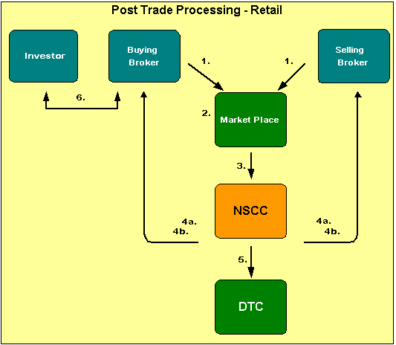
Figure 14 : Post Trade cycle - Retail investor

The above diagram represents the post-trade processing that happens in case of a retail investor.
- Since, retail investors have to always buy or sell through a broker; the Buy and sell orders are routed by the buying/selling broker respectively to the marketplace.
- Depending on the price, time and quantity the orders are matched and the trade gets executed at the exchange.
- Trade Date T: Details of the trade are then sent to NSCC for further processing. The trade details have all necessary information regarding the trade; i.e. the quantity and price it was executed, the buying broker’s ID and the selling broker’s ID. With advancement in technology most equity transactions are now sent as "locked-in" trades, which means that the marketplace has already compared (confirmed all details) the trades being reported to NSCC. Others are sent in directly by broker-dealers. With most bond trades (and some stock trades), each broker-dealer submits its side of the trade to NSCC, and NSCC compares both sides to see that all details match. This happens on the trade date “T” itself.

- T+1 and T+2:
  - On “T+1”, NSCC issues to participating firms computerized reports known as "T contracts." These contracts, the legally binding documents for a trade, show the details of all locked-in trades. These documents confirm that the transactions have compared and are ready for settlement in the Continuous Net Settlement (CNS) system. NSCC's guarantee of settlement begins after midnight of T+1 when it reports back to its customers that the trades have been compared.
  - Since, it is possible the a single broker may have multiple trades on both buy and sell side for the same security (executed for different customers); this could lead to a prohibitively large number of transactions that might have to be settled. Hence NSCC performs a process called “Netting” for each security to determine the net obligation of each broker. I.e. at the end of the process it is know for each security, whether a particular broker has to deliver shares or receive money. On “T+2”, NSCC issues to broker-dealers a summary of all compared trades, the net positions and the money settlement that will be required the following day, which is settlement day
- Settlement Date T+3: On “T+3” which is the settlement day NSCC also nets the dollar amounts that broker-dealers will receive from or pay to NSCC to satisfy their trading obligations for the day. NSCC then issues money settlement instructions to each broker-dealer and its settling bank. Each broker-dealer member of NSCC is required to designate a bank that will handle money settlement for the trades. Based on these instructions, NSCC either wires the bank money, or has the bank wire NSCC money to settle the broker-dealer's obligations. NSCC and the banks use the Federal Reserve electronic wire (or Fed Wire) system to electronically transfer funds the same day. Since all money obligations are netted, a single wire transfer can settle all the obligations for all securities handled by a broker-dealer through NSCC for an entire trading day. NSCC also maintains an account at DTC through which it can issue instructions for book-entry transfer of securities to or from customers' accounts, depending on whether they owe or are owed these securities.
- Note, that this entire process was oblivious to the retail investor. The investor’s point of contact is with the broker. The broker ensures that the investor has either delivered the money or the securities, as the case maybe before the settlement date. For each transaction executed by the broker on behalf of an investor, a commission/fees would be levied.

  - Trade Cycle: Institutional Investors
Institutional investors are usually organizations that trade securities in large quantities. Typically these are buy side firms like mutual funds, investment managers’ etc. who buy and sell securities on proprietary accounts or on behalf of investors. By virtue of the large share quantities that they trade in, they qualify for preferential treatment and lower commissions.
    - Trading
- Institutional investors may execute their orders through brokers, but with the availability of a multitude of Order Management Systems (OMS) and standard protocols like Financial Interface exchange (FIX), it is possible for institutional investors to directly route orders to exchanges, ECN or other alternative trading systems.
- Buy side Order Management Systems (OMS) applications lend desktop power to institutional managers providing a wide variety of functionality to help managers make investment decisions. Macgregor, Charles River Investment Management System etc. are examples of buy side OMS.
- The latest amongst the technology is “Direct Market Access (DMA)” that allows firms to route orders to all market destinations and pools of liquidity. Lava Trading, RealTick and FlexDMA are examples of DMA based applications.
- DMA takes a fragmented marketplace and "brings it together in one place”. It is very difficult without DMA technology to look at all the open orders. It also provides the buy side with more independence and control of its order flow and ultimately control transaction costs
- Several sell side firms are providing this facility to their institutional investors thus allowing them access to multiple markets. Several buy-side OMS vendors are also integrating this technology within their application thus empowering buy side vendors.
- Of-course all said and done, the traditional method of calling up the broker to place an order always exists, especially in case of bond instruments. If the broker receives the order, it is processed similarly to the retail order, except that the broker’s trader might access the third market, which is used for block trades* to find a counter party.

Figure 15: Trade cycle- Institutional investor
Block Orders
- When an institution buys or sells securities, they can either buy or sell a few thousand shares, or can combine orders from multiple portfolios or accounts into one larger order, called a block. Investment managers frequently combine their requirements for multiple portfolios for the same security into a single purchase. By doing so they are able to achieve cost efficiencies. The trading desk at the buy side firm usually does this activity.
- When an order for a large number of shares is received, a broker may have to ‘work the order’ to locate several different counter parties to assemble all of the required shares without moving the market price. The assembled shares constitute the block. When the block is assembled, the broker either reports to the buyer the average cost of the shares or the individual trades that constitute the block.
- Upon execution of the order, the broker sends back the trade details along with the average price at which the block order was executed.
Investment Manager
Broker/Dealer
Block Order
Counter parties
Broker
Broker
Broker
Average Price
- Since the institutional manager had combined multiple orders from different accounts/portfolios, the block trade has to be allocated back to the individual accounts/portfolios at the average price.

    - Post-Trade Processing
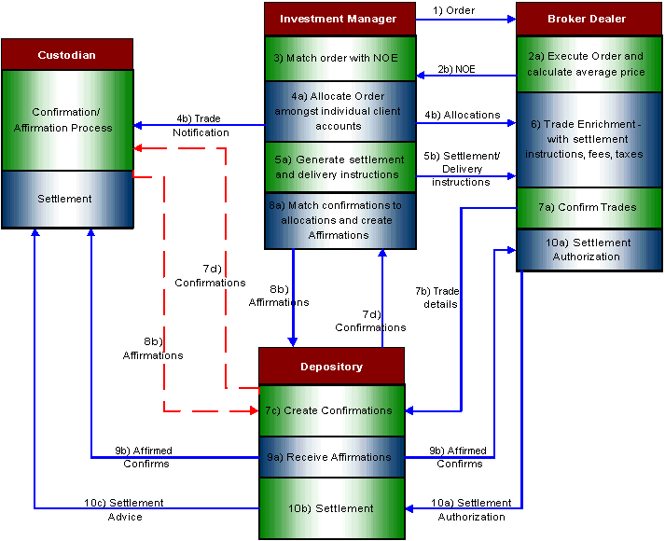
Figure 16: Post Trade cycle – Institutional Investor

Trade Date T
- The Investment Manager places an order to the broker dealer which in turn places the order on the exchange.

  - Once the counter party has been identified and the order has been executed, the broker calculates the average price.
  - The Broker dealer sends the Notice of Execution (NOE) to the Investment Manager to report the execution of the order.
- Once the investment manager receives the NOE, he matches it with the order sent to find out the discrepancies.

  - Once the order matching with the NOE is done and there are no discrepancies, the investment manager allocates shares among the client accounts. The allocation of shares is not done earlier as the investment manager needs the average price to do allocations.
  - The investment manager sends the allocation messages to the Broker Dealer and the Trade Notification message to the Custodian.

  - Once the allocations are sent to the broker, the investment manager generates settlement and delivery instructions.
  - The Investment Manager sends the settlement and delivery instructions to the Broker dealer.

Between T+1 and Noon of T+2
- The Broker Dealer enriches the trade details with settlement instructions, fees, commission and tax details.

  - The Broker dealer confirms the trade details.
  - Based on the allocation message from the investment manager, brokers submit trade details to Depository.
  - Depository then creates trade confirmations.
  - The depository forwards the trade confirmations to the investment manager with copies to the broker and custodian bank (or any other designated party). This step is normally completed on trade date or at latest by the morning of T+1.

  - The investment manager matches the allocations with the DTC sent Confirmations
  - For matched Confirmations the investment manager affirms the trade and sends an Affirmation back to DTC. An affirmation indicates that settlement may proceed.
Note: In some cases the investment manager will designate the custodian bank to verify the Confirmations and affirm the trades on behalf of the manager.

Between Noon of T+2 and T+3

  - The Depository receives the affirmations from either the investment manager or custodian.
  - The depository sends the affirmed confirms to the Broker dealer and custodian respectively. The depository also sends details of un-affirmed trades to the broker, who then has to resolve the same with the institutional investment manager.

  - The Broker Dealer sends settlement authorization to the depository. This is an authorization to the DTC to settle the trades.
  - The Depository does the settlement after receiving settlement authorization from the Broker dealer. Settlement is effected by depository on T+3. Shares are transferred by book-entry from the depository account of the delivering participant to that of the receiving participant, with the corresponding payment being credited to the delivering participant and debited to the receiving participant. During the end-of-day net settlement process, each depository participant settles its net cash position with the depository by payment or receipt of same-day funds.
  - Depository sends settlement reports to the brokers and custodian banks identifying the trades that settled on T+3 and if a delivery did not settle, specifying the reasons.

    - Straight Through Processing and T+1 Settlement
Straight-through processing (STP) is a solution that automates the end-to-end processing of transactions for all financial instruments, from initiation (Order Generation) to resolution (Settlement).
STP encompasses a set of internal and external applications, business processes, and standards that will redefine the settlement and processing paradigm within the capital markets industry. It aims to make trade processing as automated as possible, allowing STP-related business processes to be carried out without unnecessary human intervention, thereby reducing to a minimum the overall processing lead time and the related risks, including inevitable human errors.
Currently US markets have a T+3 settlement cycle for most financial instruments such as stocks, bonds etc. However the US industry and the global capital markets industry is investing billions of dollars in order to streamline the trading cycle so as to move to a T+1 settlement cycle. End-to-end automation of all the processes
The benefits of STP and a T+1 settlement are manifold:
- The most tangible benefit is cost and time savings by virtue of reduction in settlement cycle.
- Reduction in default risk as a T+1 settlement would mean streamlined clearing and settlement latest by the next day of trading.
- It would lead to fewer transaction errors and hence bring down costs associated with correcting these errors.
- Reduction in operational risk due to minimal manual intervention.

- Clearing and Settlement
Although some investors may think that a trade is finished immediately after they click “place order” it really isn’t. A transaction is never finished till the paper work is done. Even though the parties have agreed on the price and quantity to be traded neither the money nor the instrument – say, stock- has yet been exchanged.

  - Process
At the end of each trading day, concluded or locked-in trades are received. All trades concluded during a particular trading period are settled together. A multilateral netting procedure is adopted to determine the net settlement obligations (delivery/receipt positions) of Broker-Dealers . The netting procedure determines the delivery and receipt obligation of funds and securities by each member. Settlement is deemed to be complete upon declaration and release of pay-out of funds and securities.

    - Players involved in the Process
Brokers-Dealers: Also called members. These are the persons or the firms who are allowed to trade in an exchange.
Clients / Custodian: The settlement of the trades (money and securities) done by a member-broker on his own account or on behalf of his individual, corporate or institutional clients may be either through the broker-dealer himself or through a registered custodian appointed by him/client. In case the delivery/payment in respect of a transaction executed by a broker-dealer is to be given or taken by a registered custodian, then the latter has to confirm the trade done by a broker-dealer on the trading system.
- Clearing House
- Exchange

    - Preparing for Clearing and Settlement
There are 4 major steps involved in the run-up to clearing and settlement. These are:
- Trade Matching: This occurs when the counterparties to the trade match the details of completed trades to ensure that both sides to a trade agree in advance of the settlement. This reduces the chances of a fail due to mismatched instructions. This is usually done systematically by the exchanges and by the brokers themselves
- Confirmation: Confirmations are sent to investors to officially tell them what their brokers have done on their behalf. Retail investors get paper confirmations while institutional investors get electronic confirmations, though they can get paper confirmations too if they so desire. In the US, electronic confirmations are obtained through the Depository Trust Company’s (DTC) automated system for securities held by the DTC. If a customer identifies an error in the confirmation, he is required to inform the broker promptly.
- Affirmation: Institutional investors are required to affirm the broker’s confirmation; otherwise the custodian bank must let the trade fail. The affirmation acts a positive signal to the custodian to release funds or securities during settlement.
- Netting: A process of bringing together all of the trades made by the participants. The various trades by a participant for a specific security offset each other, thereby creating a single net debit or credit position for the participant at the end of the day for cash as well as for each security.
Netting can be of 2 types:
  - Bilateral Netting: In bilateral netting, each broker nets all of his trades with each of the other counterparties.
  - Multilateral Netting: In bilateral netting, all of each broker’s trades with each of the other brokers are simultaneously netted.

Let us look at an example to understand these concepts.
Suppose there are three brokers A, B and C who trade with each other on shares that have the ticker CTSH (which company could this be?) as shown below:
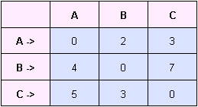
Figure 131 : Netting
Case 1: No Netting:
In the absence of netting, the number of shares that have to be transferred between A, B, C are shown in the diagram below.
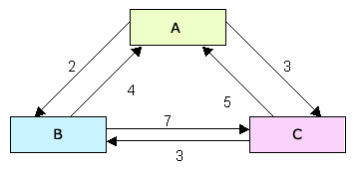
Figure 22: No Netting
Case 2: Bilateral Netting:
In this case transactions between a pair brokers offset each other. For instance, instead of A transferring 2 shares to B and B transferring 4 shares to A, there will be a single transaction in which B will transfer 2 shares to A. Thus the final transactions will be as shown below.
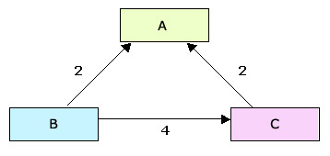
Figure 22: Bilateral Netting
Case 3: Multilateral Netting:
In this case, a broker takes part in one transfer only. For instance, instead of B transferring 2 shares to A and 4 to C, B will transfer 6 shares to a body known as Clearinghouse (we shall look at this in detail later).

The cash transfers for the trades made also vary in a way similar to stock transfers.
Trading systems based on bilateral netting are more efficient than those that don’t have netting (also known as trade-for-trade). Multilateral netting in turn is more efficient than bilateral netting.
Now suppose that in the example above, B defaults i.e. fails to deliver the stock. Both A and C would suffer from the default, as they would not get delivery of the stock. To prevent this, there are bodies known as clearinghouse who steps into the middle of a trade, becomes the counter-party to both the buyer and the seller and guarantee completion of the transaction. It guarantees that it will complete trades on the original terms, even if the original contra-party fails. This process of transferring obligation from one party to the other is also known as “Novation”.
It should be noted however that the presence of such a guaranteer does not mean that there is no risk involved in settlement. It is possible that the defaults involve such large volumes of trades that even the clearinghouse cannot satisfy the guarantee. The longer the period of netting, the bigger the risk. In USA, National Securities Clearing Corporation acts as the clearinghouse. In India, the National Securities Clearing Corporation Limited acts as the clearinghouse.
Today multilateral netting is in place in most of the markets. In the USA, the Depository Trust Corporation follows this and has been able to reduce the dollar value of transactions by 95%.
In India, the two major exchanges, the Bombay Stock Exchange (BSE) and the National Stock Exchange (NSE) follow multilateral netting for trades that involve shares. Further, multilateral netting is followed for trading in Government Securities that is done by retail investors.
We would be covering bodies such as National Securities Clearing Corporation and Depository Trust Clearing Corporation in more detail in later sections.
In future, Real Time Gross Settlement (RTGS) is expected to be adopted in the markets. RTGS is a settlement system in which processing and settlement take place on an order-by-order basis (without netting) in real time (continuously). As settlement happens at real time throughout the day, RTGS reduces settlement risk. This is because it is not possible for a buyer/seller to keep on trading throughout the day and then defaulting, unlike in netting. The moment there is a default, it is detected and actions can be taken to bar the defaulter from making further trades. Gross simultaneous settlement of securities and cash is already being used to settle trades on the Riga Stock Exchange in Latvia on a real time basis.
  - Clearing
Clearing is the process of determination of obligations, after which the obligations are discharged by settlement.
    - Clearinghouse
The clearing process is generally taken care of by a Clearinghouse. This is a specialized institution, which takes care of the following:
- Netting
- Determining the obligations of broker-dealers
- Counter party risk guarantee
Examples:
The largest clearinghouse in the US is the National Securities Clearing Corporation (NSCC). It is owned by brokers and helps brokers clear trades among themselves. The securities eligible for clearing at NSCC include:
- Corporate bonds and Equities listed on New York Stock Exchange (NYSE) and American Stock Exchange (AMEX)
- Corporate bonds and equities listed on over the counter markets like NASDAQ
- American Depository Receipts (ADRs)
- Municipal bonds
- Mutual funds

NSCC provides additional services to brokers to reduce cost and risk. These include:
- Comparison Process
- Continuous Net Settlement: This is based on multilateral netting and is processed throughout the day. Therefore at any point of time the process can identify each broker’s net position on each security traded.
- Stock borrow program: This allows participants to lend specified stocks and bonds from their accounts at the DTC to cover temporary shortfalls in the CNS. Participants can earn overnight interest on the dollar value of the loan.

The Government Securities Clearing Corporation is a sister organization of the NSCC and is used to help brokers clear government securities. It follows a system similar to NSCC and uses much of the same infrastructure. The securities that GSCC caters to include:
- Treasury bills
- Treasury notes
- Treasury bonds
The services offered by GSCC include trade comparison, netting and settlement not only for ordinary trades done on the above-mentioned securities, but also on repurchase agreements (repos)
In India the National Stock Exchange (NSE India) has setup its clearinghouse known as National Securities Clearing Corporation Ltd (NSCCL).

  - Settlement
Settlement is the conclusion of a transaction in which parties pay for securities purchased and take delivery of securities sold.
    - Types of settlements
Settlements are of two types:
Account Period: All transactions are bunched for a period and settled at the end of the period irrespective of the date of an individual transaction. Example Weekly period settlement or fortnightly period settlement. (This was being followed in India till recently.)
Rolling Settlement: Under rolling settlements, unlike in the "account period settlements", the trades done on a particular day are settled after a given number of business days instead of settling all trades done during an 'account period' of a week or fortnight. A T+2 settlement cycle means that the final settlement of transactions done on T, i.e., trade day by exchange of monies and securities between the buyers and sellers respectively takes place on second business day (excluding Saturdays, Sundays, bank and Exchange trading holidays) after the trade day.

    - Depositories
Settlement occurs directly between brokers and their retail customers, usually through a body that specializes in this. This specialized body is the security depository.
For instance, in USA, the Depository Trust Company (DTC) performs the settlement for institutional customers and for clearing firms utilizing netting. It is the world’s largest securities depository and is the primary central securities repository for stocks and bonds in USA.
Depositories have several functions including:
- Physically hold securities such as equities, bonds etc.
- Arrange for the receipt and delivery of securities during settlement
- Arrange for the cash payments during settlement
- Collecting and distributing dividends
- Re-registration in nominee name: Securities may be registered in the actual owner’s name, known as the beneficial owner, or in the name of a nominee, known as street name. Most stocks that are held by brokerage firms for their clients are registered in nominee name. Holding securities in street name expedite the process of securities delivery. Therefore re-registration is a commonly used function provided by depositories.
- Dematerialization of securities i.e. eliminate physical certificates for securities so that they exist only as electronic accounting records.
- Book-entry i.e. maintain information in electronic form about transfer of cash and securities between counterparties rather than carry out actual delivery of money in return for the physical certificates.
In India, the NSCCL takes care of settlement as well.

    - Procedure for Settlement
Initiation
This is the clearing process as has been mentioned earlier.
Funds and Securities pay in
Once the reconciliation of securities is completed by the Clearing House, the bank accounts of broker-dealers are directly debited through postings for their funds settlement obligations. Once the pay-in of securities and funds is complete, the Clearing House arranges for the pay-out of securities and funds.

Funds and Securities Payout
The bank accounts of the broker-dealers having pay-out of funds are credited by the Clearing House with the Clearing Banks on the same day. A Clearing Bank is a bank that is responsible for transfer of cash and securities on behalf of dealers and customers. This process is referred to as Pay-out of Funds.
This process of passing on delivery of securities purchased by the broker-dealers to them by the Clearing House is called pay-out of securities. This could be either in the physical form or demat form. If a broker-dealers fails to deliver the securities, then the value of shares delivered short is recovered from him at the standard/closing rate of the scrips on the trading day.
In case of Rolling Settlements, pay-in and pay-out of both funds and securities, as stated earlier, is completed on the same day.

  - Shortages and Objections
Sometimes the clearance and settlement process might not end smoothly, giving rise to shortages and objections.
    - Shortages
Shortages arise when the seller of a security is unable to deliver the security on the Pay-in day. Lets see how shortages are dealt with in the Bombay Stock Exchange (BSE). For this we first need to understand a few specifics of trading on BSE.
The scrips traded on BSE have been classified into 'A', 'B1', 'B2', 'F' and 'Z' groups. 'A', 'B1 ', 'B2' and 'Z' groups represent the equity segment. The 'F' group represents the debt market. The 'Z' group covers the companies that have failed to comply with listing requirements and/or failed to resolve investor complaints or have not made the required arrangements with the depositories. BSE also has the facility to trade in "C" group which covers the odd lot securities in 'A', 'B1', 'B2' and 'Z' groups and Rights renunciations in all the groups of scrips in the equity segment.
The broker-dealers normally download Delivery/Receive Orders based on their netted positions for transactions entered into by them during a settlement in 'A', 'B1', 'B2', and 'F' group scrips and on trade to trade basis, i.e., without netting buy and sell transactions in scrips in "C" & 'Z' groups and scrips in B1 and B2 groups which have been put on trade to trade basis as a surveillance measure.
The seller broker-dealers have to deliver the shares in the Clearing House as per the Delivery Orders downloaded. If a seller broker-dealer is unable to deliver the shares on the Pay-in day for any reason, his bank account is debited at the standard rate (which is equal to the closing price of the scrip on the day of trading) fixed by the Exchange for the quantity of shares short delivered. This is called a valuation debit. A valuation debit is also conducted for bad delivery by clearing broker-dealers. The Clearing House arrives at the shortages in delivery of various scrips by broker-dealers on the basis of their delivery obligations and actual delivery. If the auction price/close-out price of scrip is higher than the standard price of the scrip in the settlement in which the transaction was done, the difference is recovered from the seller who failed to deliver the scrip. However, in case, auction/ close-out price is lower than standard price, the difference is not given to the seller but is credited by the Exchange to the Customers Protection Fund. This is to ensure that the seller does not benefit from his failure to meet his delivery obligation.
The broker-dealers can download the statement of shortages on T+3 in Rolling Settlements. After downloading the shortage details, the broker-dealers are expected to verify the same and report discrepancy, if any, to the Clearing House by 1:00 p.m. If no discrepancy is reported within the stipulated time, the Clearing House assumes that the shortage of a broker-dealer is in order and proceeds to auction the same. However, in 'C' group, i.e., Odd Lot segment the broker-dealers are themselves required to report the shortages to the Clearing House.
In auction, the highest offer price is allowed up to the close-out rate and the lowest offer price can be 20% below the closing price on a day prior to day of auction. A broker-dealer who has failed to deliver the securities of a particular company on the pay-in day is not allowed to offer the same in auction. He can, however, participate in auction of other scrips.
This description of the procedure for dealing with shortages is specific to the BSE. In general, different exchanges have different settlement cycles. In such cases, the details of the procedure would change, though the underlying concepts and flow would remain the same.

Self Auction
The Delivery and Receive Orders are issued to the broker-dealers after netting off their purchase and sale transactions in scrips where netting of purchase and sale positions is permitted. It is likely in some circumstances that a selling client of a broker-dealer has failed to deliver the shares to him. However, this did not result in a broker-dealer’s failure to deliver the shares to the Clearing House as there was a purchase transaction of some other buying client of the broker-dealer in the same scrip and the same was netted off for the purpose of settlement. However, in such a case, the broker-dealer would require shares so that he can deliver the same to his buying client, which otherwise would have taken place from the delivery of shares by the seller. To provide shares to the broker-dealers, so that they are in a position to deliver them to their buying clients in case of internal shortages, the broker-dealers have been given an option to submit floppies for conducting self-auction (i.e., as if they have defaulted in delivery of shares to the Clearing House). Such floppies are to be given to the Clearing House on the pay-in day. The internal shortages reported by the broker-dealers are clubbed with the normal shortages in a settlement and the auction is conducted by the Clearing House for the combined shortages. A broker-dealer after getting delivery of shares from the Clearing House in self-auction credits the shares to the Beneficiary account of his client or hand over the same to him in case securities received are in physical form and debits his seller client with the amount of difference, if any, between the auction price and original sale price.

    - Objections
Before we venture into this topic, let us learn something about the Securities and Exchange Board of India (SEBI). The SEBI is a body that regulates the capital markets in India. It performs various activities such as monitoring operations within the securities markets like stock exchanges, prohibiting unfair trade practices, educating the investors etc.
When receiving broker-dealers collect the physical securities from the Clearing House on the Pay-Out day, the same are required to be checked by them for good delivery as per the norms prescribed by the SEBI in this regard. If the securities are not considered good delivery by the receiving broker-dealer, he has to obtain an arbitration award from the arbitrators and submit the securities in the Clearing House on the following day of the Pay-Out (T+4). The Clearing House returns these securities to the delivering broker-dealers on the same day, i.e., (T+4). If a delivering broker-dealer feels that arbitration awards obtained against him is incorrect, he is required to obtain arbitration award for invalid objection from the members of the Arbitration Review Committee. The delivering broker-dealers are required to rectify/replace the objections and return the shares to the Clearing House on next day (T+5) to have the entry against them removed. The rectified securities are delivered by the Clearing House to the buyer broker-dealers on the same day (T+5). The buyer broker-dealers, if they are not satisfied with the rectification, are required to obtain arbitration awards for invalid rectification from the Bad Delivery Cell on T+6 day and submit the shares to the Clearing House on the same day.
If a broker-dealer fails to rectify/replace the objections then the same are closed-out. This is known as "Objection Cycle" and the entire process takes 3 days.

  - Good Delivery and Bad delivery
In order to settle a trade, the security must meet certain qualifications for good delivery. This means that the security should be in proper form in order to comply with the contract of sale and to transfer the title to the purchaser. Good delivery includes:
- Correct type of security: The security presented for delivery should be of the same type as was decided when the deal was struck. For example if the deal was for an equity security, an equity security should be delivered, not a warrant security.
- Correct issuer: For instance, if the deal was struck for a share issued by Hindustan Lever Limited (HLL), the share presented for delivery should not be issued by Tata Power.
- Quantity: The number of securities presented for delivery should be correct. E.g. If a trader enters an order to sell 100 shares of HLL, then exactly 100 shares should be presented by him for delivery.
- Denomination of certificate: Different securities issued by the same organization can have different face values. The face value of the security offered for delivery should equal that for which the deal was struck.
- Outstanding interest coupons: For debt securities, the specifications (viz. number of outstanding interest coupons, their coupon rates and dates of payment) of the security offered for delivery should match those for which the deal was struck
- Proper endorsement: Endorsement is the authorization by signature by the seller of a security and is needed to transfer the security to another person.
- Timeliness of deliver: The security should be delivered within the timelines mandated by in the settlement cycle.
Any delivery, which does not satisfy all the above criteria, is not a good delivery and is termed a bad delivery.

  - Stock Lending
Stock lending is the temporary transfer of securities, by a lender to a borrower, with agreement by the borrower to return equivalent securities to the lender at pre-agreed time. There are two main motivations for stock lending;
- Securities-driven
- Cash-driven

In securities-driven transactions, borrowing firms seek specific securities (equities or bonds), to facilitate their trading operations. Firms that need to deliver securities (usually as a result of selling them), but have an insufficient quantity of the securities, may choose to borrow them. This enables the delivery to be completed, enabling the seller to receive money at the earliest. The money can then be used either to reduce the seller’s cash borrowing (if the seller has borrowed cash) and hence the interest incurred on it, or be lent in the market to earn interest.

Securities-driven transactions have one more objective. Continued failure of the seller to make a good delivery can cause the buyer to invoke buy-in procedures. In a buy-in, the buyer buys the necessary quantity of securities at the current market price. The securities are then delivered to the buyer and any additional costs incurred in the buy-in are charged to the original seller.

In the cash-driven trades, the lender is able to increase the returns on an underlying portfolio by receiving a fee for making its investments available to the borrower. Such transactions may boost overall income returns, enhancing, for example, returns on a pension fund.

In stock lending, the legal title to the lent securities passes from the lender to the borrower for the loan period. However the lender continues to hold the right to any dividends or coupon (interest) payments received during the loan period.

Similar to the most common form of lending i.e. lending money, stock lending can also be collateralized i.e. in order to secure the lender against the potential non-return of the lent securities, the borrower provides collateral in the form of some other asset, typically cash or other securities.
Lending and borrowing of securities can be effected through three methods:
- Direct lender to borrower contact
- Automated lending and borrowing through custodians
- Lending through a lending agent

Direct lender to borrower contact is possible in the case of institutional players that can employ securities lending and borrowing specialists, whose job is to identify opportunities to lend or borrow securities, in order to maximize income and minimize costs. After identifying such opportunities, these specialists contact the parties who might be interested in borrowing or lending the securities, and negotiate the terms and conditions of the deal.

Large custodians typically maintain very large aggregate securities holdings for their account holders, and offer lending or borrowing services. The custodians act as middlemen and attempt to match the needs of the account holders who want to borrow with those of account holders who want to lend. Borrowing on an automatic basis means that at any time the account holder has matching instructions to deliver securities from the account, the delivery date has been reached and the full quantity of securities is not available for delivery, there will be an attempt to borrow the necessary quantity.

Lending through a lending agent is similar to lending through custodians. However there is small difference. A dealer who doesn’t hold an account with the custodian cannot avail of the custodian’s lending and borrowing services. This is where the lending agent comes in. Lending agents typically have access to a large network of parties who are willing to lend or borrow securities. The lending agent acts as a middleman and brings them together, so that they can borrow or lend based on their needs.

  - Sell-out
We have just learnt what a buy-in is. A sell-out is just the opposite of a buy-in. If a buyer of securities is unable to make payment for the purchase, he can be made to go through a sell-out procedure. The seller can then sell the securities in the marketplace at the current market price. The funds generated from this are used to satisfy the original seller and any shortfall between the original sale amount and the actual sell-out is charged to the original buyer.

Now that we have understood the process of clearing and settlement, let us take the example of the Bombay Stock Exchange and understand the chronology of events that occur during clearing and settlement.

The Bombay Stock Exchange, like the other exchanges in India, follows a T+2 rolling settlement cycle i.e. delivery of funds and securities has to be done within two days after the trade takes place.
DAY | ACTIVITY
T
  Trading on the BOLT and daily downloading of statements showing details of transactions and margins at the end of each trading day.
  Downloading of provisional securities and funds obligation statements by broker-dealers.
  6A/7A* entry by the broker-dealers / confirmation by the custodians.
T+1
  Confirmation of 6A/7A data by the Custodians upto 11:00 a.m. Downloading of final securities and funds obligation statements by broker-dealers.
T+2
  Pay-in of funds and securities by 11:00 a.m. and pay-out of funds and securities by 1:30 p.m. The broker-dealers are required to submit the pay-in instructions for funds and securities to banks and depositories respectively by 10: 30 a.m.
T+3
  Auction on BOLT at 11.00 a.m.
T+4
  Auction pay-in and pay-out of funds and securities by 12:00 noon and 1:30 p.m. respectively.

* 6A/7A : A mechanism whereby the obligation of settling the transactions done by a member-broker on behalf of a client is passed on to a custodian. The custodian can confirm the trades done by the member-brokers on-line and upto 11 a.m. on the next trading day. A late fee is levied if the trade is confirmed after 11:00 a.m. upto 12:15 p.m., on the next trading day.

The transactions in securities of companies which have made arrangements for dematerialization of their securities by the stipulated date are settled only in Demat mode on T+2 on net basis, i.e., buy and sale positions in the same scrip are netted and the net quantity is to be settled. However, transactions in securities of companies, which have failed to make arrangements for dematerialization of their securities or /are in "Z" group, are settled only on trade to trade basis on T+2 i.e., the transactions are settled on a gross basis and the facility of netting of buy and sale transactions in a scrip is not available. For example, if one buys and sells 100 shares of a company on the same day which is on trade to trade basis, the two positions will not be netted and he will have to first deliver 100 shares at the time of pay-in of securities and then receive 100 shares at the time of pay-out of securities on the same day. Thus, if one fails to deliver the securities sold at the time of pay-in, it will be treated as a shortage and the position will be auctioned/ closed-out.

In USA, the NYSE and NASDAQ follow a T+3 settlement cycle.

  - Margin Management
The initial part of this section concerns the post-trade functions when the security that is traded is a futures contract. Later in the section, we will look at margin trading for stocks.

    - Initial Margin
Before initiating trade in a futures contract, the broker collects a deposit called initial margin from his clients. Initial margin is sometimes called Original Margin. This may be in the form of cash or acceptable securities. The broker holds this deposit in an account known as margin account.

Similarly the clearinghouse requires the clearing members to maintain a deposit with it to cover the margin requirements.

The initial margin is intended to represent the maximum one-day net loss the investor could be expected to incur on a position. Thus initial margin varies with the contract in question as it depends on the volatility of the contract. Initial margins are typically based on VaR. The margin is usually calculated to cover a movement of about 3-5% in the price of the contract in a day. However it can be changed during a trading day if the situation in the market demands it. This happens when there is a very large movement in the contract price. In that case the margin is called intra-day margin.

    - Maintenance margin
Maintenance margin is some fraction—perhaps 75%—of initial margin for a position. Should the balance in the margin account fall below the maintenance margin, brokers require investors to deposit funds or securities sufficient to restore the balance to the initial margin level. Such a demand is called a margin call. The additional deposit is called variation margin. If the investor fails to make a variation margin payment, the broker will immediately liquidate some or all of his positions.

So how does margin account actually fall below the maintenance margin? It happens because of a mechanism known as marking-to-market.

    - Marking-to-market
This is recording the price or value of a futures contract on a daily basis, to calculate profits and losses. At the end of each trading day, the profit or loss is calculated on the futures position held by the investor. If there is a loss, the broker transfers that amount from the investor’s margin account to the clearinghouse. E.g. Suppose Hero Hiralal had bought a futures contract for Rs.100 yesterday and for some reason its market price fell to Rs.95 today. Therefore Hero Hiralal suffered a loss of Rs.5 today. As a result, his broker would have transferred Rs.5 from the margin account to the clearinghouse. Similarly, if there is a profit, the clearinghouse transfers that amount to broker who then deposits it into the investor’s margin account. This is the daily margining process. The clearinghouse's margin cash flows net to zero. For every margin payment it receives from one party, it makes an offsetting margin payment to another party.

You might have realized by now that because of this margining process, futures settle every day. So even though Hero Hiralal didn’t ask his broker to sell the futures contract, he had to sell the contract and incur the loss. In practice this selling activity takes place at the closing price is in the market, and is followed up buying the contract again at the closing price. So the investor’s position remains unchanged, but the losses / profits are real and affect the balance in the margin account.
The balance amount in the margin account is returnable to the investor when he closes his position.
Let us go through an example to understand the concepts above.

Example:
Suppose a silver trader, Chandi Tola Ram contacts his broker on June 5 to buy a silver futures contract on the New York Commodity Exchange (COMEX). Suppose the futures price is $4000/kg. Chandi Tola Ram contracts to buy 10 kg at this price. Contract size for each future contract is 1kg, so he will have to buy 10 future contracts. The broker tells Chandi Tola Ram that the initial margin is 50% of the contract size, i.e. $2000/contract, while the maintenance margin is 37.5% i.e. $15000/contract. At the end of each day margin account would be marked-to-market. Now suppose that at the end of the day, the futures prices drops to $3700/kg. Chandi Tola Ram thus makes a loss of $3000 (=10 * 300). The margin account balance therefore reduces to $17000. Chandi Tola Ram’s broker pays this $3000 to the clearinghouse (no this is incorrect, he will pay only if margin balance falls below maintenance margin). On the other hand, had the price at the end of the day been $4300/kg, Chandi Tola Ram would have made a profit of $3000. The account balance in this case would have been $23000. The $3000 would have been transferred by the broker to the margin account. Chandi Tola Ram is entitled to withdraw this $3000 and buy gifts for his family.

Now let us take the example a step further. Suppose at the end of the day futures price is $3970 and the margin account balance is $17000. Chandi Tola Ram’s bad luck continues, and the futures price keeps on tumbling. The table below illustrates the operation of the margin account.
Day | Futures Price ($) | Daily Loss ($) | Cumulative Loss ($) | Margin Account Balance ($) | Margin Call ($)
 | 4000 |  |  | 20000
5-Jun | 3700 | 3000 | 3000 | 17000
6-Jun | 3600 | 1000 | 4000 | 16000
7-Jun | 3400 | 2000 | 6000 | 14000 | 6000
8-Jun | 3000 | 4000 | 10000 | 16000
9-Jun | 2900 | 1000 | 11000 | 15000 | 5000
At the day end on 7th June, the margin account balance falls below the maintenance margin. The broker therefore issues a margin call, and Chandi Tola Ram has to deposit $6000 to the account so that balance equals the initial margin. Similarly on 9th June, he has to deposit $5000.

Now that we have some idea of what margin means, let us look at how it can be used in stock trading.

    - Buying on Margin
Buying on margin is borrowing money from a broker to purchase stock. It allows the investor to buy more stock than he would be able to normally.
To trade on margin, the investor needs a margin account with the broker. This is different from a regular cash account that is used to trade using the money in the account. By law, the broker is required to obtain the investor’s signature to open a margin account. An initial deposit, known as the minimum margin, is required for a margin account. Once the account is opened and operational, the investor can borrow up to a fixed percentage (usually 50%) of the purchase price of a stock. The portion of the purchase price that the investor deposits is known as the initial margin. The investor does not have to borrow all the way up to 50%. He can borrow less, say 10% or 25%.
The investor can keep the loan as long as he wants, provided he fulfils the obligations. First, when the investor sells the stock in a margin account, the proceeds go to his broker against the repayment of the loan, until it is fully paid. Second, there is also a restriction called the maintenance margin, which is the minimum account balance the investor must maintain. If the margin account balance becomes lower than the maintenance margin, the broker issues a “margin call”. This is a notice that asks the investor to add funds to the margin account. The broker has the right to liquidate the position if the investor does not honour the margin call i.e. the broker can sell the investor’s stocks to ensure that the account balance is greater than the maintenance margin.
Borrowing money isn't without its costs. Marginable securities in the account are taken as the collateral. Interest also has to be paid on the loan. Over time, the debt level increases as interest charges accrue against the investor. As debt increases, the interest charges compound further, and so on.
Therefore, buying on margin is mainly used for short-term investments.

Example:
Assume that Mr. Chandan Churiwal, an investor, deposits Rs.10,000 in a margin account. Because he puts up 50% of the purchase price, this means he has Rs.20,000 worth of buying power. Then, if he buys Rs.5,000 worth of stock, he still has Rs.15,000 in buying power remaining. He has enough cash to cover this transaction and thus hasn’t tapped into his margin. He starts borrowing the money only when he buys securities worth over Rs.10,000.
There is an important learning here: the buying power of a margin account changes daily depending on the price movement of the marginable securities in the account.
Buying on margin increase the “leverage” i.e. the possible gains (in case of favourable outcome of investment) and losses (in case of unfavourable outcome of investment) increase significantly. Let us understand this by continuing the above example.
Suppose Mr. Chandan Churiwal decides to invest Rs.10,000 in shares of Hindustan Lever Limited without utilizing a margin account. The current market price is Rs.100/share, so he buys 100 shares. After one month he needs to purchase a TV and decides to sell the shares. If the share price then is Rs.110 (i.e. favourable outcome of investment), Chandan makes a profit of Rs.10/share, and overall profit of Rs.1000. On the other hand, if the share price is Rs.90, i.e. unfavourable outcome of investment), Chandan makes a loss of Rs.10/share, and overall loss of Rs.1000.
Now let us see what would have happened had Chandan decided to buy on margin. He could have originally bought 200 shares since the market rate was Rs.100 and his buying power was Rs.20,000. After one month if the share price then is Rs.110 (i.e. favourable outcome of investment), Chandan makes a profit of Rs.10/share, and overall profit of Rs.2000. On the other hand, if the share price is Rs.90, i.e. unfavourable outcome of investment), Chandan makes a loss of Rs.10/share, and overall loss of Rs.2000. Thus the potential profits and losses doubled when Chandan decided to buy on margin. For the sake of simplicity, we did not consider the interest charges in this example in case of buying on margin.
  - Asset Servicing
Asset servicing functions begin after settlement and are performed for as long as the investor owns the security. The brokers and custodians holding the investor’s assets conduct many of these asset-servicing functions.
As a part of this chapter, we will be looking at Income Collection (dividend and interest collection) and Corporate Actions (mandatory and voluntary actions).
Income collection can be of two types:
- Dividend Collection
- Interest Collection
Any action that changes the capital structure of a firm is a corporate action. Conceptually these actions are easy to understand. The difficulty arises in processing their details and errors are very expensive for firms to correct as they may involve a financial loss for the investor that the broker / custodian has to cover.
Corporate actions can be of two types:

Mandatory actions: A mandatory corporate action is one where the issuer has the right to insist that the corporate action takes place. The action is therefore mandatory for the investor. The actions that will be covered here are:
- Mergers
- Acquisitions
- Stock Splits
- Reverse Stock Splits
- Calls & Redemptions
- Spin-offs
- Dividends
Voluntary actions: A voluntary action on the contrary is one where the holder of the security has the right to decide whether to accept or reject the proposed corporate action. The topics that will be covered in this are:
- Optional Convertible Bonds (Conversions)
- Tender Offers
- Warrants
- Put Options
In the end we shall have a look at some other asset servicing actions like Pricing, Proxy and Escheatment

    - Dividend Collection
Though we saw dividends and dividend collection are two separate asset-servicing topics, we shall combine them here to aid ease of learning.
Dividends are a portion of a company's profit paid to common and preferred shareholders.
In the context of dividends, four dates are of critical importance to investors and portfolio managers. These are:
- Declaration Date/ Announcement Date
- Ex-Dividend Date
- Record Date
- Payment date
A company’s board of directors is responsible for declaring dividends. The date on which the information regarding dividends is released to the public is called the Announcement Date. Once a dividend has been declared for a share, the issuer determines the names of the holders by asking the transfer agent for a list of holders. For this purpose, a key date is the Record Date. This is the date at which the shareholders on an issuer’s register are identified. This is also known as the Books Closing Date. In a T+3 settlement cycle, investors who buy at least 3 days prior to record date are entitled to get the dividends, as their name will appear as legal owner on the record date. This particular date is known as Ex-Dividend Date as any trade happening after this date will not be eligible for dividends. The information about the shareholders is then forwarded to a paying agent, who is responsible for transferring the correct amount of dividend from the issuer to the registered owners of the securities. The date on which the dividend is paid is called the Payment Date.
Let us understand these concepts with the help of an example.
Example
Hindustan Lever Ltd (HLL) declares a dividend of 250% on July 1st, 2003, which is the Declaration Date. But the company’s announcement would also mention a Record date. Suppose, it is July 25th, 2003. That means, HLL would pay dividend to all those investors whose names appear in its records as on July 25, 2003. Since there is a time lag between purchase of shares and getting one’s name registered as a shareholder, the Ex-Dividend Date is July 22nd 2003 for T+3 settlement cycle. That means, whoever is purchasing the stock on July 23rd, 2003 (before the record date and after the ex-dividend date) cannot get the announced dividend. Suppose, the Dividend Payment Date is here Aug 5th, 2003, which means HLL would pay dividend only on Aug 5th, not before.

Because of the significance of different dates associated with dividend payment, market price of the stock also moves in tandem. Upto, but not including the ex-dividend date, the price payable is known as the ‘cum-dividend’ (CD) price. This would carry within itself the ‘embedded dividend’ component. On and after the ex-dividend date, the price quoted is known as ‘ex-dividend’ price. Thus, everything else remaining same, on the ex-dividend date, the price of the stock ought to come down by the amount of embedded dividend.

Book Closure
As mentioned above, before a company declares a dividend or issues bonus or rights shares, it closes its register of members for a certain period, from one week to a month, during which no transfer of shares is registered. Only those shareholders whose names appear on the register after the book closure are eligible to receive dividends and bonus shares and entitlement to rights shares. After the book closure, shares are quoted as ex-dividend, ex-bonus (if bonus has been announced) or ex-rights (if announced) prices, and carry XD, XB, XR after the price figures. Before book closure, the shares are quoted with CD, CB, CR (Cum-dividend) after the price figures. The buyer of a share at CD price is entitled to the dividend declared if he buys the share before the closure of the company’s books. Dates of book closure dates are announced in leading financial newspapers and journals.

Dividend Cover / Dividend Payout Ratio (DPR)
DPR is dividend payout as a proportion of undistributed net profit transferred to reserves. Dividend cover is reciprocal of that. Say, one third of the net profits are a distributed as dividend, the dividend cover is 3 and DPR is 0.33.

Dividend Yield
Dividend Yield is the Dividend per share divided by its market price, multiplied by 100.
Gujarat Ambuja Cement Ltd. (GACL) declares 50% interim dividend. Face value of GACL is Rs 10 and market price is Rs 230.
Then Dividend Yield is (5*100/230) = 2.17%.
Historically, almost each time that the average yield on common stocks for the S & P 500 fell below 3 percent, a bear market started, with the market declining. For example, in 1987 after the average yield dropped below 3 percent to 2.68 percent, October shocked the market with a precipitous crash.
Now let us understand the dividend payment process.
It is possible that a broker or custodian holds the physical certificate for the investor. In such cases the broker or custodian is called the nominee i.e. can act on behalf of the investor. In such cases the nominee is the registered holder, receives the dividend and then must identify the actual owners and transfer to them the correct amount of money. So the paying agent determines who the registered owner is. If the owner is a custodian or a broker, the paying agent credits the depository’s account. This has been referred to as Credit Checks in the diagram below. The depository in turn determines how much each custodian or broker should receive in dividend and credits their accounts. Finally the custodians or brokers pass on the dividends to the actual investors.

The entire dividend payment process is depicted below:
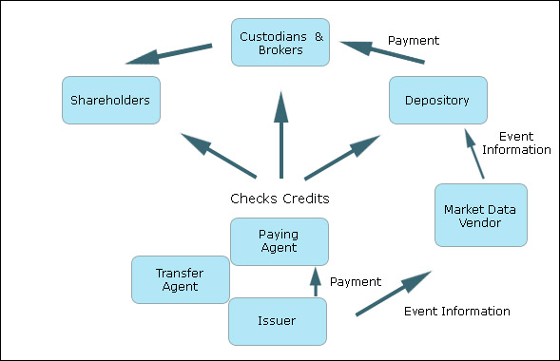
Figure 23: Dividend payment process

    - Interest Collection
Interest collection is the process of distributing interest on bonds to investors (called bondholders).
Bonds pay interest that is usually defined at the time of issuance. Similar to dividend collection, at the time of interest payments, the issuer of the bond provides the paying agent the money to make the interest payments. However, in this case the transfer agent notifies the paying agent of the identity of the holders. For variable rate bonds, the paying agent has to verify that the interest rate is correct.
Interest payments are the obligations of the issuer and therefore it is the issuer’s responsibility to ensure that the correct amount is paid to the holders. The paying agent also is responsible to the holders, not to the issuer.
Just like dividend collection, bonds can be held by nominees who receive the interest from the paying agent, and then transfer it to the actual owners.
There are two key dates in interest processing:
- Record Date: This is the date on which entitlement to the interest payment is established.
- Payment Date (Due Date): This is the date on which the payment of interest is made. Incase the interest payment date is a holiday, the payment is made on the next working day, known as the Value Date.
The interest payment process is depicted below:
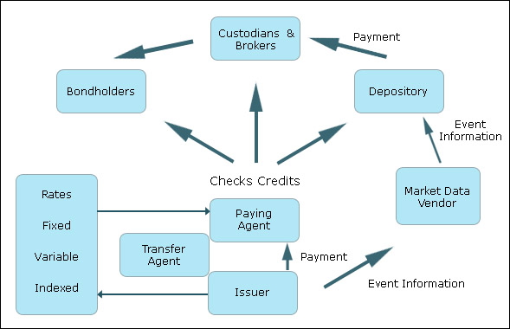
Figure 24: Interest payment process
There can be slight changes to processes of dividend and interest payment from what has been described above. At times another intermediary steps in after the paying agent. This intermediary, known as the sub-paying agent, receives the money from the paying agent, and then passes it on to other players like the shareholders.
Further, sometimes paying agents perform the role of providing event information and pre-advice to the depository. The depository then passes on the same to the custodians and brokers.
Also, sometimes there is another agent, known as the rate fixing agent, whose role is to fix the rates incase the bonds have variable rate of interest. The rate fixing agent conveys the interest rates to the paying agent.
In general paying agents come into the picture not only for dividend/interest payment, but in various actions that change the capital structure of the company. For example when the company shares recalls the shares issued by the public, the company has to compensate the investors for shares held by them. In such cases the paying agent performs a role similar to the one mentioned above.
Let us now look at some mandatory corporate actions.

  - Mandatory Corporate Actions
Merger
A merger is a combination of the assets and liabilities of two or more companies into one legal entity through the exchange of equity. In a merger, the old shares are cancelled and new ones are issued. For instance, in 1984, Indian Explosives Ltd, Chemicals and Fibers of India Ltd and Alkali and Chemical Corporation of India Ltd merged to form ICI India, all the existing shares of these companies were destroyed, and new shares were issued by ICI India.

Acquisition
An acquisition happens when a corporation acquires control of another corporation, known as the target. This can be done by purchasing shares of the target or even by exchanging shares. In an acquisition, the shares of the target firm are then cancelled. Thus the acquisition of Compaq by Hewlett-Packard led to the cancellation of Compaq’s shares

Stock Split
A company can change the number of outstanding shares through the process of ‘stock splits’. Also known as a forward stock split, it essentially increases the liquidity of stocks and with the price fall after the split, retail investors with lower amount to invest can also trade in these stocks.
For example Cognizant has done a 3 for 1 stock split in 2002 to increase retail participation.
A 1984 NYSE Study concluded that stock prices on average, react positively to stock split announcements (and Dividend announcements) that are not contaminated by other simultaneous announcements, such as earnings releases and merger announcements.

Reverse Stock Split
In a reverse stock split, the issuer of the shares reduces the number of shares. To do this the issues has to issue new shares of a higher nominal value to replace the older ones that had a lower nominal value. This is done in a way so that the market capitalization of the issuer remains constant. For example, in September 2002, Commerce One announced a 1-for-10 reverse stock split. Suppose just before the action, there were 10 million shares of the company, each of the nominal value $ 1. After the action, there would then have been 1 million shares, each share having the nominal value $ 10. Thus the market capitalization would remain unchanged at $ 10 million. Similarly, the market price of the share increases after a reverse stock split.
It's usually a bad sign if a company is forced to reverse split. Companies do it typically when they are performing badly and consequently the shares are quoting at very low prices. The motive could be to make their shares "look" more valuable, but in reality nothing changes. A company may also do a reverse split to avoid being de-listed on stock exchanges. This is because some exchanges have minimum price requirements, below which they force the companies to de-list their shares.

Calls and Redemptions
Suppose infrastructure bonds had been issued by ICICI Bank in January 2002, the tenor of the bonds being 3 years. This means that in January 2005, the bond will mature. When this happens, ICICI Bank will redeem the bonds for cash, which will be returned to the investors. This is called redemption. Redemptions at maturity are mandatory for the investors.
Some bonds have an option for the issuers, whereby the issuer can retire the bond earlier than the maturity date. This is known as calling the bond, and the issuer has to issue a call notice to exercise the option. In some cases, the issuer can decide to call only a part of the total bonds issued. The owners of those bonds must then present the bonds for redemption. (Note: In still other cases, the bondholders also have the option of rejecting the call notice. The corporate action in such cases is voluntary, not mandatory)
When the bond matures or is redeemed for any reason, it is usually presented to the paying agent, although a separate redemption agent can be appointed. The paying agent verifies that the bond has not been stolen or stopped. It then obtains the necessary funds from the issuer, or from a trustee incase the issuer had formed a sinking fund for this purpose, and then pays the bondholder the amount due.

Spin Off
A spin off occurs when an independent company is created from an existing part of another company. The new company is established as a separate legal entity. It can also happen when a firm owns shares in another firm and distributes them to its own shareholders. The new firm, if established as a corporation, has its own capital structure.

  - Voluntary Corporate Actions
Now let us look at some voluntary actions.
Convertible Bond (Conversion)
A conversion occurs when one instrument is exchanged for another instrument, usually with same company. For example convertible bonds issued by companies are usually exchangeable for common shares. The exchange ratio is fixed at the time of issuance of the bonds.
Indian companies typically issue Foreign Currency Convertible Bonds (FCCB). In such bonds, the bonds are denominated in foreign currency and can be converted into Global Depository Receipts (GDRs) listed in foreign exchanges, or even into shares listed in India, i.e. Rupee denominated shares. In case the FCCB is converted into GDRs, it is not necessary that the GDRs should be listed in the same exchange in which the FCCBs were listed.
For instance, in October 2002, BSES Ltd raised $120 million through the issue of Foreign Currency Convertible Bonds. BSES' bonds listed on the Luxembourg Stock Exchange and the GDRs, which will be issued on conversion, will be listed on the London Stock Exchange.

Tender Offer
A tender offer is a formal offer by one company or individual to buy the shares of another company with cash, securities or a combination of the two. It is thus a takeover bid. Generally, it takes the form of a public invitation to shareholders to sell their stock, at a price above the market price. If the corporation that is being taken over or its shareholders object to this action, it is called an unfriendly or a hostile takeover.
Tender offer by itself is a voluntary action, but if it is successful, the acquirer may decide to take mandatory actions.

Warrant
A warrant is a certificate, usually issued along with a bond or preferred stock, entitling the holder to buy a specific amount of securities at a specific price, usually above the current market price at the time of issuance, for an extended period, anywhere from a few years to forever. In the case that the price of the security rises to above that of the warrant's exercise price, then the investor can buy the security at the warrant's exercise price and resell it for a profit. Otherwise, the warrant will simply expire or remain unused. Warrants are like call options and are listed on options exchanges. They are negotiable instruments, can be detached and traded independently of the security with which it was issued.
Warrants are often used as inducements to investors along with other instruments like bonds.

Put Option
A put option gives the holder of the option the right to sell an asset by a certain date for a certain price. Thus this option is the opposite of call options that we had discussed above. Suppose ICICI issues bonds that have embedded in them put options for the bondholders. The bondholders can them redeem the bonds earlier than the maturity date. This is known as putting the bond. The issuer of the bonds i.e. ICICI is then obligated to redeem the bonds.

Pricing
Custodians and brokers price their customers’ portfolios at defined periods of time. While real-time market prices are used to make buy and sell decisions and determine margin positions, month-end prices are used to establish the portfolio value.
The prices are generally obtained from the exchanges or from market data vendors through a batch file used by the firm’s application to value the portfolios. Most of the commonly traded securities can be priced electronically, based upon the last trade on the day of valuation. For illiquid securities like municipal bonds, brokers and custodians acquire estimated prices from vendors that provide such a service or by calling traders and asking their opinions.

Proxy
Most of us would have understood this term while in college. Its meaning in the asset servicing context is similar, however, it is very much legal.
A proxy is a form that is given by a shareholder to authorize someone else to vote in the shareholder’s place at a shareholder meeting. The proxy notice is the official notice of the specific issues requiring a vote by the shareholders, and a description of the shareholder’s voting rights. The shareholders can place their own vote, or give their proxy to someone else to vote in their place.
The registrar of the company that has issued the security knows which investors hold the security in the physical form and knows the amount of securities that are held by the DTC and directly by brokers and banks. As shown in the diagram below, the registrar will distribute documents:
- Directly to the investors
- To the banks and brokers
- To a proxy service that is used to distribute the material. The proxy service then forward the documents to the investors, collect the proxies that are returned by the investors, and record the votes.
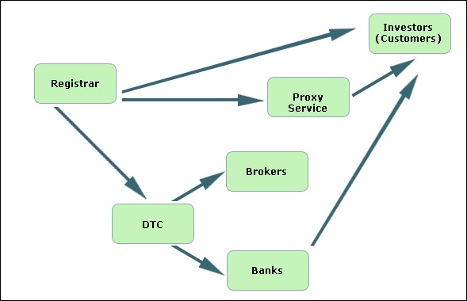
Figure 25: Proxy process
The overall flow of the proxy process consists of the following steps:
- The corporation decides upon the issues requiring a vote.
- It advises the market of the event.
- Depositories, banks and brokers identify shareholders based upon the record date established by the corporation.
- Banks and brokers that do their own proxy processing notify the corporation of the number of proxy packages they need.
- Banks and brokers that use a proxy service provide the service with a list of names and addresses.
- Banks, brokers and services all receive the proxy packages from the corporation.
- They then mail these packages to the investors.

Escheatment
Escheatment is the process of turning over unclaimed or an abandoned asset to a state authority, such as if a person dies without a will. The state authority is required to maintain unclaimed funds and related owner information for claim by the rightful owner. It should make a sincere attempt to find the rightful owner and refund the property to him / her without taking any payment for the same.
Different states in the US have different rules, but generally the assets are remitted to the state incase the rightful owner cannot be located within 3 years. If the rightful owner is identified subsequently, he / she can reclaim the property from the state.
Unclaimed assets related to the securities industry include:
- Savings and checking accounts
- Uncashed checks
- Certificates of Deposit
- Uncashed death benefits
- Stocks and dividends

- Custody
  - Custodian
In this chapter we shall look at the role of custodians and the services they provide to their clients. The term custodian has been used generically in this module to describe those organizations that effect settlement on behalf of individuals / organizations trading in securities. A custodian is appointed by the account holder to take care of his securities and cash and to carry out his instructions to deliver or receive securities and / or cash. This is a comparable arrangement to an individual’s relationship with a bank. We shall look at different types of custodians and the services they provide.

    - Services provided by Custodians
When the account holder first sets up an account with a custodian, the custodian, first of all, typically advises the account holder of market procedures and practices.
In a more day-to-day sense, the services provided by custodians relate to two main areas:
- Holding of securities and cash in safe custody
- Movement of securities and cash as instructed by the account holder

Holding of securities and cash in safe custody
For previous purchases of securities, by the account holder, that have already been settled, the custodian holds the securities in safe custody. The services provided for such securities include:
- Keep them safe from the threat of theft or loss
- Provide daily statements of securities and cash holdings
- Provide current market valuations of securities holdings
- Provide securities lending or borrowing facilities
- Collect income or additional securities as per account holder’s entitlement. This typically arises from corporate actions like dividend distribution, rights issues, bonus issues etc. Custodians not only collect the income or securities, they also actively track corporate actions, interest schedules etc. and calculate the account holders’ entitlements.
- Advise account holders of voluntary corporate actions
Following purchases of securities and their settlement, the custodian debits the cash account of the account holder.
A custodian may or may not allow the account holder to hold cash balances. In case it does allow it, the services provided to the account holder include:
- Keep it safe from the threat of theft
- Pay interest on cash balance
- Provide daily statement of cash balance

Movements of securities and cash
When the account holder sells securities held by the custodian or buys securities that will be held by the custodian, he/she issues a settlement instruction to the custodian in order to effect the movement of securities and cash. The services provided by the custodian include:
- Acknowledge receipt of the settlement instruction to the account holder
- Apply the current pre-settlement status of the instruction. E.g.
- Unmatched
- Matched
- Failed to settle
- Transmit the current status of each instruction to the account holder
- Effect the delivery or receipt of securities and cash in accordance with the account holder’s instructions
- Upon settlement of each instruction
- Apply the status of ‘settled’ to the instruction
- Update the account holder’s securities holding
- Update the account holder’s cash holding
The account holder may wish to transfer funds to the cash account to and from external accounts like a savings bank account. In such cases the account holder issues an instruction to pay away or a pre-advice to receive cash.

    - Types of Custodians
The different types of custodians are:
Central Securities Depository
The first type of custodian we need to look at is the Central Securities Depository (CSD). This is an organization that holds securities and is usually the ultimate place of settlement.
National Central Securities Depository
National Central Securities Depository (NCSD) is a CSD that handles the domestic securities of the country in which it is located. An NCSD is typically set up and operated on behalf of the members of the national stock exchange of the country, as the core and primary repository of securities issued, traded and settled in the country.
The NCSD operating in USA is the DTC, while in India the NCSD is the NSDL.
International Central Securities Depository
International Central Securities Depository (ICSD) is a CSD that handles domestic and international securities. Only two organizations are recognized as ICSDs: Clearstream (Luxembourg) and Euroclear (Brussels).
Agents, institutional investors and custodians from around the globe can become its members. Securities are held on behalf of the ICSD by depository banks in numerous financial centers, and correspondent banks manage the external movement of currencies.
Settlement at ICSDs falls into 3 categories:
- Internal i.e. between participants in the same ICSD.
- Bridge i.e between a participant of Euroclear and that of Clearstream. Here ‘bridge’ refers to the electronic link between the two ICSDs.
- External i.e. between participants of an ICSD and an NCSD via electronic links. This is also known as cross-border settlement.

Global Custodians
This is a custodian who has an additional network of local (or sub-) custodians that hold securities and cash and effect settlement of trades on behalf of the global custodian.
The figure below depicts how a global custodian operates.
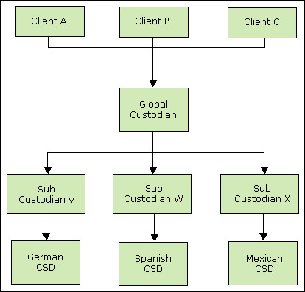
Figure 26: Global Custodian
A global custodian is appointed by the account holder to facilitate trade settlement and the holding of securities and cash, by using its worldwide network of sub-custodians. Each sub-custodian is usually a member of the local CSD. The client issues settlement instructions to the global custodian, which then directs its instruction to the appropriate sub-custodian. This sub-custodian then effect settlement on behalf of the global custodian.
The exchange of securities and cash resulting from a trade executing between buyer and seller occurs at the CSD, where accounts of the sub-custodians representing buyer and seller will be debited or credited with securities and cash.

    - Risks associated with the Custodian’s role
The areas that a custodian must pay careful attention to include:
- Holding of securities and cash
- Acting upon settlement instructions
- Deliveries and receipt of physical securities and cash
- Management of corporate actions
- Failure to focus on these areas introduces the risk of loss from both the account holder’s and the custodian’s perspective.
Let us look at some these in detail:

Holding of securities
In many markets, the certificates representing securities holdings are in the electronic or dematerialized (known as Demat in India) form. In such cases, the holding with custodian is secure as it is maintained in book-entry form.
In some markets physical securities certificates are still being used. These can further be of types: Registered and Bearer. In case of registered securities, securities holders have their name, address, amount of securities held etc. recorded on a register of holders maintained by the company’s registrar. In case of theft or loss, duplicate certificates can be obtained from the registrar. However for bearer securities, proof of ownership is the physical possession of the certificate. There is no centrally held register containing the list of owners. Therefore the very nature of bearer securities requires that the custodian should custodian should keep them extremely secure. In fact depositories usually maintain vaults for the physical safekeeping of the securities. E.g. The DTC’s vault and certificate-handling practices ensure tight security and accurate processing.

Acting upon Settlement Instructions
Custodians must remain vigilant regarding the authenticity of settlement instructions received, which appear to be sent by the account holder. This is particularly important regarding instructions to deliver securities FoP, and for payments of cash.
The responsibility for a custodian acting upon an instruction that was not issued by the account holder is typically detailed within the agreement between the account holder and the custodian.

Receipt of Physical Certificates
If the account holder has instructed the custodian to receive physical certificates, and upon receipt of the same the custodian fails to check their authenticity, there is a risk that the certificates are fraudulent. This fact will be revealed only on events such as maturity payment.
Management of corporate actions has already been discussed in the chapter on Asset Servicing.

- Reconciliation
The process of proving that a securities trading firm’s books and records are accurate is commonly known as reconciliation. An efficient trading firm seeks proof that its books and records are accurate, by comparing each component of its securities positions and cash balances with the outside world on a daily basis, as well as ensuring that its books and records reconcile internally.
The firm’s complete picture of an individual security can be summarized by comparing its trading position (also known as ownership position) with the sum of the open trades and the settled positions (also known as location position).
Let us understand what these terms mean.
- Open Trade is a trade for which settlement has not yet occurred.
- Settled Position is the quantity of securities held in the account of an account holder, at a custodian.
- Trading position is the number of securities held or owed by the investor on the day the trade is made. It can be positive or negative. Positive trading position implies that the net result of all transactions was that the investor owns a certain number of securities, where as negative trading position implies that the investor owes a certain number of securities.
Differences in the settled position and trading position are usually due to one or many open trades

  - Types of reconciliation
The list of reconciliation is depicted in the figure below (the dashed arrows represent reconciliation):
Trade-by-Trade Reconciliation: This is an automated reconciliation that proves that all trades captured by the traders are successfully captured within the settlement system. Not conducting this reconciliation can result in failure to process individual trades. The possibility of trades not coming into the settlement system is very much there. That’s why this reconciliation is important. Its importance will increase as the settlement cycle shrinks.
Trading Position Reconciliation: This reconciliation is designed to prove that the trade dated security positions calculated by the trading system agree with the equivalent positions calculated by the settlement system. Not conducting this reconciliation can result in trades being executed from the incorrect trading position, where the trading system is found to be incorrect. Discrepancies can arise where trades have not been received by the settlement system, and where trade amendments and cancellations have been effected within one system but not the other.
To be certain of being in a fully reconciled position, both the trade-by-trade and trading position reconciliations should be done.
Open Trades Reconciliation: This reconciliation aims to prove that open trades held within internal books and records are actually open at the relevant custodian, or generally have the same status at the custodian.

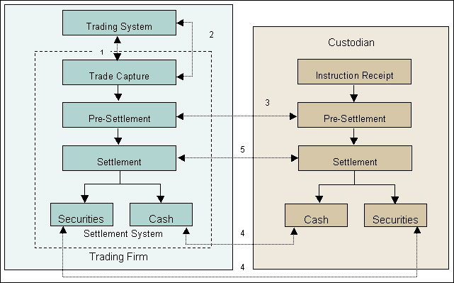
Figure28: Reconciliation
Custodian Position Reconciliation: The aim of this reconciliation is to prove that settled securities positions held within internal books and records agree with the equivalent positions as advised by the custodian. This is therefore another fundamental control and confirms to the firm that the securities that it believes are held by the custodian are actually held by the custodian.
Settlement System Integrity Reconciliation: This reconciliation intends to prove that the settlement system is in balance i.e. the total of securities owned is equal to the sum of the location position. If the firm employs double-entry bookkeeping, theoretically this will be true by default. Still this reconciliation must be performed frequently to prove that the system is in balance.

  - Methods of Reconciliation
The reconciliation described above can be categorized into either non-cumulative reconciliation or cumulative reconciliation.
Non-cumulative Reconciliation
The trade-by-trade, open trade, settlement and custody system integrity reconciliation do not involve an opening and closing balance. Rather they are ‘snapshot’ type reconciliation. Such reconciliation is called non-cumulative reconciliation.
Cumulative Reconciliation
The trading position and the custodian position reconciliation involve opening balances, movements and closing balances and are therefore called cumulative reconciliation.

SECTION IV

TECHNOLOGY IN INVESTMENT BANKS AND CAPITAL MARKETS

Business processes in Investment banking domain include IPO, Mergers and Acquisitions, Loan Syndication and Corporate finance. In some investment banks Capital markets functions include institutional brokerage business, proprietary trading and equity research.

Capital market functions are characterised by much higher incidence of technology than traditional corporate finance and investment banking functions. The following table lists technology requirements across different business functions in Investment banking and capital markets.

- Technology in IPO, M&A and Corporate Finance
  - Market Data access
Corporate data bases are used for tracking different companies. Current news and corporate events are tracked using market data information providers like Bloomberg and Reuters.
Some of the leading products of used to access market information by M&A, IPO and Corporate finance teams in Investment Banks include
- M&A League tables and databases:
  - Bloomberg M&A League tables and Bloomberg Underwriter rankings have information about mega-deals as well as smaller private transactions, and act as source for most information available on financial and legal deal representation.
  - Some other key databases providing corporate transaction details include DoneDeals® database, MergerStat Online Transaction Roster.
- Reuters Knowledge: Reuters Knowledge is used by investment bankers, portfolio managers and corporate clients focused on company and/or Industry specific research.
Information available on World Wide Web free of cost is also used by Investment banking analysts to scan market landscape. Search capabilities provided by engines like Google and AltaVista are widely used for the purpose.

  - Modelling
Models used for valuations for M&A, IPO are done using Excel sheets. Valuation models used are highly proprietary. Also many of the valuation models are tailored for specific deals. These valuation models are built by analysts and associates working on the deal using Excel sheets, Excel and VBA macros.

  - Collaboration and Communication
Collaborative applications for communication within Investment bank include Lotus Notes Suites, MS collaboration systems. The purpose of Collaborative communication technology is to facilitate transfer of information between different groups of analysts working on deals. For example, team handling sales and road shows for IPO would want to collaborate with valuation team. In addition, collaborative technologies will allow teams working in diverse geographical locations to work with each other.
Key technologies that are used in Investment banking for communication and collaboration include
- Electronic communication tools to send messages, files, data, or documents between people and hence facilitate the sharing of information.
  - Examples include: E-mail, faxing ,voice mail ,Web publishing
- Electronic conferencing tools also facilitate the sharing of information, but in a more interactive way.
  - Examples include: data conferencing ,voice conferencing ,video conferencing ,Internet forums ,chat rooms ,electronic meeting systems
- Collaborative management tools facilitate and manage group activities.
  - Examples include: Time management software, Project management systems ,Workflow systems ,Knowledge management systems

  - Loan Syndication
- Market data providers like Reuters and Bloomberg are used for obtaining data on Loan syndication
- In addition, number of products support workflows involved in Debt & Loan syndication. ACBS Loan systems (currently owned by Fidelity Information systems) has modules like ACBS SyndTrak which are used for in area of Loan and debt syndication.
- ACBS SyndTrak was introduced in 1998; and has become market standard front office system for loan syndication. ACBS SyndTrack supports following business processes.
  - Contact management,
  - Book building
  - Tracking Customer appetites for debt
  - Market tracking
  - Maintaining deal calendars
The latest versions of Debt syndication software have taken Debt syndication capability online. ACBS SyndTrak online extends the book building functionality of ACBS SyndTrak onto the Web. Using the deal and investor information already contained in ACBS SyndTrak, it enables clients to efficiently create secure “deal sites” on the Web for transmitting documents and other vital information about syndicated loans to investors, trading counterparties and holders.

- Capital Market Processes and Technology

As discussed in earlier sections Capital markets deal with trading in different products and instruments. The processes in capital markets are more conducive for automation. The following figure shows the processes involved in the front, middle and back offices of the buy-side as well as sell-side players in the securities industry.

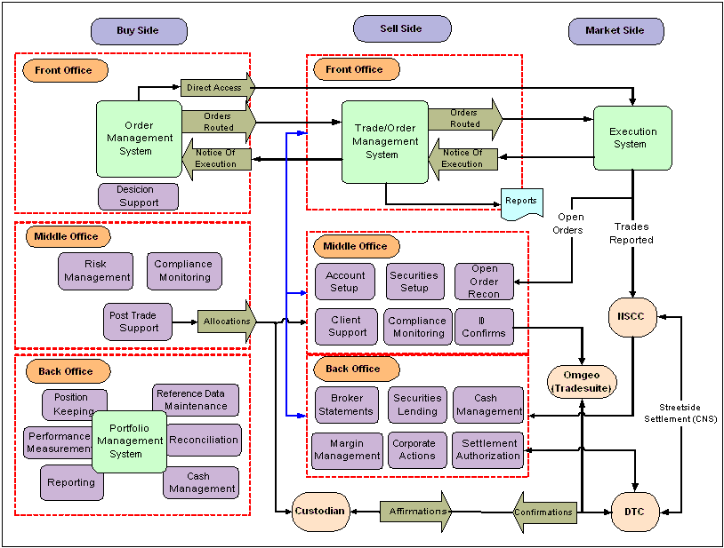

At a high level the various steps in trade lifecycle (on the sell-side) can be categorized into steps presented in figure below. Business processes for each of these steps along with technology used to support them are detailed out in subsequent sections

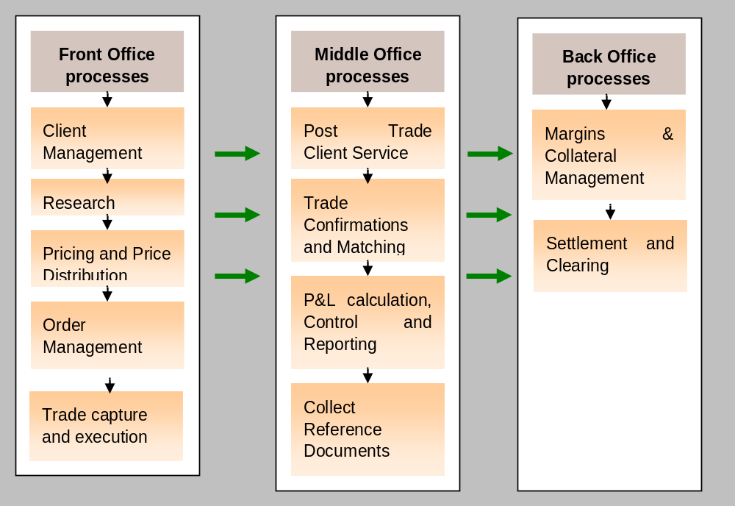

  - Front Office
The Front-office is a term used to describe the trading and sales staff in a financial institution. The Front-office forms the hub of an institution's buying and selling operations. Key Business processes in Front office include
- Client management
- Research
- Pricing and Price Distribution
- Order Management
- Trade Execution
The following section describes each of the above processes in detail along with technology and products used to support the processes

    - Client Management

Introduction
The client contact is typically made using telephone or dedicated line. The records of actual deals were traditionally maintained in excel sheets or paper.
However more advanced integrated applications are used both by sales team of investment bank as well as clients. They have enabled clients to check the status of their requests real time. Also aggregated inventory of all the requests across different members of the sales team can be maintained.

The current focus of banks for client management include
- Provide client-facing solutions to business: Maintain inventory of client requirements and client behaviour which will allow product design based on actual customer data and requirements.
- Customer Facing Front End: Provide customers accurate valuations of their portfolios, real time.

Business processes in Client Management
Set Up Contact with Client
Receive request of Trade
Review Credit and Legal Documents
Maintain Records of Actual Trades
Set Up new client details
Check client suitability
Obtain Credit Approval
Liaise with client MO
Collect Reference Documents
Pre-trade capture process
Discuss client requirements
Receive trade request
Calculate credit line availability
Check transaction suitability

- Identify and set up contact with Potential Client
  - Receive request of trade from client or initiate contact or receive call from client for new deal
  - Conduct reviews of credit and legal documentation and suitability
  - Maintain records of actual trades
- Set Up New Client
  - Check client suitability
  - Obtain credit approval for credit lines (for lending or fixed income business)
  - Liaise with Client Documentation Group to understand client reporting and documentation requirements
  - Initiate legal documentation, with the help of legal documentation team
  - Collate required reference data
- Pre trade capture processes
  - Discuss Client requirements with the trader
  - Receive order/trade request from client.
  - Calculate Credit exposure and credit line availability, for fixed income business
  - Check transaction suitability

Investment banks go for custom built solutions for client management. Applications are built using web enabled technologies like J2EE, as real time web based interface has to be provided to the clients. In addition, software products and services provided by leading software product vendors also provide client management capabilities. These include
- Adaptive and BRASS product from Sungard.
- MX3 product developed by Murex provides full management of margins and sales credits. (Sales credits are Reward “points” to sales persons for getting the business to bank)

Information managed by Client Management Systems
- Customer Information: Customer information is useful for:
- Business Managers for sales strategy and sales performance and deal verification.
- Salespeople for deal verification, trends and performance
- Middle Office for deal verification and revenue sharing
- Custody and Treasury Solutions Group for revenue sharing

- Client Valuation: This is an important after sales-service that provides accurate valuations on various Credit and Rate products that customers buy from the bank. Client Valuation is useful for:
- Prioritizing Client Demands according to sensitivity and Revenue return.
- Carrying out Semi Annual client re-sponsorship exercise to redefine portfolio content, client contact details.
- Liasing with clients, sales and marketing to establish new account
- Identifying and confirming product type, valuation source or calculation method

    - Research
Equity research involves three key business processes from the point of view of technology incidence. They include

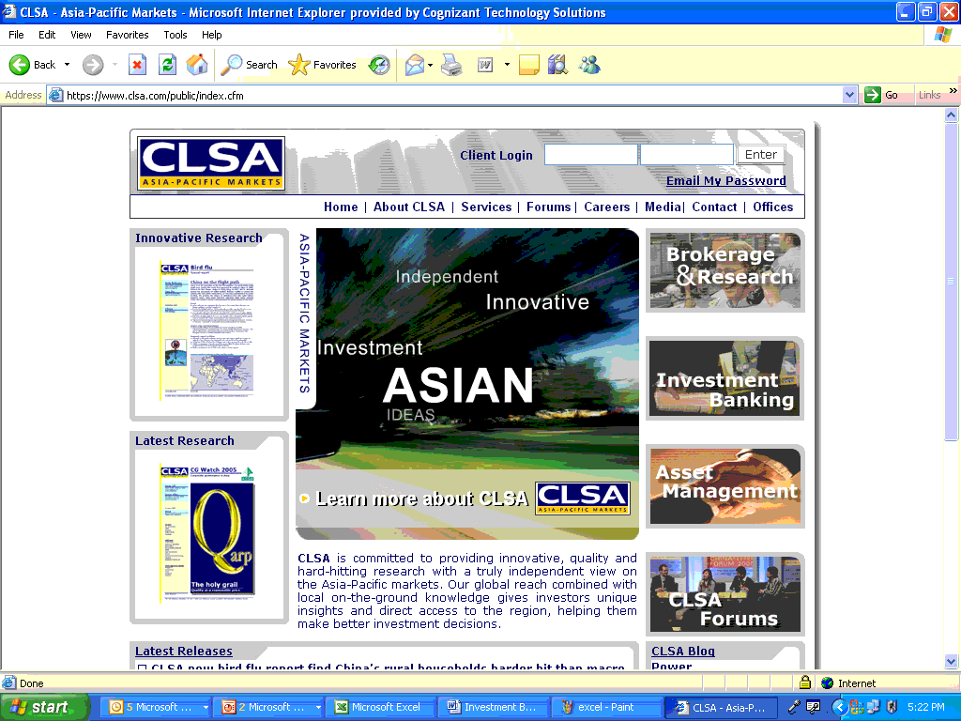
Develop Equity Research Models
Research Data Aggregation
Equity Research Delivery
Excel
Research Delivery Website
DB

Development of Research Valuation Models
Equity research valuation models are developed by analysts. Each equity research team develops its own valuation model which is very proprietary.
- Equity Research models are built using MS Excel and embedded VBA macros
- Market data providers for development of research models include Reuters and Bloomberg.

Research delivery
Research data used to delivered to clients through mail using brochures and booklets earlier. Recently research data is provided as a value added service to brokerage clients of bank. Research data is delivered online. Research data or reports are available to clients having online brokerage accounts with banks depending on user privileges.
Key differentiator for Equity Research delivery (in addition to research quality) is effective delivery mechanism and intelligent bundling of equity research along with traditional brokerage offerings.
Technology used for equity research delivery involves equity research websites. For example, equity research for Asia pacific is delivered by CLSA through its website https://www.clsa.com/public/services/index.cfm?id=12

Research Data Aggregation
Research analysts track different instruments (Equity, Fixed income instruments, FX, derivative instruments) across different geographies. For example an equity research team of 3 analysts will cover large cap stocks in IT sector in India (e.g. Infosys, TCS, Wipro, HCL Tech). Research outputs from different analysts have to be collated in centralized locations for effective delivery. Key research parameters are entered by analysts in a centralized database.

One of the emerging trends in research is multi location research. Equity research is conducted remotely with distributed teams. For example, team of analysts covering Microsoft will be based in different geographical locations with lead analyst based in New York and 2 supporting analysts based in Mumbai. The team of 3 analysts physically based in different locations will together cover the stock. The concept of distributed teams for research has resulted in greater need for tools for collaboration.

    - Pricing and Price distribution
Pricing function for different trades are done using analytical functions and libraries developed in house by investment banks and brokerage houses. In addition, trading products from Sungard, ADP, Murex, Reuters are used. These products have pricing functions in built into them.

Trading products also allow users’ dual flexibility of either using pricing analytic functions in built into the product or integrating user-defined analytics into those provided by the product. For example, MX.3, a Murex product, features the Structured Trade Builder (STB), a pricing and structuring framework covering various products and providing ability to define new structures. Each product can be associated to valuation models selected from the rich Murex analytics library (MACS), or from proprietary models integrated by the bank’s clients.

Pricing is done by traders and the price quote is relayed back to the sales team for confirmation from the client. Pricing analytic libraries are typically built using C, C++ libraries.

Some of the pricing analytics for different financial products are presented below for reference.
Product | Key Pricing / Analysis analytic
Equity | MACD, Moving average of price, RSI
Fixed Income | Yield to Maturity or Asset swap arbitrage pricing for securities  Zero Coupon Yield Curve
Derivatives | Greeks (Delta, Vega), Volatility Surfaces
Credit Trading, Loans | Sensitivities to default rates, LGD (Loss given default), EDF (Estimated default frequency)

    - Order Management
Order management systems are designed for providing a transparent order flow process that is flexible via advanced order routing rules, saving money on transaction cost via internal order crossing, and is compliant to the regional compliancy regulations.

Business processes in Order Management
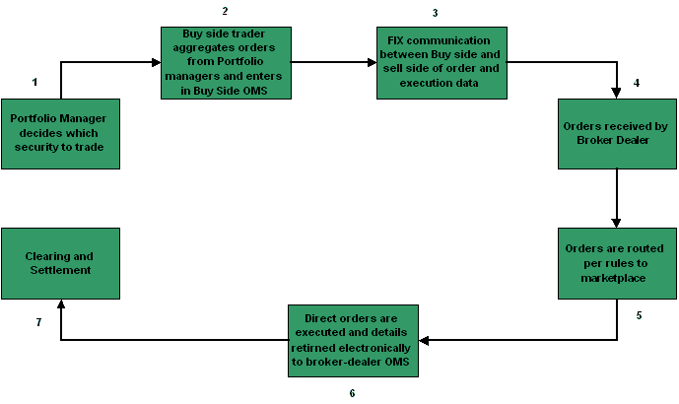

- The Portfolio manager decides which securities to trade in. The portfolio manager then places the order with the buy side trader.
- The Buy side trader aggregates all the orders from the Portfolio manager and enters the orders into the buy side Trade Management System.
- Orders are transferred from the buy side to the sell side via FIX (Standard communication protocol used for financial data exchange).
- Price is obtained from trader maintaining inventory or accessing price quotes from the market
- Dispatch price quote to client or buy side trader for confirmation
- Confirm details of transaction by phone or fax with client on trade date
- Once the sell side broker -dealer receives the orders from the sell side, the orders are entered in the sell side Order Management System.
- Orders are routed as per rules to the marketplace (Exchange or OTC).
- Once the order gets executed, order details are returned back electronically to broker-dealer’s Order Management System which are then sent to the clearing firm for Clearing and Settlement.

Features of a Sell Side OMS
Order Capture via FIX
The most important function of an Order Management System is ‘Order Capture’. Order capture is done when orders are transferred from the buy side trader to sell side broker-dealer.
Market Connectivity – Multiple instruments, multiple exchange connectivity
An Order Management System enables real time trading on the multiple markets it can connect to such as Exchanges, ECNs, ATS, etc. A trader can do trading in various products (Equity, derivatives, and bonds) and on various markets (Euronext, LSE etc).

Trader’s Workstation
Most Sell side OMS provide a variety of features that would enable a trader at the sell side form’s trading desk to make correct and timely trading decisions. The various features offered by such a system includes
- Market watch that allows the trader to view bid-ask quotes for various instruments as well other market information such as volumes last traded price, market depth (i.e. the number of outstanding orders on both bid and ask side for each security).
- Additional trading features like fast trading (ability to place orders with minimum keyboard strokes), basket trading (ability to place orders for multiple securities simultaneously), and program trading (generate and route orders based on pre-programmed trading tactics and strategies.
- Trading tools to identify arbitrage opportunities and make trading decisions on derivative instruments.

Order/ History Management tools
An Order Management System maintains a history of all the orders placed by the system with the help of Trade Blotters. These blotters not provide detailed information on the status (whether executed, partially executed, rejected, modified, cancelled etc.) of various orders but also maintain the order history of a user (orders placed by a user) and also the history of the executions.

Order Routing
Another important function of an Order Management System is Order Routing, wherein the OMS routes the orders to the various traders, which in turn place the order on the exchange. It can even route an order to the different market places depending on which market gives the best deal. This is known as Smart Order Routing done using smart routing algorithms. Examples some popular Sell side OMS includes GL Trade, Fidessa, Davidge Data Systems, NYFIX etc.

    - Trade Capture and Execution
(Source: US Securities and Exchange Commission http://www.sec.gov/investor/pubs/tradexec.htm)
Features of Trade capture and Execution
When you place an order to buy or sell stock, you might not think about where or how your broker will execute the trade. But where and how the order is executed can impact the overall costs of the transaction, including the price you pay for the stock.

Trade Execution Isn’t Instantaneous
Many investors who trade through online brokerage accounts assume they have a direct connection to the securities markets. But they don't. When you push enter key, your order is sent over the Internet to your broker—who in turn decides which market to send it to for execution. A similar process occurs when you call your broker to place a trade.

While trade execution is usually seamless and quick, it does take time. And prices can change quickly, especially in fast-moving markets. Because price quotes are only for a specific number of shares, investors may not always receive the price they saw on their screen or the price their broker quoted over the phone. By the time your order reaches the market, the price of the stock could be slightly – or very – different.

Broker Has Options for Executing Your Trade
Just as you have a choice of brokers, your broker generally has a choice of markets to execute your trade:
- For a stock that is listed on an exchange, such as the New York Stock Exchange (NYSE), your broker may direct the order to that exchange, to another exchange (such as a regional exchange), or to a firm called a "third market maker." A "third market maker" is a firm that stands ready to buy or sell a stock listed on an exchange at publicly quoted prices. As a way to attract orders from brokers, some regional exchanges or third market makers will pay your broker for routing your order to that exchange or market maker—perhaps a penny or more per share for your order. This is called "payment for order flow."
- For a stock that trades in an over-the-counter (OTC) market, such as the NASDAQ, your broker may send the order to a "NASDAQ market maker" in the stock. Many NASDAQ market makers also pay brokers for order flow.
- Your broker may route your order – especially a "limit order" – to an electronic communications network (ECN) that automatically matches buy and sell orders at specified prices. A "limit order" is an order to buy or sell a stock at a specific price.
- Your broker may decide to send your order to another division of your broker's firm to be filled out of the firm's own inventory. This is called "internalization." In this way, your broker's firm may make money on the "spread" – which is the difference between the purchase price and the sale price. Typically workflow followed for internalization would involve two sets of traders, Sales Traders and Position Traders
  - Sales Trader (ST): This trader interfaces with the clients of his firm and gets the orders from the clients. The orders are recorded and typically pushed to the Position Traders or executed electronically on the exchange. Sales traders are responsible for
    - Capturing orders from the clients
    - Monitoring orders and tracking to closure, and
    - Understanding customer needs and trading trends.
  - Position Trader (PT): This trader gets the order from the Sales Trader (Client Order), or can create an order for the firm’s own account (Firm or Proprietary Order). This trader is close to the source of liquidity, which is typically a stock exchange.
When the trader executes the order in the trader workstation, it can either
- Go to electronic exchange such as NASDAQ, ARCA, INCA, INET, BRUT, etc. via Electronic Communication Network (ECN) or
- Go to manual exchanges such ash NYSE, Amex, or other regional exchanges.

The graphic below shows your broker's options for executing your trade:
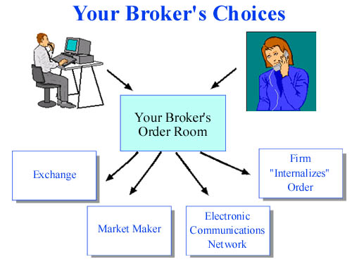
Broker Has a Duty of “Best Execution”
Many firms use automated systems to handle the orders they receive from their customers. In deciding how to execute orders, your broker has a duty to seek the best execution that is reasonably available for its customers' orders. That means your broker must evaluate the orders it receives from all customers in the aggregate and periodically assess which competing markets, market makers, or ECNs offer the most favorable terms of execution.
The opportunity for "price improvement" – which is the opportunity, but not the guarantee, for an order to be executed at a better price than what is currently quoted publicly – is an important factor a broker should consider in executing its customers' orders. Other factors include the speed and the likelihood of execution.
Here's an example of how price improvement can work: Let's say you enter a market order to sell 500 shares of a stock. The current quote is $20. Your broker may be able to send your order to a market or a market maker where your order would have the possibility of getting a price better than $20. If your order is executed at $20.05, you would receive $10,025.00 for the sale of your stock – $25.00 more than if your broker had only been able to get the current quote for you.
Of course, the additional time it takes some markets to execute orders may result in your getting a worse price than the current quote – especially in a fast-moving market. So, your broker is required to consider whether there is a trade-off between providing its customers' orders with the possibility – but not the guarantee – of better prices and the extra time it may take to do so.

Investor has options for Directing Trades
If for any reason you want to direct your trade to a particular exchange, market maker, or ECN, you may be able to call your broker and ask him or her to do this. But some brokers may charge for that service. Some brokers offer active traders the ability to direct orders in NASDAQ stocks to the market maker or ECN of their choice.
SEC rules aimed at improving public disclosure of order execution and routing practices require all market centres that trade national market system securities to make monthly, electronic disclosures of basic information concerning their quality of executions on a stock-by-stock basis, including how market orders of various sizes are executed relative to the public quotes. These reports must also disclose information about effective spreads – the spreads actually paid by investors whose orders are routed to a particular market centre. In addition, market centres must disclose the extent to which they provide executions at prices better than the public quotes to investors using limit orders.

Business processes involved in Trade Capture
- Check Compliance with applicable regulations
- Record details of client order
- Record special trading and settlement instructions from the client if applicable
- Input trade into system (includes amendments)
- Obtain necessary approvals
- The trade capture system typically routes the order to exchanges, OTC platforms, ECNs or another division of broker's firm to be filled out of the firm's own inventory through a single interface.

In addition to custom built solutions, Investment banking corporations use a wide variety of products to facilitate Trade Capture Execution and Order management.
Product | Key Product names
Reuters | Reuters 3000Xtra for brokers  ROMEX Trader for Market makers and proprietary traders  ROMEX Futures for derivatives and options traders
Sungard | SunGard's BRASS is a highly flexible order management system that supports NASDAQ, listed and sales trading. It can be used by traders involved in market making, fee-based trading, working on listed block desk, trading sectors or acting in hybrid mode.
ADP | FinancePro for Fixed Income Sector
Murex | MX.3 provides end to end transaction life cycle including trade capture

    - Business needs for Front Office processes
Product | Key Product names
Client Management | Availability and Usability of interface for the bank’s clients  Providing Direct Market Access (DMA) to bank’s clients
Trade Capture | Reducing paper / excel based processes and multiple data entry points for trade capture  Managing high volume data for order management  Reduction in number of entry points for trade capture and analysis.
Pricing | Flexibility to integrate pricing analytic capabilities provided by products with in house pricing analytic libraries  Availability of multiple pricing analytics through a single interface
Order Management | Client connectivity to different trade execution locales through single interface.  That means trader should be able to send the order to exchanges, OTC platforms, ECNs or another division of broker's firm to be filled out of the firm's own inventory through a single interface.

  - Middle Office
The major functions of this BU are
- Post Trade Client Service
- Risk Management (Trading Risk Management , Market Risk / Operational Risk / Credit Risk Management)
- P&L calculation, Control and Reporting
- Position Management and Reconciliation

    - Post trade client service
Middle office groups; interact with client and front office staff to obtain information about special enrichments expected for trade information reporting, settlement. Middle office is responsible for providing customised client service in the area of information access and reporting and sending confirmations for trades. Areas include
- Handle client inquiries.
- Manage post trade confirmation and resolve issues related to the same
- Maintain client reference data and client documentation

    - Trade Matching and Confirmations
The Middle office group is also responsible for obtaining necessary allocation information from the client. Based on the allocation Middle office will proceed with preparation of confirmation which are then dispatched to the client.
Trade matching and Confirmation reporting is supported by number of Vendor system applications and file formats. Oasys is a leading trade confirmation and trade matching format

Oasys
Oasys Global allows the electronic on-line matching and affirming of Broker to Client trades. Oasys can be used in one of two ways, either at Confirmation level or at Block level.
When using Oasys at confirmation level the basic procedure is as follows
- Broker receives client order and account details from investment house.
- Broker books out the trade(s) in question.
- Trade(s) is processed and an electronic confirmation message is generated from the Oasys terminal to the client terminal.
- Client receives trade electronically and either "Affirms" the deal, or "Rejects" with a narrative if they do not agree the trade details.
- Once the deal is affirmed it is fully matched and confirmed.

Using Oasys at Block level the flow is as follows
- Broker receives bulk client order but is not informed of the account splits.
- Bulk order is sent over to the client via the Oasys terminal.
- Client views the bulk transaction and if the details are agreed sends back all of the account splitting information
- Once received the Broker checks account splits and returns the trade splits to the client.
- Client checks the booked trades online and affirms.

Swift
For investment managers and broker / dealers wishing to communicate with each other directly, or via an ETC provider, SWIFT offers the ISO 15022 trade confirmation messages. The following diagram depicts facilities provided for post-trade pre-settlement trade confirmation message flow using SWIFT.
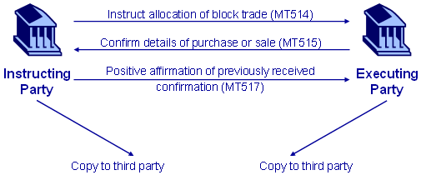
Other online trade matching and confirmation formats include TradeNetX, XNet, and SmartBridge.

    - P&L calculation, Control and Reporting
P&L calculation involves calculation Profit and loss for individual trades for different time buckets. The value of various assets is marked to market and changes in their present value are calculated. These changes are then attributed to various factors like Interest rate movement; Movement in Credit rating, Forex changes etc. This activity is closely linked with the risk management function and provides an overall consolidated view of the profit and loss incurred and risks faced by the Bank. It also acts as input for the trader in-order to fine tune his strategy. These P&L calculations can take place at various levels of the Business hierarchy, Country-Sector, Products.

Monitoring, Control and Reporting is one of the important activities of Middle office. Some of the key reports that are used for the purpose are
- P&L reports – By product, instrument, geography or trading desk
- P&L Analysis reports - To drill down and analyse the cause of P&L variations.
- End of Day MIS reports (the most famous of these is 4.15 report for JPMorgan)
- P&L Estimate reports – To track the estimates mentioned by Front office vs. actuals

Types of P&L
The following are different types of P&L that are reported or computed for analysis
P&L
Impact due to financial deal
Realized P&L
Unrealized P&L
Daily P&L
Month to date P&L
Mark to Market
Inception

- Daily P&L is the change in the value of P&L on account of daily market movements. Whereas, MTD P&L is change in P&L over period of 1 month
- Daily P&L = Price or PV (Today) – Price (Yesterday)
- MTD P&L = Price or PV (Today) – Price or PV (Last Month)
- Realized P&L is P&L amount that is obtained after maturity of an instrument or squaring of transaction. Unrealized P&L is reflected in the price of the instrument in the market, but the price gain has not yet been realized.
  - For example for a fixed in come instrument
  - Price(Last Month) = A
  - Price(Today) = B
  - Coupon payment in the interim period = Y
  - Realized P&L MTD = Y and Unrealized P&L MTD = B-A
Concept of Realized and Unrealized P&L is also useful to track gain or loss, when position in any instrument is partially liquidated.
  - For example for a fixed income instrument
  - Price(Last Month) = A per unit Quantity held = q1
  - Price(Today) = B per unit Quantity held = q2
  - In the interim period, quantity q1 –q2 was sold at C per unit
- Realized P&L MTD = (C-A)*(q1–q2) and Unrealized P&L = (B*q2) – (A*q2)

Components of P&L
P&L calculated is decomposed into parts, in order to analyse the cause of the difference in the P&L values. The following are the different components into which P&L can be decomposed.

P&L Explain
- P&L change due to Market environment variables (for example change in Interest Rate, FX rate etc)
- Cost of carry

P&L due to Funding Cost
- Funding cost for transactions (e.g. Repo Funding, Funding by Call Money)

P&L Deal Activity
- New Trade
- Trade Amends
- Cancellations in Trades

The diagram presented below identifies activities in generation of P&L, Reconciliation and reports for fixed income instruments and swaps.

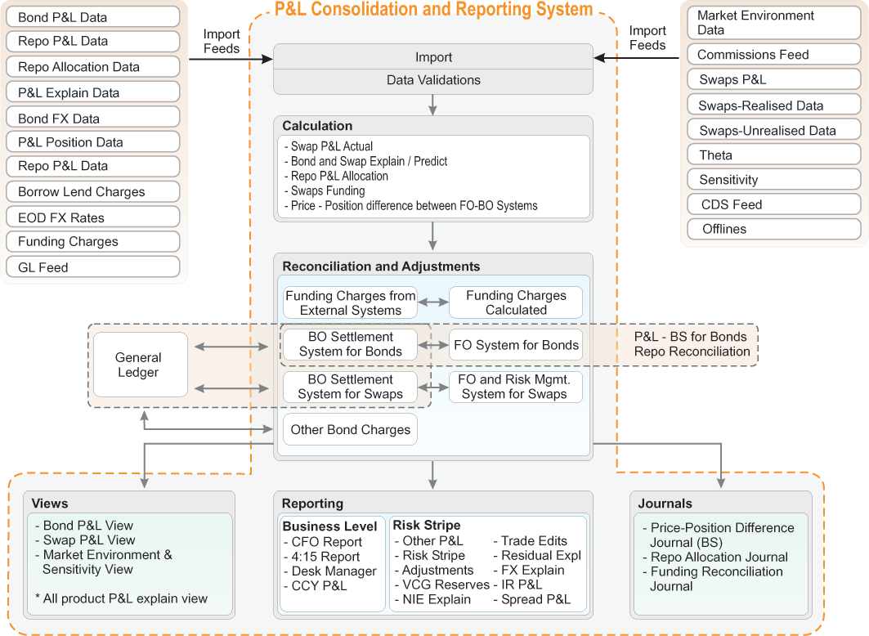

    - Transaction Accounting and Reconciliation
Transaction details are booked to ledgers, for purpose of accounting. Ensuring that the accounting entries are correctly booked and reconciling the ledgers with transaction records is also one of the functions of IB Middle Office. In addition to the above, IB Middle office is involved in maintaining legal documents and records for different client and transactions.
Some of the activities in Transaction accounting include
- Compute and maintain trader’s commission
- Send formal client valuation reports
- Sales Credit granted to sales team by trading desk
- Any cost of trade incurred for procuring securities

    - Reference data management
Reference data management, (for example, Client details form a part of reference data) was traditionally a job of Middle office group. However, separate horizontal groups (working across all the divisions of the bank, not just investment bank) have replaced them.

    - Technology incidence in Middle Office
Maintaining information for client service requires MO of investment banks to work with following technologies
- MS Excel, for quick updates and calculations
- Client Server technologies are preferred because client facing applications are not prevalent. Additionally, the number and types of reports required are high.
- Reporting tools like BO are used to provide drill down capability to allow the MO user to “Slice and dice” data. The need to drill down is critical for control reports to identify the root cause of deviation. For example, in case there is a significant drop in P&L, MO will want to investigate as to which desk or desks are primarily responsible for the drop.
- The MO is gradually moving towards web based interfaces and products supporting end to end transaction flows. The need for this transformation is driven by
  - Consolidation: Different MO groups can now no longer afford to work in silos
  - Aggregated reporting: Risk and data aggregation is need in response to regulations like Basel II
  - Move towards Straight Through Processing: FO applications now need to “talk” to Middle office applications in order to provide integration. Repetitive data entry has to be reduced for STP. More ever high volume transactions, driven by new businesses like Program trading and Direct Market Access, are driving integration between FO and MO applications.

    - Business needs for Middle Office processes
Product | Key Product names
Post Trade Client Service | Availability and Usability of interface for the bank’s clients  Providing Direct Market Access (DMA) to bank’s clients
Trade Confirmations and matching | Reducing paper / excel based processes and multiple data entry points for trade capture  Managing high volume data for order management
Risk Management  (Trading Risk Management , Market Risk / Operational Risk / Credit Risk Management) | Risk tracking and measurement  Ability to define and enforce controls  Facility to manage multiple instruments
P&L calculation, Control and Reporting | Ability to interface with multiple upstream and downstream systems and products  Drill down and analysis facility for P&L and Risk reporting  Ability to define and enforce controls
Position Management and Reconciliation | Consolidated system for Position Reporting

  - Back Office
The back-office is a term used to describe the staff responsible for processing trades in a financial institution. They handle settlement, clearing, regulatory compliance, accounting and cash management procedures.
Financial institutions face an array of challenges from changing regulatory requirements and the adoption of international accounting and industry standards, to shorter trade cycles and a demand for new, complex financial products. At the same time, they need to improve efficiencies and provide a better service for their customers. Effective trade management, in which the back-office plays a key role, is crucial to successful performance.
Back-office staff needs a range of tools to simplify the tasks they have to undertake. To process daily confirmations and payments efficiently, back-office staff must have the ability to connect easily with third-parties, such as SWIFT, the standard network for effecting international banking transactions, and securities clearing houses. Back-office staff wants tools that automate calculations, help with valuation and enable them to report their firms' holdings and transactions in accordance with international and local accounting standards.
Back-office staffs also need reliable pricing and reference data, including securities pricing and evaluations, corporate actions, terms and conditions for fixed income instruments, and historical data.
Key functions of Back office include margins and collateral management and settlement.

    - Margins and Collateral management
Trading firms ask their counterparties to sign master documentation allowing them to call for daily cash (or near cash) collateral cover of all outstanding positions. Major benefits arising from daily collateralisation are the reduction in risk amounts and, therefore, capital usage (both economic and regulatory) and significant shortening of the potential future exposure risk window.

    - Settlement
The following are key entities that form a part of settlement flow. Clearing House is responsible for matching the instructions sent by the bank and the counterparty as well as doing the actual settlement. Depository holds the security and cash accounts for both the bank and the counterparty. Each of them will have their own depository. The actual movement of instruments and cash during settlement takes place between the depositories.
The following diagram presents settlement flow supported by typical settlement system

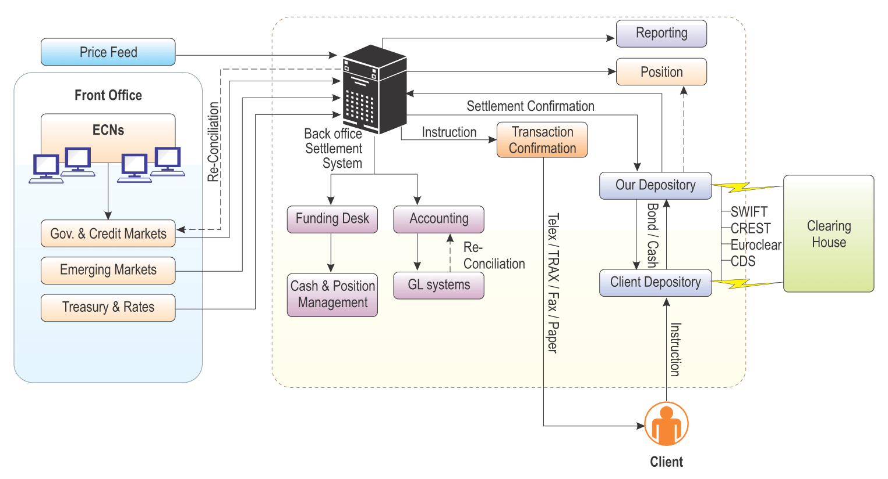
- Once the trade validation process is complete and the trades are actually into the settlement system.

- Delivery instructions are assigned to the deal and settlement system then sends these instructions to the clearing house through the depository on the trade date itself.

- The Clearing house also receives instructions from the Client/Counterparty.

- The primary task of the Clearing house is to match the instructions. If the instructions from both the parties do not match, both parties are informed of the mismatch. The instructions are resent after analysing the error and fixing it.

- Clearing House interacts with the depositories who maintain a stock of current instrument and cash position for both the bank and the client.

- The trade flow diagram below shows two depositories “Our Depot” and “Client Depot”. “Our Depot” is the depository where instruments for the bank are held. Similarly, “Client Depot” serves the same purpose for the client. The actual instrument and cash transfer during settlement takes place between these two depositories.

- The settlement system also maintains its own positions and this is reconciled with the depository as shown in the trade flow above. Apart from sending instructions to depository, the settlement system also faxes a trade confirmation (a legal document) to the client on the trade date.

- Funding Desk is the group that provides the funds for any transaction. It is the responsibility of the funding desk to arrange money for successful settlement of a transaction. The settlement system provides an update to the Funding Desk that a trade has taken place and when it is due to settle (value date).

- As the trade flow diagram indicates, settlement system also interfaces and sends trade information to the accounting division to update the general ledger accounts and facilitate reconciliation of postings and account balances.

- The settlement system also reports to regulatory bodies on each and every trade. For example, Bank of England should be reported in UK. The TRAX system should also be updated with the trade within 45 minutes of the deal.

- The settlement system also needs to inform the Credit Systems for every trade in order to facilitate risk management.

    - Risk Management
Risk management is business action taken to preclude or mitigate risk, and to take advantage of the opportunities that risk presents. These efforts necessarily include risk identification, evaluation and reporting, and may also extend to scenario modelling, which enables enterprises to discover risk potential or unknown risk.
Risk management needs be performed at the corporate level than at the level of business unit. Centralized approaches to risk centralization are evolving. Credit risk, collateral management need to be tracked at counterparty level rather than at instrument level. Risk management at the relationship level demands enterprise wide view of customer- and investment-related information.
The diagram presented below is taken from http://www.sun.com/solutions/documents/white-papers/fs_RiskManagement_dd.pdf white papers published by Sun Microsystems. The figure depicts how different functional elements enterprise-wide tie in to have a cohesive risk management approach. The figure also

Although risk management is an enterprise-wide activity, many of the elements presented in the risk management value chain, from transaction to presentation are handled by Middle Office. They include

Transaction | Data | Knowledge | Information | Presentation
- Aggregation of transaction details  - Reference data for each product  - Collect settlement instruction from the clients  - Control reports, P&L tracking | - Manage Reference Data  - Manage Historical Data  - Risk Events Archive | - Accounting based on standards like FAS | - Tracking compliance reports

Brokers-dealers are typically members of an Exchange

